CSE Website Update
Year V Results (2020-2021)

Major Activities:
To achieve a student support program at our college, we provided an array of support services to ensure progress and completion by students, from the moment they joined the S-STEM program through degree completion and transferring. Those support services included counseling sessions with STEM mentors and weekly activities including seminars, post seminar discussions, and group meetings. Furthermore, students meet with their mentors privately to discuss their transfer plans, scholarship (non S-STEM) applications, and opportunities for summer research internships. All meetings were done via Zoom in 2020-2021 FY due to the COVID-19 restriction and social distancing.

Significant Results:

Program Statistics and Activities
In FY 2020 – 2021, we started with 40 students in the fall. Those 40 students were comprised of students who continued from the spring 2020, students who applied to the program and expressed their interest to participate actively in the program. However, over time, the number dwindled down to 24 in the spring 2021. Students expressed difficulty in maintaining fulltime enrollment, challenges in online classes, family obligation, etc. The data here were based on the spring 2020 database.
Of the 24 active participants, 37.5% are female and 62.5% are male. The ethnicity distribution includes 21% Asian/Asian American including Filipinos and South East Asians, 67% Latinos/Hispanics, 8% Caucasians, and 4% two races or more. No African American students participating in the program.
Fields of study/ majors include engineering (52%), biological sciences(26%), computer science (13%), and physical science (9%).

Seminars
Our program incorporates seminars, workshops, and internships aimed at helpingstudents learn, train, and develop as future scientists.
Fall 2020

We started with a Meet and Greet event in September 4th in which mentors, program staff, continuing students, and potential students met for the first time after their summer break. The second seminar was on September 18 where Ms. Stephanie Martinez and Ms. Lysette Zaragoza presented their summer internship experiences, the fully online summer internship during Covid-19. Ms. Contreras participated in the Children’s Hospital Oakland Research Institute (CHORI) program. The program elements included tutorials on how to read scientific journals, how to conduct online searches, how to give oral presentations, how to do poster presentations, and they attended online lectures by medical professionals from CHORI and UC San Francisco Medical School. Ms. Zaragoza worked under the supervision of Contra Costa College STEM advisor Eleanor Pangilinan, and her duties included online searches and collecting information for STEM students on scholarships, internships, transfer, etc.
We had one seminar and one workshop in October 2020. The seminar was on Immunology to defeat Covid-19 by Dr. Steven Mack of UC San Francisco. Dr. Mack is an Associate Professor in the Pediatric Department and a National Science Foundation Principal Investigator on immunogenomic research. In his presentation, he explained how certain groups of people are more inclined to be asymptomatic and/or showing lighter health effect of Covid-19 based on their genes. Then on October 16, we had a joint workshop with UC Davis folks on their Avenue E and Avenue B programs. Both Avenue E and Avenue B are programs designed to help community college transfer students smoothly transition to UC Davis, and ultimately, a career in biology (Ave B) and engineering or computer science (Ave E). Ave E program was developed by UC Davis and founding corporate partner, Chevron, in collaboration with Los Rios, Peralta, San Joaquin, and Contra Costa Community College Districts. The program richly benefit students by offering mentorships, research opportunities, and other academic activities. The UC application workshop was hosted by UC Berkeley Transfer Center's Community College Liaison staff.

There was one seminar and one workshop in November. The seminar on November 6 featured Mr. Beshoy Tawfic, our College alumnus, UC Berkeley School of Engineering graduate, and current employee of BOEING Company, and shared his experience going through the engineering program at UC Berkeley, some students’ dream school, and his experience working for BOEING. He gave valuable advice to our current students on how to continue and extend education and training after graduation and how to increase marketability in the job market.
Spring 2021

We started the semester activities on February 5 with mentor meetings, orientation, and setting up goals for the semester. On February 26, we had a workshop on scholarships and internship applications. Many of our students are not eligible for the S-STEM scholarships due to their estimated family contribution (EFC) although their family annual incomes were by no means sufficient for living in the Bay Area of San Francisco. Thus, all students are encouraged to apply for external scholarships for economic reasons. This semester we introduced hands-on project for engineering and computer science students, supervised by our engineering, physics, and CS faculty members. Mentors helped students in scholarships and internship searches, assisted students in preparing competitive applications, and wrote many letters of recommendation for their mentees.

We had two seminars in March. On March 5, Mr. Caleb Turner of the Groundwork Richmond presented their organization’s work on air quality. He discussed how they collected air samples and monitored air quality in Richmond and surrounding areas (Richmond, CA). He discussed the air quality during October 2020 when there were so many fires in northern California. On March 19, we had Dr. Hengameh Zahed Kargaran gave a seminar on the clinical aspect of health care during Covid-19 lockdown. Dr. Zahed is an alumna of our College and STEM program, a graduate of UC Berkeley Molecular Cellular Biology program, and a graduate of UC San Francisco Medical School’s MD/PhD. Program. She also shared her struggles and challenges maintaining balance between school, work, and family. Our students, staff, and mentors enjoyed her presentation.
As mentioned above, we introduced hands-on projects in engineering and computer science. The spring project included a wind-tunnel and two app design projects. They presented their projects to our college community on April 23. The students will continue working the summer of 2021 so that they have enough data to present in the 2021 American Society of Engineering Education Conference in July.

Program Successes
Our program required students to be enrolled as fulltime students, maintain at least a 3.0 GPA with science and math classes not lower than C, and participate in program activities. At the end of the academic year, 52% of student participants maintained 3.51 – 4.00 GPA, 9% maintained 3.00 – 3.50 GPA, and 39% maintained less than 3.00 GPA. Moving forward, mentors will discuss improvement plan with students who have less than 3.00 GPA so that they can remain competitive in the STEM fields. This decline in GPA could likely be explained by the added difficulties that our students faced during the shelter-in-place. Classes with laboratory components meet face to face on alternate days with masks and social distance protocol. Students could not linger and learn, thus many of them went through their challenges alone. Furthermore, many faced challenges due to limited technology resources at home.

Transfer Success
Eight students or one third of the participants will be transferring in Fall 2021: five students to Universities of California (Berkeley, Davis, and San Diego), two to San Jose State University, and one to University of Santa Clara.

External Scholarships
As stated above, significant number of our students are ineligible to receive the S-STEM scholarships due to their estimated family contribution (EFC) calculation. They are by no means affluent based on the high cost of living in the Bay Area of San Francisco. Thus, our mentors spent countless hours assisting students in their scholarship applications and writing letters of recommendations for them.
The scholarship sources mentioned here are external scholarships, from our College Foundation and other non-profit organizations. Of the many students who applied for external scholarships, five received big scholarships totaling $46,250.

Degrees and Certifications
Ten students obtained a combination of twenty associates’ degrees and eighteen certifications in various STEM fields.

Internships and Hands-on Projects
Up to 2019, we typically place five to ten students in research institutions and/or industries to gain research experience. Last summer (summer 2020) we were only able to place two students, in Children Hospital Oakland Research Institute (CHORI) and at our College. This summer, and only two students received summer internship offers, one with CHORI and one with the City of Richmond (CA) Department of Engineering. Ms. Ngoc Trinh will work under the supervision of Dr. Jennifer Price of CHORI. Her duties included conducting online study on the subject that was agreed upon between her and Dr. Price as well as shadowing Dr. Price and pharmacists. Ms. Diana Osorio will be working under the supervision of Mr. Thomas Bolyen, the Assistant General Manager of the City of Richmond Waste Water Plant. Her duties will include learning all aspects of waste water treatment plant operation and analysis. She will get real-time, hands-on experience since she is an environmental science major.

Spring and Summer 2021 Hands-on projects on campus
Knowing that there will be limited opportunities for summer internships, we encouraged our engineering and computer science students to participate in hands-on projects.
Spring 2021 projects were supervised by our Physics, Engineering, and Computer Science faculty members who also served as the mentors in the CSE program. A total of eight students worked on three projects:

- A group of six students worked on designing and building a wind tunnel. The students first designed the wind tunnel using CAD software. Next, they built a model out of cardboard for testing purposes. Finally, they built the wind tunnel out of acrylic plastic. They also used Arduino microcontrollers along with force sensors to be create a means of examining the forces exerted upon a model car placed in the wind tunnel. They have explored the effects different wind speeds and of variations to the model car.

- Jacob Tuttle created an android app using the Kotlin Programming Language. His app was designed to be used by pharmacies during the COVID-19 Pandemic. The app would take patient information and schedule an appointment for this patient based on availability. Currently, the patient information is stored within the runtime memory of the app. Jacob's future work includes incorporating a database to store patient information so the information exists even when app is no longer running, and would also like to create a website as an alternative means for patients to register for an appointment. The app is working. However, he hopes to incorporate the database and website features over the course of the coming semesters.

- Ana Amurrio created a website using JavaScript, html and css. Her website was designed to act as a to-do list. The website would take information from users and create a list. Items could be added to this list at any time. As the items on the list are completed, they could be checked off and there after removed to make space for new items. Ana hopes to further expand on this project by creating an IOS app using swift and have the app interact with the website.

In summer 2021, two students will continue their work on their wind tunnel project by implementing their findings for improved data and for their poster presentation in the ASEE Conference. Ten engineering and computer science students are going to do hands-on projects described below:

- Creating a Statistical Analysis Website for free basic data analysis: The goal of this two-person project is to create statistical data analysis software packages that do not cost an inordinate amount to purchase, which makes these tools inaccessible for students and folks who want to learn more about the data around them. The hope is that this project will feed into the future production of an open-source app and software package. Mentor: CS Professor TJ Bansal.

- Software Application development on IOS Platform: The goal of this two-person project will be to work together to create an app that would convert Apple standard picture format to a PDF file format. For this purpose, they will learn SWIFT Program language and IOS Development. Mentor: CS Professor TJ Bansal.

- Designing and building programmable robots: Students will use the same robotic kits, Arduino Shield-Bots from Parallax Company. They will build the robots and program them in Arduino language to do different tasks. Students will take online tutorials in building the robots, learn Arduino language, and submit proposals to their mentors on what tasks they are planning to use for their robots. Besides doing the proposed tasks, Dr. Liu is also going to create a maze and all robots must be able to navigate around the maze.

Regardless of the project chosen, students were introduced to the engineering design process and given the opportunity to put to practice the skills and knowledge that they had acquired in their courses. Students started with a brainstorming process, then identified problems, followed by a requirements analysis. Projects were divided into components. Students used their skills learned from Engineering Design Graphics to create detail drawings for analysis. Team leads were chosen for each of the various components so that students had the opportunity to improve leadership skills and teamwork skills. During mentor meetings, the students reported back on progress made and challenges encountered for the various components, then the team reevaluated the plan and timeline.

Project dissemination to STEM Communities
The progress and results of the spring 2021 projects were presented on April 23, 2021 to the STEM community on campus. Students took turns conducting their part of work and demonstrating their set-ups.
The spring 2021 progress and results were also presented in the 2021 Association Society of Engineering Education Annual Conference poster session on July 26-29, 2021. Students who had participated in the projects have registered for the conference and would be participating actively in the conference. Furthermore, their names were included in the poster and would be included in future publications.

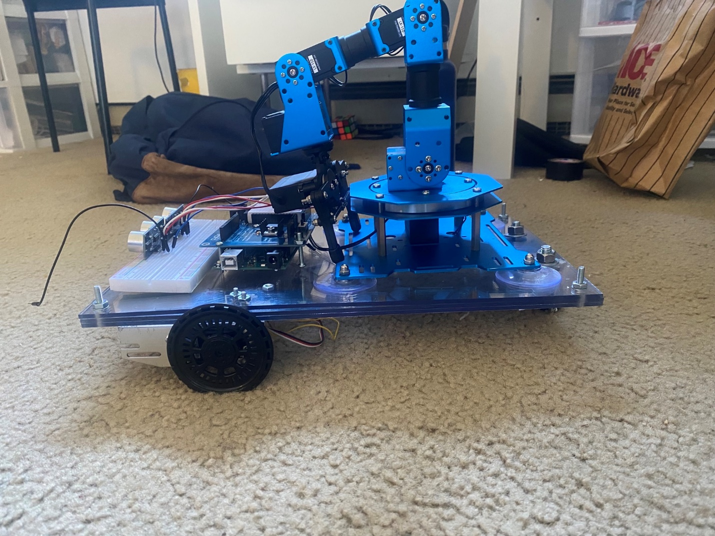

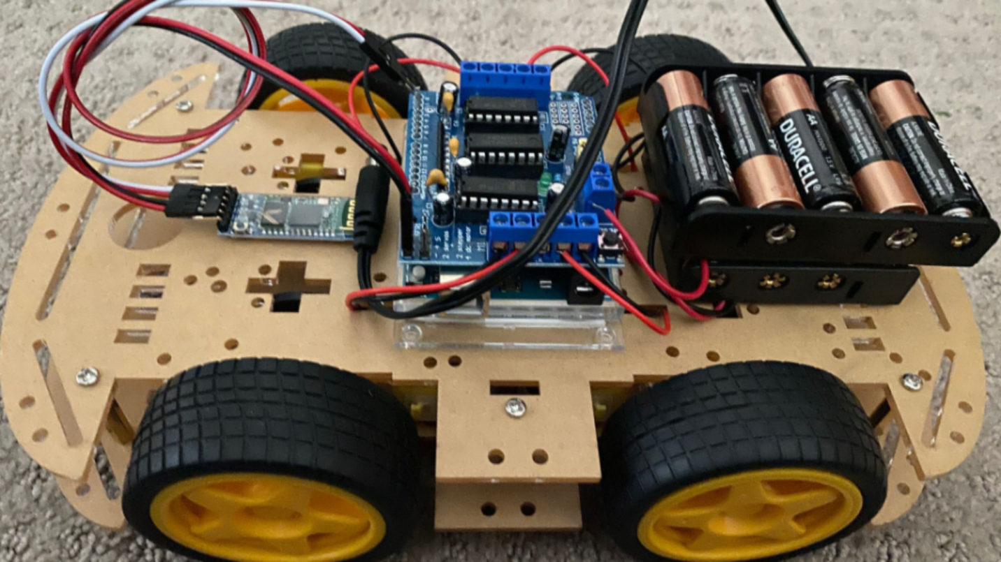

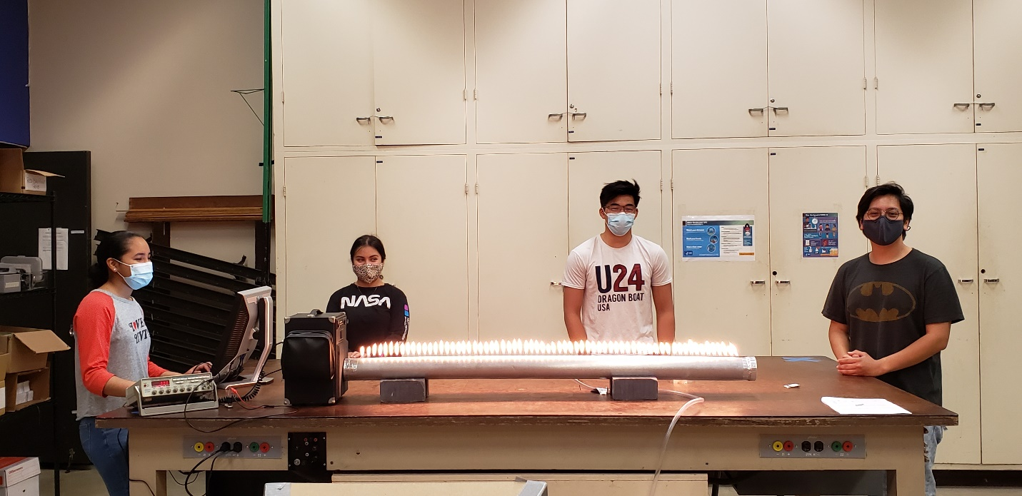
Rubens Tube – From L to R Nathalie Zaldivar, Yesenia Rodriguez, Daven Ng, and Jonathan Canel

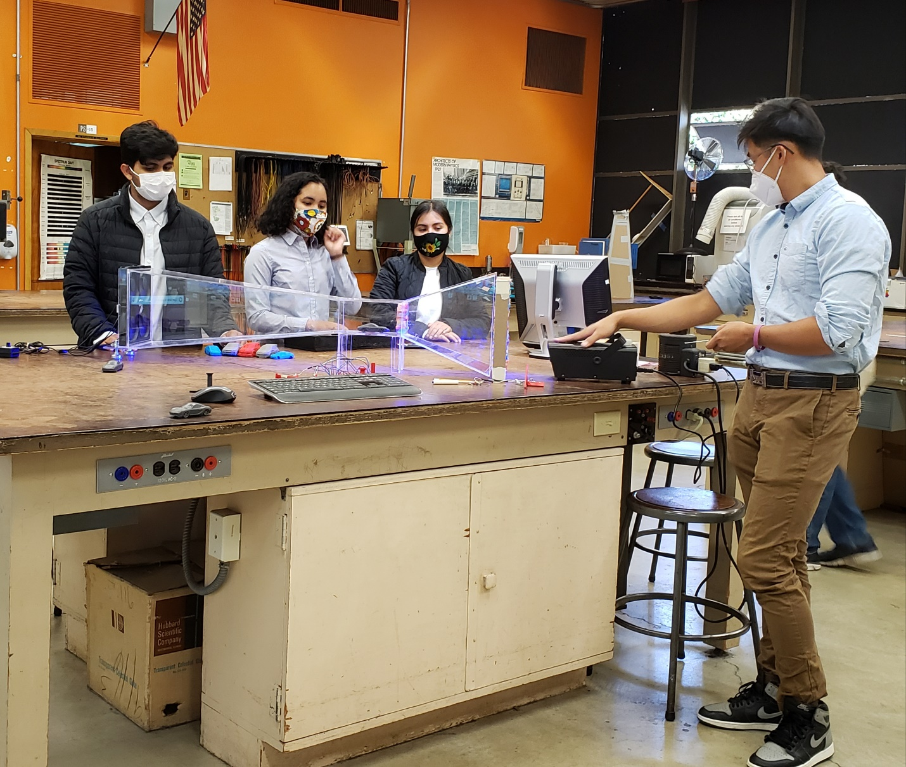
Wind tunnel presentation at the 2021 AAAS Conference – Zoom presentation
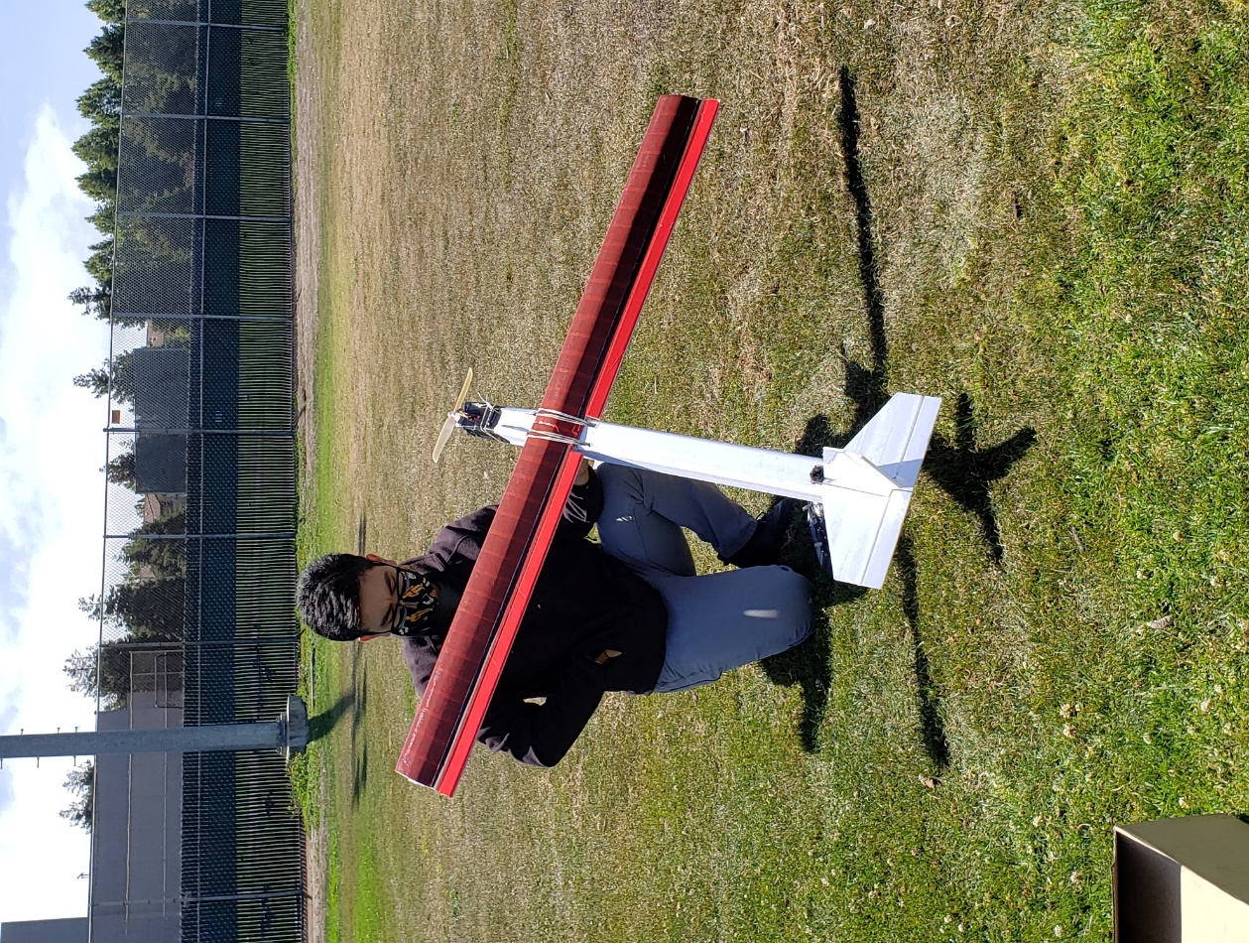

Anthony Lopez with his robotic airplane at CCC soccer field

