CSE Website Updates
Year IV Results (2019-2020)
Program Statistics and Activities
In FY 2019-2020, we served 29 students in the fall semester and 37 students in the spring semester. The data we presented here were based on the Spring 2020 database. Of the 37 students, 43.24% are females and 56.76 males. On the ethnicity breakdown, 56.76% were Asians including Filipinos and other SouthEast Asians, 43.24% Latinos/Hispanics, 18.92% a mix of two ethnic groups or more, and 5.40% African Americans. Fields of study include Engineering (54.05%), biological sciences (21.62%), physical science (13.51%), and computer science (10.81%).
Seminars
Our program incorporate seminars, workshops, and internships aimed at helping students learn, train, and develop as future scientists.
Fall 2019
We started with a Meet and Greet event where mentors, program staff, continuing students, and potential students met for the first time after their long summer break. Then we had a summer internship panel where six students shared their research experience at institutions including a USDA lab, Oakland Children Hospital, Harvard University, University of Michigan, and City of Richmond. They also shared tips on how to search and create competitive applications.
Mid semester in fall 2019, we had two workshops; on the Avenue E program at University of California Davis and on UC transfer applications. Avenue E is a program designed to help community college transfer students smoothly transition to UC Davis, and ultimately, a career in engineering or computer science. The program was developed by UC Davis and founding corporate partner, Chevron, in collaboration with Los Rios, Peralta, San Joaquin, and Contra Costa Community College districts. This program richly benefited students by offering mentorships, research opportunities, and other academically enhancing activities. The UC application workshop was hosted by UC Berkeley Transfer Center's Community College Liaison staff.
The program also hosted Ms. Cat Bobino, a STEM education promoter from the KQED Public Media, a public radio and TV station. Ms. Bobino shared her educational journey and love for science and how she combined her journalism and science backgrounds to obtain wonderful travel opportunities useful for her videos and podcasts. Ms. Bobino also shared her unique perspective as a young black woman in science and radio.
Spring 2020
We started the semester at the end of January with a Meet and Greet followed by group mentor meetings to discuss the focus of the program in the spring: applying for scholarships and summer internships. Mentors helped students in scholarships and internship searches, assisted students in preparing competitive applications, and wrote many letters of recommendation for their mentees.
We had only one seminar prior to the shelter-in-place response to the COVID-19 pandemic. Our speaker was Mr. Mohammad Sham. He is an alumnus of CCC and a recent UC Berkeley Mechanical Engineering graduate. He shared his educational and transfer experience as well as his project in underwater robotics. He was to spend two weeks of research in Tahiti.
During the shelter-in-place, our mentors and program staff reached out to students throughout the semester via emails and phone calls to check in on how the students were doing and ensure their continued success. We offered advice and resources that would help them overcome the challenges posed by the shelter-in-place restrictions. With the assistance of our colleagues from the HSI program and other programs on campus, we provided textbooks/calculators/computer loans, free access to internet, tutoring, and updates on free food programs.
Program Successes
Our program required students to be enrolled as fulltime students, maintain at least a 3.0 GPA with science and math classes not lower than C, and participate in program activities. Students are strongly encouraged to apply for summer internships and external scholarships. In the Fall 2019 academic term, 45.70% of students maintained 3.50 - 4.00 GPA, 37.10% maintained 3.00 - 3.49 GPA, and the rest (17.10%) close to 3.00 GPA. We considered this to be a success considering that the students who earned around 3.00 GPA were mostly engineering majors, which required students to take very challenging courses. In the Spring 2020 academic term, the percentage of students who earned 3.50-4.00 GPA remained constant at 45.90%. The percentage of those who earned 3.00 - 3.49 GPA decreased to 18.90% and the percentage of students who earned below 3.00 GPA increased sharply to 35.20%.
This decline in GPA could likely be explained by the added difficulties that our students faced during the shelter-in-place. We went into countywide shelter-in-place on March 19 and this continued until well past the end of the semester. Initially, our students found the shelter-in-place very challenging at many levels: uncertainties about the future, sudden and unexpected financial pressures, technology challenges (access to reliable internet, laptops, and apps), housing challenges (crowdedness due to all family members having to stay home), and the feeling of isolation from their educational cohort.
Key outcomes or Other achievements:
Transfer Success
Twelve students will be transferring in Fall 2020. Seven students (58.30%) will be transferring to California State Universities: mainly to CalPoly of San Luis Obispo and San Jose State University for their strong engineering programs. Five students (41.70%) will be transferring to University of California; mainly to UC Berkeley and UC Davis for their strong programs in engineering and biological sciences. A couple of students decided to delay transferring due to the switch to fully online instruction expected at the 4 year schools during the Covid-19 pandemic.
External Scholarships
Our mentors spent countless hours assisting students in their scholarship and internship applications and writing letters of recommendations for S-STEM scholars. The scholarship sources mentioned here are external scholarships, from our College Foundation and other non-profit organizations. Eleven students received a combination of twenty-five scholarship awards for a total award amount of $71,550.
Internships
In the past, we have had a range of 10 - 15 students participating in summer research/hands-on experiences at universities, national labs, teaching hospitals, City of Richmond, and local industries. However, most research internship hosts have canceled their summer programs due to the COVID-19 pandemic.
We managed to locate two summer internship positions offering online research opportunities: one at the Children Hospital Oakland Research Institute (CHORI) and the other at the STEM Center of Contra Costa College. The CHORI program was called "Envision Yourself in Science." This program lets students develop basic understanding in research design, review scientific literature, develop professional relationships with mentors and professionals, understand cyber security and safety, create a reserach proposal, etc. The internship at the STEM Center involves researching and gathering data on comprehensive academic resources for students in pandemic situation. Both students work for eight weeks, 40 hours/week. We will save the funding allocation for the summer internships for later use.
Degrees and Certifications
Eleven students obtained a combination of thirty-two Associate Degrees and twenty Certifications in the STEM fields.
Opportunities for training and professional development
Conferences
We partnered with the Statewide MESA and HSI Program at CCC to provide opportunities for students to participate in conferences.
Two students participated in the 2019 MESA Student Leadership Conference (SLC) on October 25 and 26, 2019. Both students truly loved their experience in SLC. They met many fellow STEM students and professionals with similar cultural backgrounds, learned to collaborate in problem solving activities, and learned to enhance their overall communication skills. A picture of the two students is included in this report.
One student participated in the 2019 SACNAS conference in Honolulu, Oahu, on October 31 - November 2, 2019. He was immersed in learning about research opportunities and professional development sessions as well as attended multicultural celebrations.
Hands-on projects on campus
In fall 2019 semester, engineering students formed groups of three and worked on building robotic hands from Arduino microcontrollers, cardboard, straws, strings, and servo motors.
In the spring 2020 semester, the engineering students formed three groups working on separate projects prior to the Covid-19 shelter-in-place:
1. First group attempted to build an environmental sensing robot using the ActivityBot 360 from Parallax.
2. Second group chose to build a model rocket with a sensor payload.
3. Third group of students were interested in sound and vibration. They tried to assemble a Ruben’s tube and Chladni plate. This was led by Alexis Ortiz and here is the presentation
https://www.youtube.com/watch?v=t0gr7spGPJQ&feature=youtu.be

Project dissemination to STEM communities of interest
Professor Mark Wong and Dr. Seti Sidhara participated in the poster session presenting their S-STEM program's three year findings in the 2019 Symposium NSF S-STEM on September 12-14 at the Hyatt Regency Capitol Hill, Washington, DC.
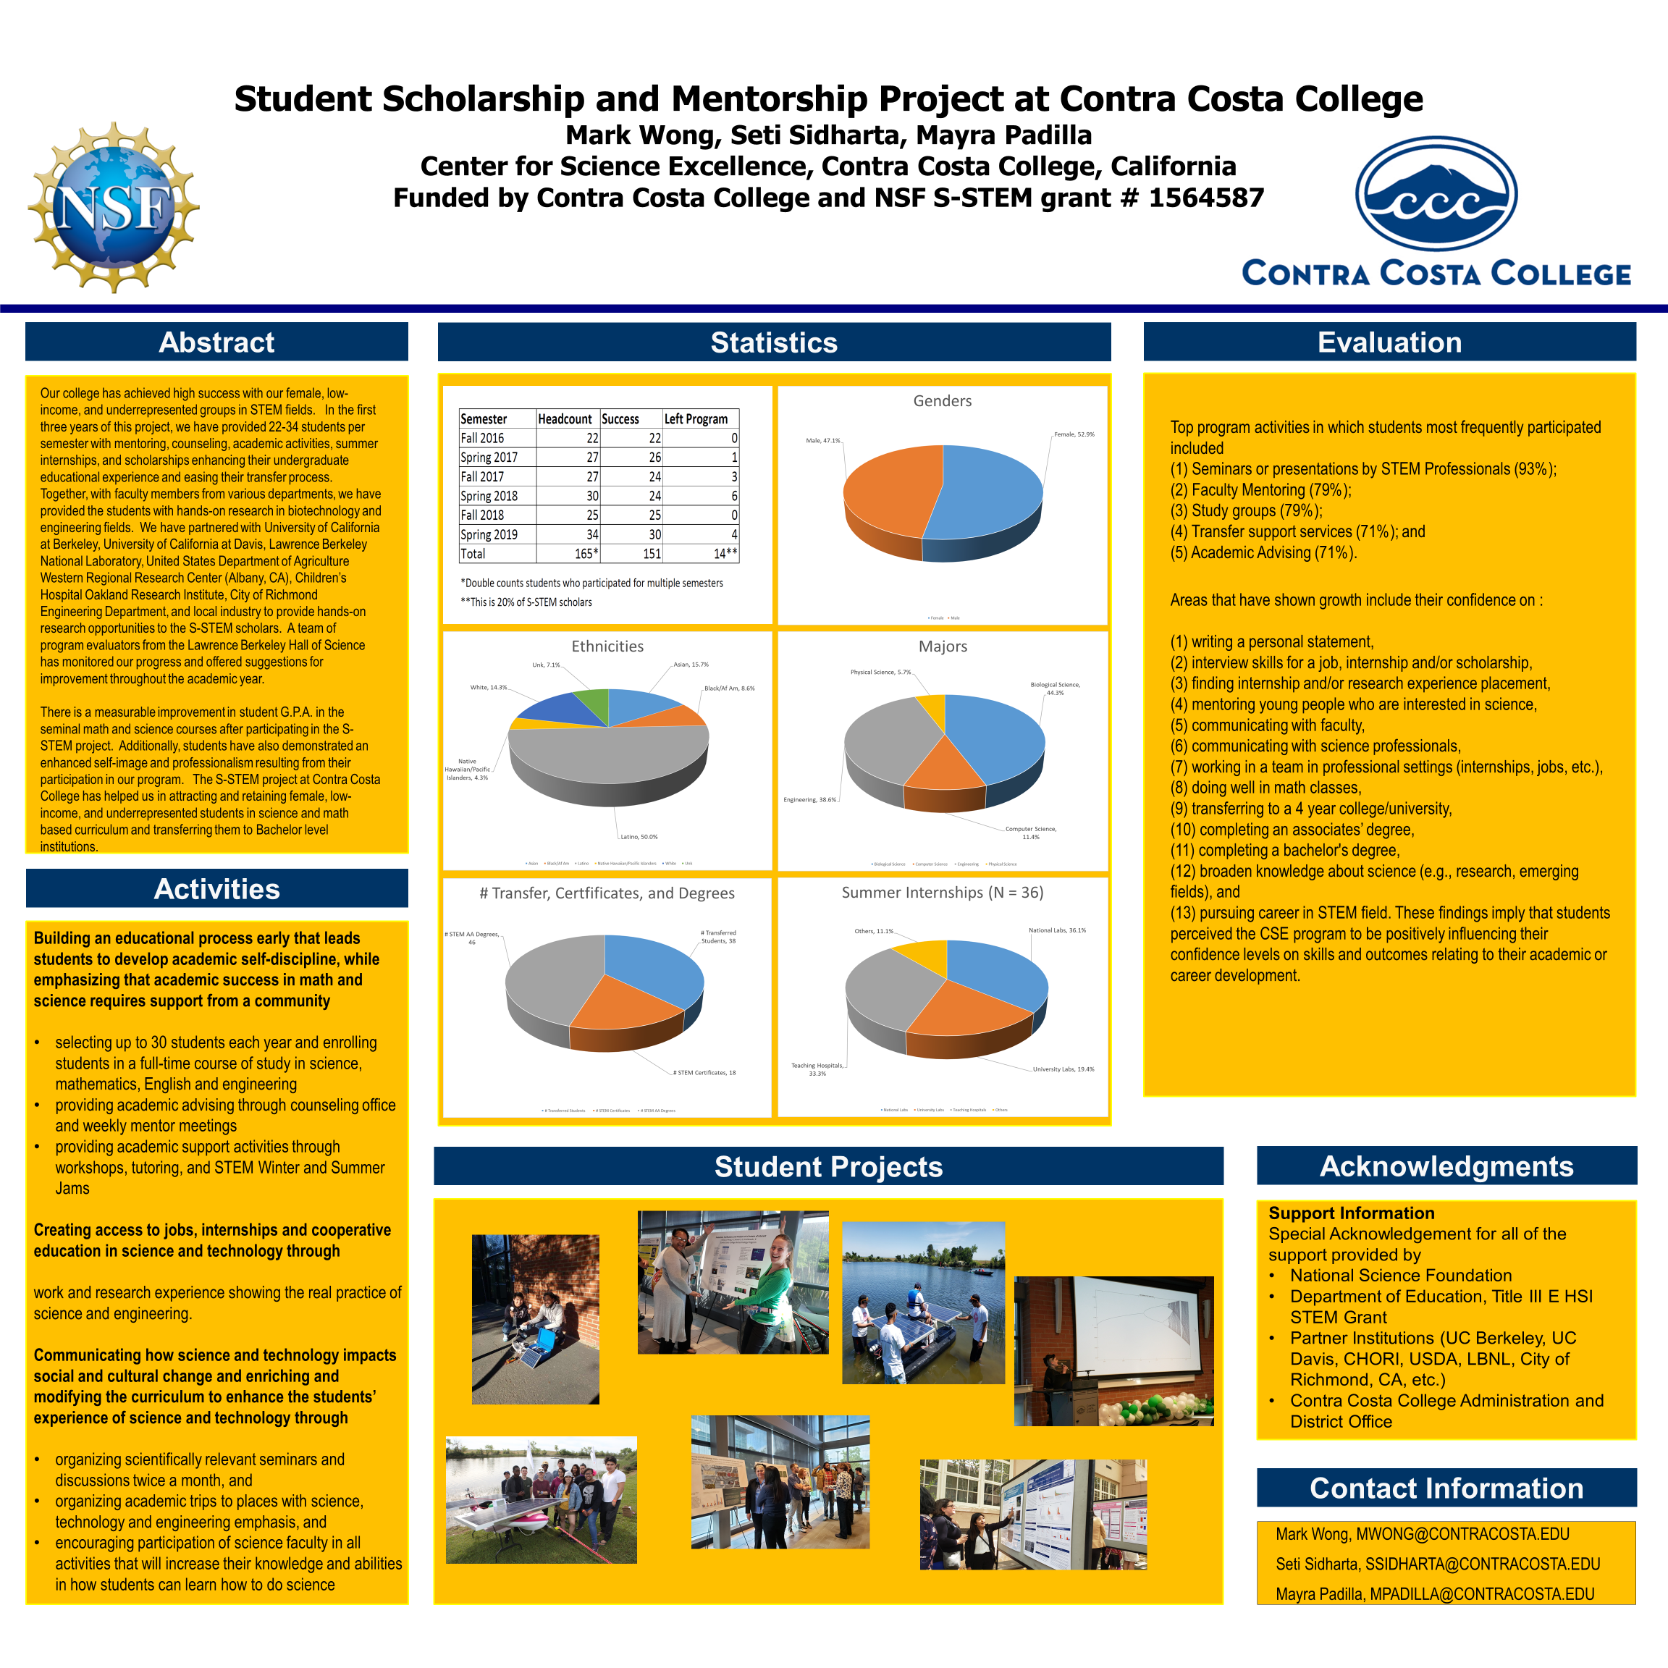
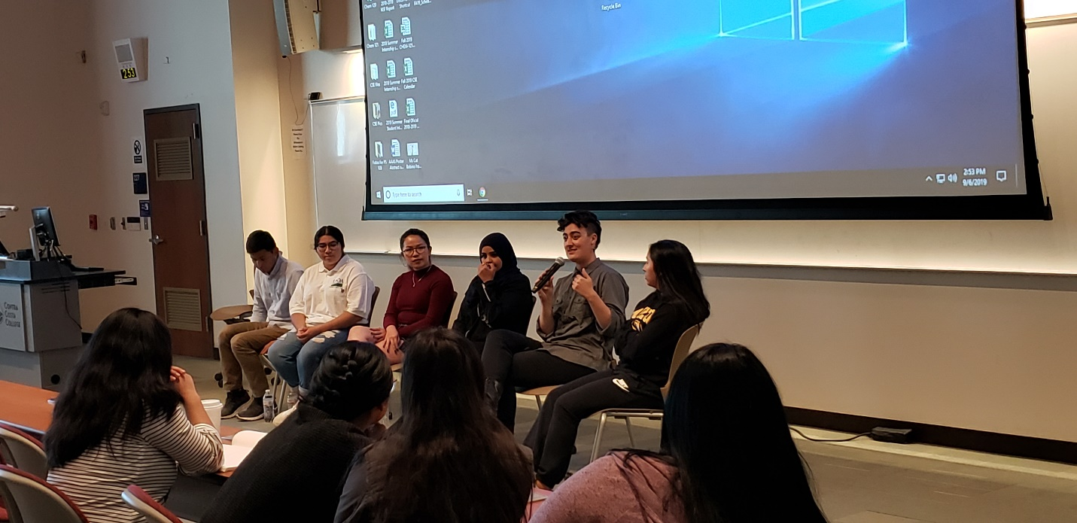
Fall 2019 Summer Intern Panel, from L to R Carlos Arevalo, Mayra Ramirez, Elissa Lee, Hanan Dabwan, Hannah Moore, Lysette Zaragoza
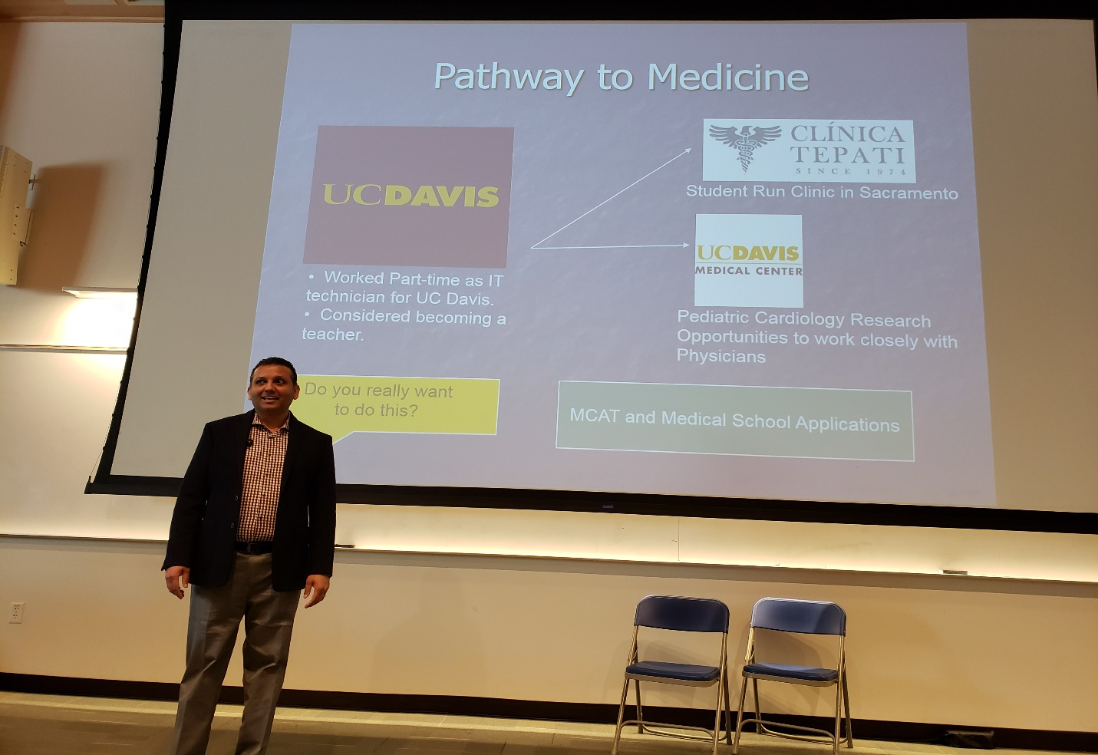
Dr. Paul Bhambra, alumnus of Center for Science Excellence, UC Davis, and School of Medicine

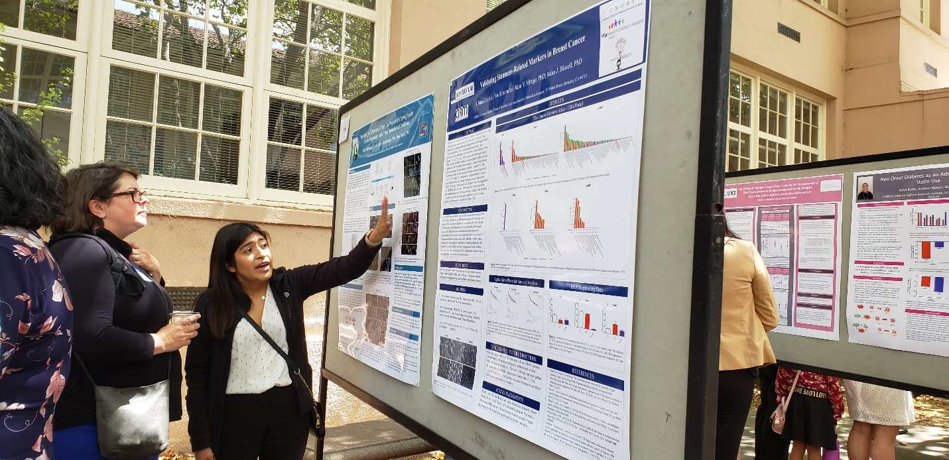
Lilly Hernandez in 2019 Poster Symposium for the Chidren Hospital Oakland Research Institute (CHORI) Summer Program
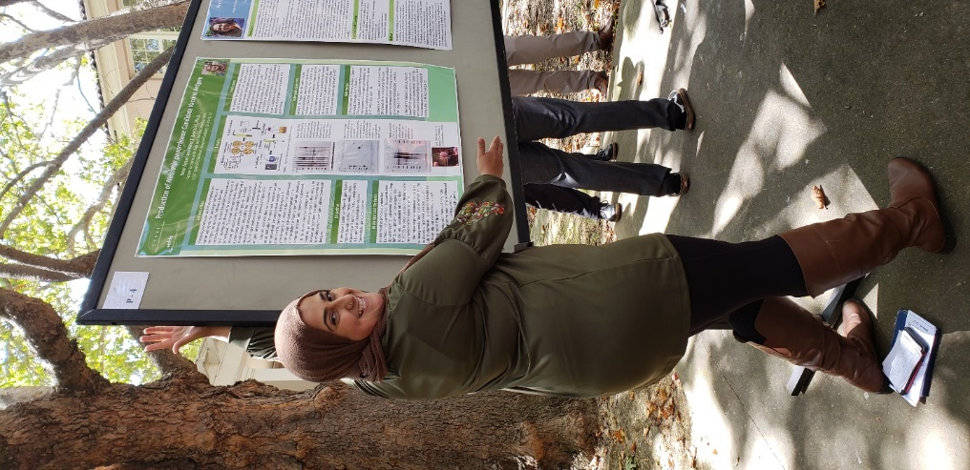
Noor Ayyad in 2019 Research Symposium for the CHORI Summer Program

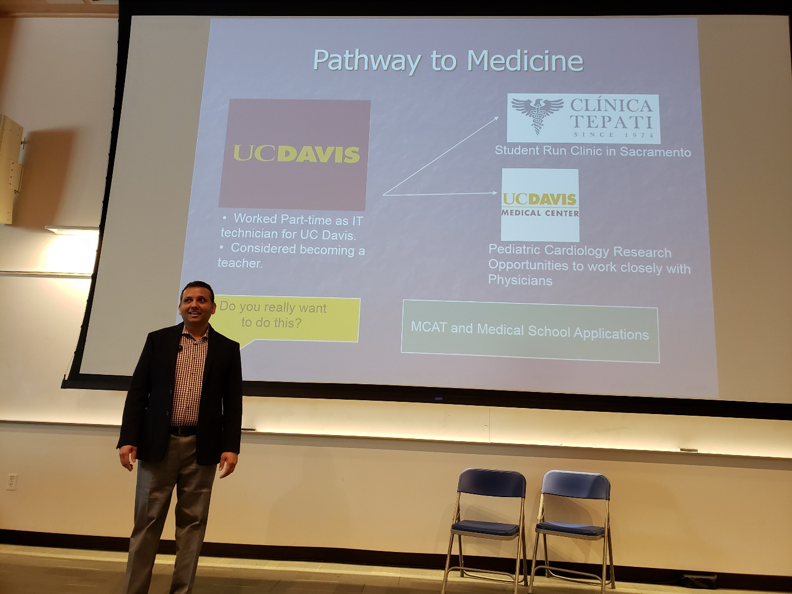
Dr. Paul Bhambra, alumnus of CSE program, UC Davis

