CSE Website Update
Year III (2018-2019)
Major Activities:
We provided multi-pronged approach to achieve our program goals through mentoring, counseling, transfer application workshops, tutoring, STEM seminars, academic trips, summer internships, and scholarships. Twenty-five students participated in the S-STEM program in the fall 2018 semester and thirty-four students participated in the spring 2019 semester. Most of the students were low-income and/or underrepresented in the STEM fields.

Of the thirty-four students participating in the spring 2019, sixteen received S-STEM scholarships in both semesters while thirteen received a scholarship for one semester only. S-STEM awarded scholarships to eligible students based on

- PELL eligibility and unmet needs
- fulltime enrollment and taking the required transfer courses
- 3.0 or above GPA
- active participation in program activities

Of the thirty-four students, 55.9% are females. The ethnic distribution includes 14.7% African Americans, 20.6% Asians, 35.3% Hispanics, 2.9% Pacific Islander, 11.7% White and other. Of the thirty-four students, 41.2% major in biological science, 3% in computer science, 38.2% in engineering, 5.9% in math, and 11.7% in physical sciences.

As a component of the learning strategies, we organized academic seminars and academic trips for our student cohort so that they expand their knowledge beyond classroom learning. In this fiscal year, we organized

- two meet and greet sessions so students and mentors could get to know each other
- one summer internship panel so students could learn about the application process and the experiences that are gained by summer interns
- one alumni panel where five alumni who worked in the Amyris Company (Emeryville, CA) shared their experience working in fast-paced biotechnology company
- two transfer application workshops by transfer staff from UC Berkeley and UC Davis who specialized in helping STEM students, and 6) five STEM seminars in engineering and medical fields.

We leveraged our resources with the HSI STEM program on academic trips; students participated in trips to HBCU campuses, UC Davis STEM Day, and to the Amyris Company.
Furthermore, a big part of our learning strategy is hands-on projects and summer internships. Students worked together cooperatively; they designed, built, and tested their prototypes. Details were below. Summer internship positions were located in nearby universities, research institutions, city engineering departments, and other industry. Internship details were below.

Significant Results:
Of the thirty-four student participants, four students (11.7%) decided to leave the program mid semester. The reasons for leaving the program were centered on their inability to participate in activities, thus we have 89.3% retention during this fiscal year.

Of the remaining thirty students, all students were enrolled fulltime and taking required transfer courses. 50% of the students maintained 3.5 - 4.0 grade point average (GPA), 32.4% maintained 3.0 - 3.49 GPA, and 5.9% were slightly lower than 3.0 GPA (2.8-2.9).

Eleven students (36.7%) will be transferring in the fall 2019 to obtain their baccalaureate degrees. Those eleven students are transferring to Universities of California: six to UC Berkeley, two to UC Davis, two to UC Santa Cruz, and one to UC Merced.

Those eleven transfer students also graduated from Contra Costa College with a combination of fifteen Associate in Arts/Science degrees and nine certificates in STEM fields.

Key outcomes or Other achievements:

Six students participated in the solar boat project. They spent months of designing, planning, and building the solar boat gaining experience through this activity.

Four students, part of the Society of Hispanic Professional Engineering chapter (SHPE) participated in the solar suitcase project. The goal of the project is to learn the basics of circuitry as related to solar energy. Students learned to build solar powered systems for common uses such as nighttime light, cell phone chargers, etc. The solar suitcase kits were donated by the Pacific Gas and Electric Company and California State East Bay University. The students presented their work at the CCC's College Earth Day celebration and Research Symposium on May 9, 2019.

Eight students participated in Engin-298 class, an Independent Study class with Professor Chao Liu, one of the S-STEM mentors. The students' project was to design, build, and test rockets. The rockets were low-power rockets and the solid fuel burned out in the air within 2 seconds. The students completed their rockets and tested them at the soccer fields in Contra Costa College in May 23, 2019. They went up to 800 feet and used a launching rod and protection pad at the bottom so they did not scorch the ground.

Both projects were under the supervision of Professor Mark Wong, our S-STEM grant PI.

Opportunities for training and professional development

Dr. Seti Sidharta, the S-STEM Project Coordinator, worked with partner institutions to secure summer internship positions and encourage the program students to apply for them. Summer internships provides practical training and experience. Students learned to interact and socialize as young professionals.

In summer 2018, fourteen of our students secured summer internships. Two students were funded by their hosts and twelve are funded by our partner HSI STEM. The summer internship placements include:

- 1 at Harvard Medical School Lab
- 1 at in the University of Missouri Bioengineering Department
- 4 at in the United States Department of Agriculture (USDA Albany Lab, CA)
- 2 at the Children Hospital Oakland Research Institute (CHORI)
- 2 at the City of Richmond (Richmond, CA), 1 in the Lindsay Museum (Walnut Creek, CA)
- 1 at the Asbestos TEM Lab (Berkeley, CA)
- 2 with the College's Department of Physics and Engineering.

The summer internship projects focused on two areas: biological sciences and engineering. In Harvard Medical School Lab, the internship was on neuroimmune interactions in brain development using pre-clinical models. The summer internship at the University of Missouri Bioengineering Department was focused on biomaterials with a mix of mechanical and tissue engineering. The projects in the USDA involved the relationship between plants and pathogens in various plants. At USDA labs, students learned to prepare seedlings, bacterial cultures, prepare and count colonies of spores, and induce gene transmission. At CHORI, students shadow physicians and conduct research in immunology and diseases.
At the City of Richmond, students shadowed city engineers and visited area project sites, drafted memos, updated databases, and learned about ADA compliance and public transportation plans. Students in the College's Department of Physics and Engineering Department were involved in the redesigning of one of the apparatuses used to determine acceleration due to gravity.

Project dissemination to STEM communities of interest

As previously stated, various projects were presented on-campus in a poster session. The Solar Boat team tested and entered their solar boat in a competition at the Rancho Seco Recreational Area on May 3 and 4, 2019 (Sacramento, CA). The regatta was sponsored by the Sacramento Municipal District. The solar suitcase team presented their work at the College Earth Day celebration and Research Symposium on May 9, 2019. The rocket team completed and tested their rockets at the soccer field in Contra Costa College in May 23, 2019, attended by faculty, staff, and managers.

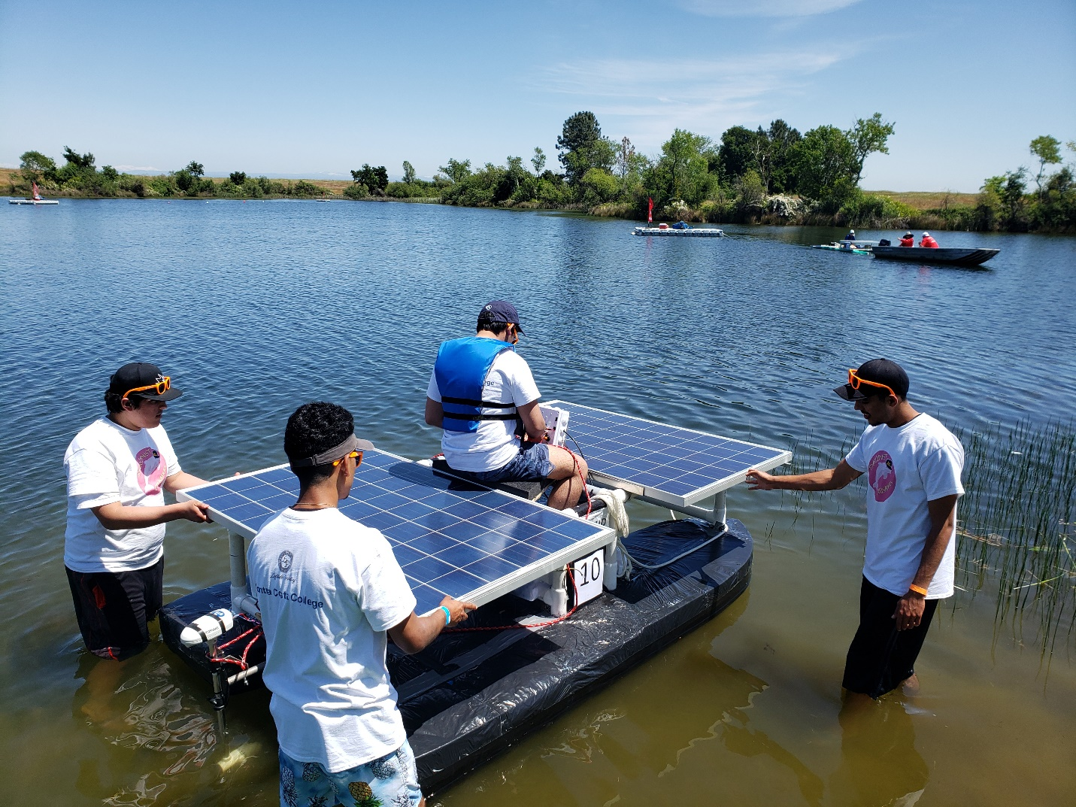
2018 Solar Boat Regatta in Sacramento

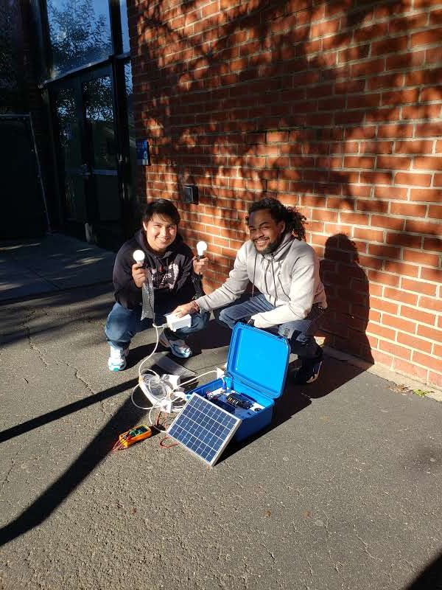
Solar Suitcase project

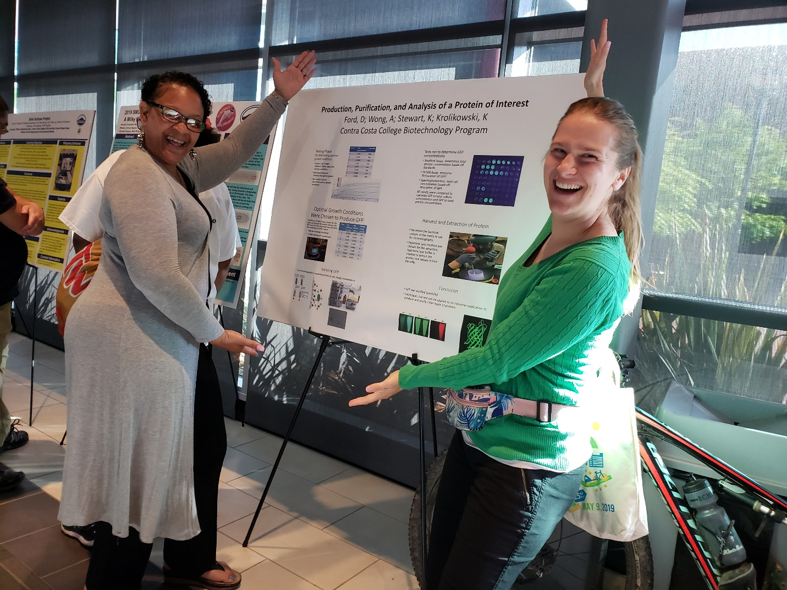
Spring 2019 poster session at CCC – L to R: DeAngela Fod and Kathryn Stewart

