[insert college logo here]

**Institutional Self-Evaluation Report**

**In Support of an Application for**

**[insert status: Candidacy, Initial Accreditation, Reaffirmation of Accreditation]**

Submitted by

[insert College Name and

College Address]

to

Accrediting Commission for Community and Junior Colleges

Western Association of Schools and Colleges

[insert date of submission: Month Year]

**Certification**

To: Accrediting Commission for Community and Junior Colleges

Western Association of Schools and Colleges

From: [insert Name of Chief Executive Officer]

[insert Name of Institution]

[insert Institution Address]

This Institutional Self-Evaluation Report is submitted to the ACCJC for the purpose of assisting in the determination of the institution’s accreditation status.

I certify there was effective participation by the campus community, and I believe the Self-Evaluation Report accurately reflects the nature and substance of this institution.

Signatures:

|  |  |
| --- | --- |
| [Chief Executive Officer of Multi-College District, if applicable] | [Date] |
| [Chief Executive Officer] | [Date] |
| [Chairperson, Governing Board] | [Date] |
| [Name, Title, Representing] | [Date] |
| [Name, Title, Representing] | [Date] |
| [Name, Title, Representing] | [Date] |
| [Name, Title, Representing] | [Date] |

NOTE: Suggested total ISER page limit is 250 pages.

Contents

A. Introduction 5

College History 5

Student Enrollment Data 5

Labor Market Data 5

Demographic Data 5

Socio-economic Data 5

Sites 5

Specialized or Programmatic Accreditation 5

B. Presentation of Student Achievement Data and Institution-set Standards 6

C. Organization of the Self-Evaluation Process 7

D. Organizational Information 8

E. Certification of Continued Compliance with Eligibility Requirements 9

F. Certification of Continued Institutional Compliance with Commission Policies 10

G. Institutional Analysis 12

Standard I: Mission, Academic Quality and Institutional Effectiveness, and Integrity 12

A. Mission 12

B. Assuring Academic Quality and Institutional Effectiveness 13

C. Institutional Integrity 16

Standard II: Student Learning Programs and Support Services 20

A. Instructional Programs 20

B. Library and Learning Support Services 26

C. Student Support Services 27

Standard III: Resources 30

A. Human Resources 30

B. Physical Resources 34

C. Technology Resources 36

D. Financial Resources 37

Standard IV: Leadership and Governance 42

A. Decision-Making Roles and Processes 42

B. Chief Executive Officer 45

C. Governing Board 47

D. Multi-College Districts or Systems 50

H. Quality Focus Essay 54

# Introduction

## 

## About Contra Costa College and Contra Costa College District

Contra Costa College affirms that all individuals have inherent worth and dignity and are entitled to develop their full potential. The college is an integral part of the greater community and serves as a model of excellence providing education to help its students fulfill their dreams. The college maintains that its students will enjoy an improved quality of life, that communities will prosper economically and socially, and that families and neighborhoods will be strengthened when residents share a commitment to lifelong learning. This philosophy is reflected in our [Mission, Vision, Strategic Goals, and Institutional Student Learning Outcomes](https://www.contracosta.edu/about/mission-vision/).

**Mission**

Contra Costa College is a public community college serving the diverse communities of West Contra Costa County and all others seeking a quality education, since 1949.  The College equitably commits its resources using inclusive and integrated decision-making processes to foster a transformational educational experience and responsive student services that ensure institutional excellence and effective student learning.​

Additionally, the College adheres to the following goals, vision, beliefs, and values statements:

**Strategic Goals**

To fulfill its mission and to be consistent with its beliefs and values, Contra Costa College is committed to the following goals:

* Equitably Improve Student Access, Learning and Success
  + Create opportunities for thoughtful reflection that uses quantitative and qualitative data to improve student outcomes.
* Strengthen Community Relationships and Partnerships
  + Build pipelines that guide and prepare both K-12 students and the adult population for success in higher education and employment.
* Promote Innovation, Create a Culture of Continuous Improvement and Enhance Institutional Effectiveness
  + Provide opportunities to enhance institutional effectiveness and opportunities for employees at all levels to continually gain new skills and knowledge, seek out effective practices, and share ideas with one another in order to continually enhance learning and improve student success.
* Effectively Optimize Resources to Support Student Learning and Success
  + Demonstrate sound judgement to effectively optimize the college’s human, physical, financial and organizational resources to better serve its students and community.

**Values**

Contra Costa College’s commitment to its mission derives strength and guidance from institutional values. As a community of educators, we value:

* COMMITMENT to helping students learn and to improving the economic and social vitality of communities through education;
* RESPONSIVENESS to the varied and changing learning needs of those we serve;
* DIVERSITY of opinions, ideas and peoples;
* FREEDOM to pursue and fulfill educational goals in an environment that is safe and respectful for all students, all faculty, all classified staff, and all managers alike; and
* INTEGRITY in all facets of our college interactions and operations.

**Institutional Student Learning Outcomes**

Support an environment that encourages and enables the members of our community to gain:

* Critical thinking skills and abilities, including evaluating, analyzing, and applying information;
* Communication skills using verbal, auditory, written,  numerical, and visual forms;
* Awareness of themselves, their community, and the world around them, leading to personal responsibility, ethics, and civic engagement.

Contra Costa College (CCC) is a comprehensive community college that primarily serves the residents of West Contra Costa County. Contra Costa College was the first of the three colleges to be established in district. Originally named Contra Costa Junior College, West Campus, it began in 1949 at the old Kaiser Shipyards in Point Richmond. The first classes started February 14, 1950, with a beginning enrollment of 500 students. Planning began for the new campus on an 83-acre site in the rolling hills overlooking San Pablo Bay, and, in 1956, the college moved to its present location.



Subsequent development yielded buildings for physical education, music, the library, the student union, vocational education, and administrative headquarters. By 1966, CCC had 10 permanent buildings in addition to 15 temporary structures. The Health Sciences Building, planetarium, and physical sciences annex were completed by 1975. The had opened the year before. In February of 1976, $2.5 million was approved for construction of the Applied Arts Building. In 1980’s, the new Performing Arts Center and the Applied Arts Building finally opened for use. Middle College High School joined the CCC campus in 1987.

In 2002, the CCCCD passed a construction bond, which supported modernization efforts. In 2004, the Early Learning Center opened and in January 2007, the Computer Technology Center opened its doors for the beginning of the spring semester. In September 2006, Contra Costa College celebrated the groundbreaking for the Student Services Center and the remodeled Library and Learning Resource Center opened in fall 2007.

In 2006, CCCCD passed a second construction bond, which led to the development of an Educational Master Plan and Facilities Master Plan to guide the next stage of campus modernization and revitalization.

In July 2008, the new Student Services Center opened, funded by a CCCCD construction bond passed in 2006, creating a one-stop location for the major student services offices: Admissions and Records, Financial Aid, Counseling, Disabled Students Programs and Services (DSPS), Extended Opportunity Programs and Services (EOPS), International Students, and the office of the Dean of Student Services.

In fall 2013, CCC broke ground for the new College Center, which will house all student life functions, the bookstore, new campus administration spaces, the culinary arts program and a dining center, as well as a new classroom building and a new community meeting room building.

Facilities improvements since Fall 2017 from [Contra Costa College Construction Calendar](https://www.contracosta.edu/wp-content/uploads/2017/07/CCC-Construction-Calendar-Fall-2017.pdf) include:

|  |  |  |  |
| --- | --- | --- | --- |
| Project | Construction Start | Move-in & Occupation | Projected Start of Operation |
| AA Building Renovations | Fall 2017 | Summer 2018 | Fall 2018 |
| Campus Safety Center | Spring 2018 | Summer 2018 | Summer 2018 |
| PE/Kinesiology Complex Modernization | Spring 2019 | Summer 2020 | Fall 2020 |
| Science Building | Fall 2019 | Fall 2021 | Spring 2022 |

The current [campus map](https://www.contracosta.edu/quick-links/maps-parking/campus-map/) shows growth and lay out of Contra Costa College.

**Accreditation Status and Certifications**

Contra Costa College is accredited by the [Accrediting Commission for Community and Junior Colleges of the Western Association of Schools and Colleges](http://www.accjc.org/) (ACCJC), an institutional accrediting body recognized by the Commission on Recognition of Postsecondary Accreditation and the U.S. Department of Education. ACCJC also fully affirmed that Contra Costa College met all standards at their January 10-12, 2018 meeting which is detailed in the [2018 ACCJC Accreditation Action Letter.](https://www.contracosta.edu/wp-content/uploads/2018/01/Contra-Costa-College_01_26_2018.pdf)

Program accreditation includes the California Board of Registered Nursing and the California Board of Vocational Nurse Examiners. The College is approved for the training of veterans, and for the education of foreign students by the United States Department of State and the United States Immigration and Naturalization Service.

More information about accreditation can be found on [Contra Costa Accreditation homepage](https://www.contracosta.edu/about/achttps:/www.contracosta.edu/about/accreditation/creditation/).

**Academic Programs**

Contra Costa College has [125 degrees and certificate](https://www.contracosta.edu/wp-content/uploads/2019/06/061119_CCC_LetsDoThis_DegreeChart.jpg) options that meet the needs of our students. Whether they are interested in transferring or training for an exciting career, students can choose a variety of classes and programs. CCC has been recognized for many of its academic and career education programs locally, statewide and nationally:

* The Center for Science Excellence, a mentoring program providing a solid foundation in the sciences, mathematics and engineering, as well as transfer preparation, is funded through multiple grants including the National Science Foundation.
* Most recently, the college received a second Title III, part F HSI (Hispanic Serving Institution) STEM grant to continue the goal of increasing the number of students from under-resourced communities in the fields of science, technology and math.
* One of the fastest growing curricula is that of “green energy” programs. The Career Education (CE) experience at CCC is notable for the Electric/Hybrid Automotive Technology Program and offers the only Hybrid Technician Certification in the Bay Area.
* The Culinary Arts Program is one of the signature, job-training programs on campus. The program operates the elegant Aqua Terra Restaurant and hosts an annual Food and Wine fundraising event that has enabled CCC students to travel to Italy, China and France to study with notable chefs.

Other premier programs include:

* [Journalism](https://www.contracosta.edu/classes/academic-departments/journalism/): CCC continues to be a leader in journalism, with its college newspaper, The Advocate, winning state and national honors for excellence.
* [Nursing](https://www.contracosta.edu/classes/academic-departments/nursing/): One of the oldest CE programs on campus, responsible for preparing many local health professionals for careers throughout the Bay Area.
* [International Education](https://www.contracosta.edu/admissions/apply-now/international-students/): CCC’s international education program now serves students from 11 countries.

**Contra Costa College District**

Established in December 14, 1948, Contra Costa Community College District (CCCCD) services the greater Contra Costa County. The District is comprised of three college and two sites: Contra Costa College, Los Medanos College, and Diablo Valley College, Brendwood Center and San Ramon Campus.

**College Service Areas**



**Changing Landscape**

Since the last accreditation, the California Community College System have adopted and CCC have incorporated several new initiatives and mandates that heavily focused on student success, equity, and performance in their planning, budgeting, programs, and services.

* Guided Pathways – A highly structured approach to student success through a framework that promotes improved students onboarding, clear progression and success in courses, and wrap-around services that ensure future student success. The principles of [Guided Pathways](https://cccgp.cccco.edu/About-Guhttps:/cccgp.cccco.edu/About-Guided-Pathwaysided-Pathways) are based on four pillars aligned with a student’s educational journey.
* Moving from Integrated Plan (Basic Skills, Equity, and Student Success and Support Program) to Student Equity and Achievement Plan – Revised planning and funding allocation that integrates the BSI, Equity, and SSSP funds and planning into one comprehensive Student Equity and Achievement Plan. Along with the implementation of Guided Pathways, the [Student Equity and Achievement program](https://www.cccco.edu/About-Us/Chancellors-Office/Divisions/Educational-Services-and-Support/Special-Populations/What-we-do/Student-Equity) addresses achievement gaps for underrepresented populations.
* Assembly Bill 705 (AB 705) – An updated placement model utilizing high school coursework, grades, and grade point average and other placement methods to maximize the ability of students to complete college-level coursework in English and math within a one-year timeframe. The [legislation](https://assessment.cccco.edu/ab-705-implementation) aims to address the large number of students who are placed in remedial courses that could be a barrier to their educational progress.
* Student-Centered Funding Formula – A revised [allocation model](https://www.cccco.edu/About-Us/Chancellors-Office/Divisions/College-Finance-and-Facilities-Planning/Student-Centered-Funding-Formula) comprised of three components: enrollment, supplemental allocation based on students receiving financial aid, promise grant, or AB 540, and student success allocation based on outcomes such as degree completion, transfer and other metrics.
* Promise Program – A collaborative approach utilizing current infrastructure, expansion of emerging best practices, and development of new strategies and intervention to increase college going rate, improve support systems for students, and increase transfer and completion.

These initiatives and how Contra Costa College has implemented them are further discussed in subsequent sections of this report.

**2020 to 2025 Strategic Planning Development**

Contra Costa College is currently in the process of developing its 2020-2025 Strategic Plan. A consultant has been brought on board, interviews and mapping have been initiated. The work to adopt a new strategic plan is slated for completion in Spring 2020 and will guide Contra Costa for the next five years. Below is the identified processes and projected timeline for the Contra Costa 2020-2025 Strategic Plan.

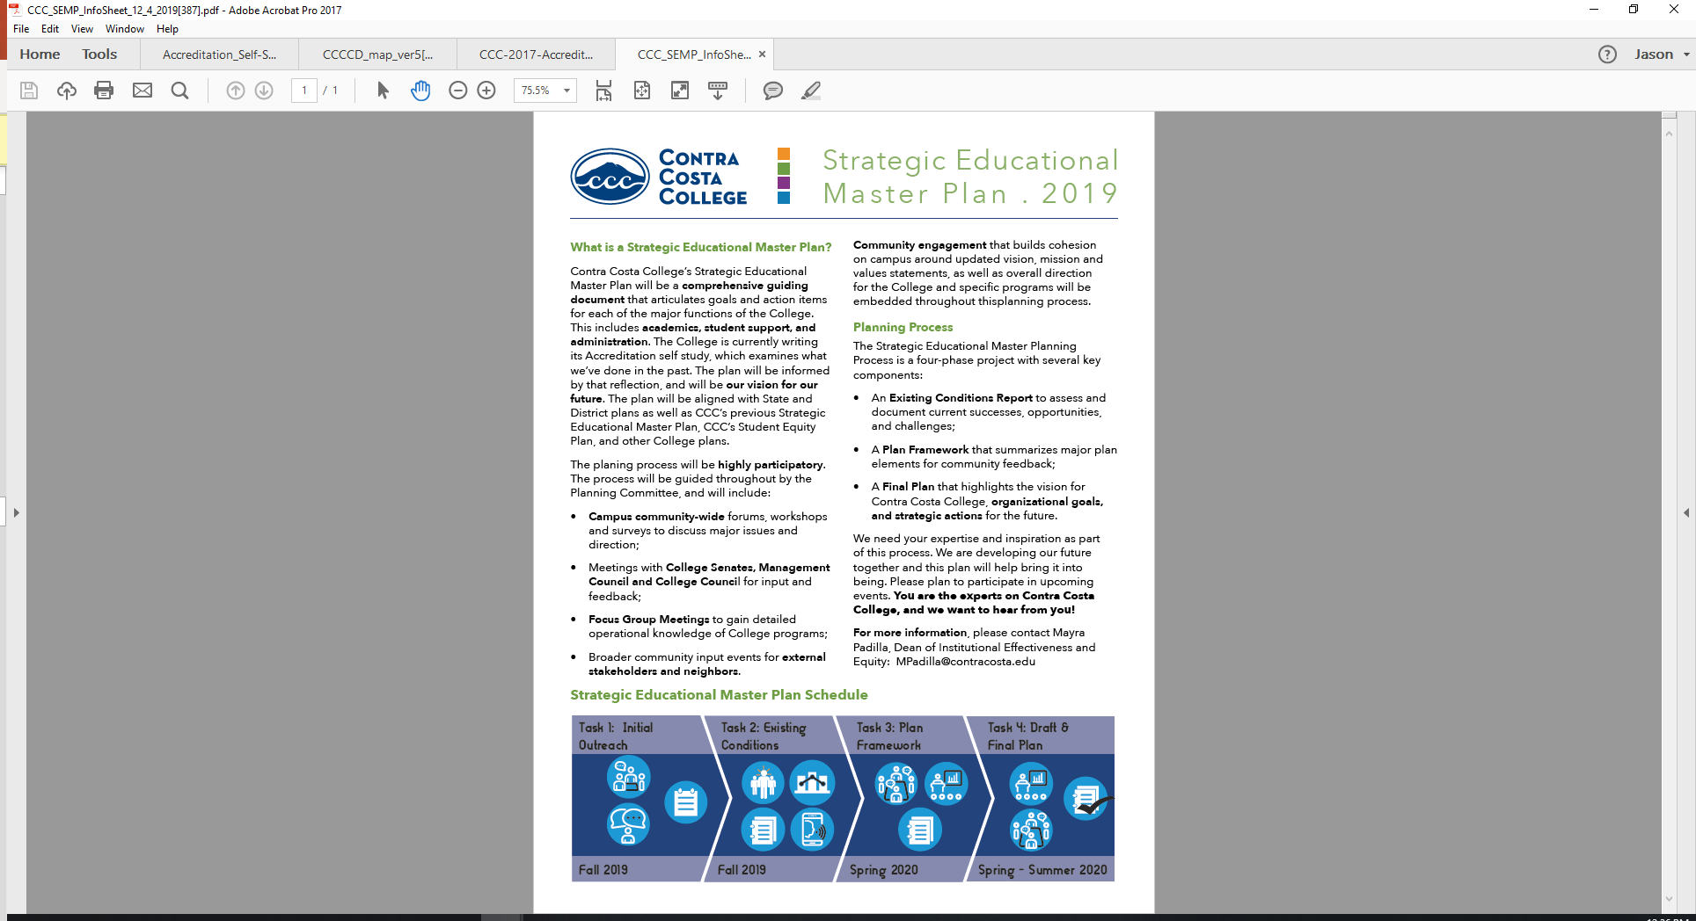

## About Our Community: Contra Costa County

Contra Costa County is located on the northern area of the East Bay region of the San Francisco Bay area. It is 716 square miles and was one of the original 27 counties at the time of California’s statehood. Many of the original families whose land grants made up Contra Costa County such as Martinez, Pacheco, Moraga, and Los Medanos are now city names. West Contra Costa includes El Cerrito, Richmond, San Pablo, Pinole, Hercules, Crockett, and El Sobrante.

According to the Contra Costa County Office, there were approximately 1,149,363 people living in Contra Costa County in 2017. This is an increase of over 100,000 people from the 2010 Census count of 1,049,025. 49% of the population identified as male and 51% identified as female. About 23% are under 18 years old and 62% are between 18 to 64 years of age. Roughly 8% are Veterans.

Contra Costa residents also come from very diverse backgrounds, about a quarter are immigrants from Asia and Latin America. About 35% of Contra Costa residents can speak another language other than English. The ethnic groups with most changes since 2010 in Contra Costa County are: Asian/Pacific Islands (+39.2), individuals who identify as two or more races (+21.9), and Hispanic (+19.7). In West County, Asian/Pacific Island, Hispanic, and individuals who identify as two or more races also experience double digit increases. However, there is decrease of 9.1% in the Black or African American group.



When it comes to educational attainment, of those who are 25 years of age and older, about 22.2% have some college experience but no degree and 49.1% have earned at least an associate degree. About 11 % do not have a high school diploma or equivalent.

Based on the 2017-18 data, the tables below provide an estimate of the percentage of Contra Costa residents 18-64 years of age who are in college.



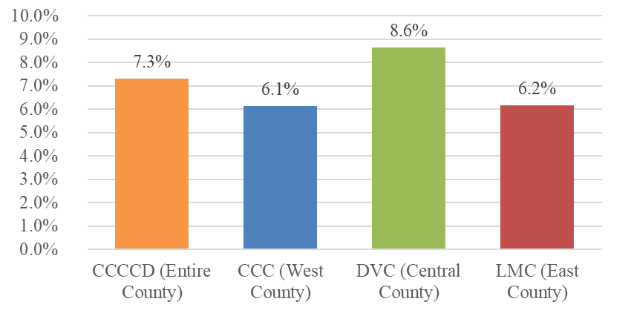

According to the Employment Development Department, Contra Costa County employment rate is at 2.7%. In 2017, the per capital income is $76,527 and has increased from 2016 and 2015. The median household income also trending up at $101,463 in 2018, bouncing from previous dip caused by the last recession. Median Cost of Home sold in 2016 is $565,000.

Contra Costa Personal Income

|  |  |
| --- | --- |
| Year | Per Capita Personal Income |
| 2017 | $76,527 |
| 2016 | $72,195 |
| 2015 | $66,348 |

Over the last few years, the personal income reported by working residents of Contra Costa has increased in the past few years. Likewise, household income over the last 10 years have steadily increased despite the dip brought on by the last recession.

Median Household Income -$101,463

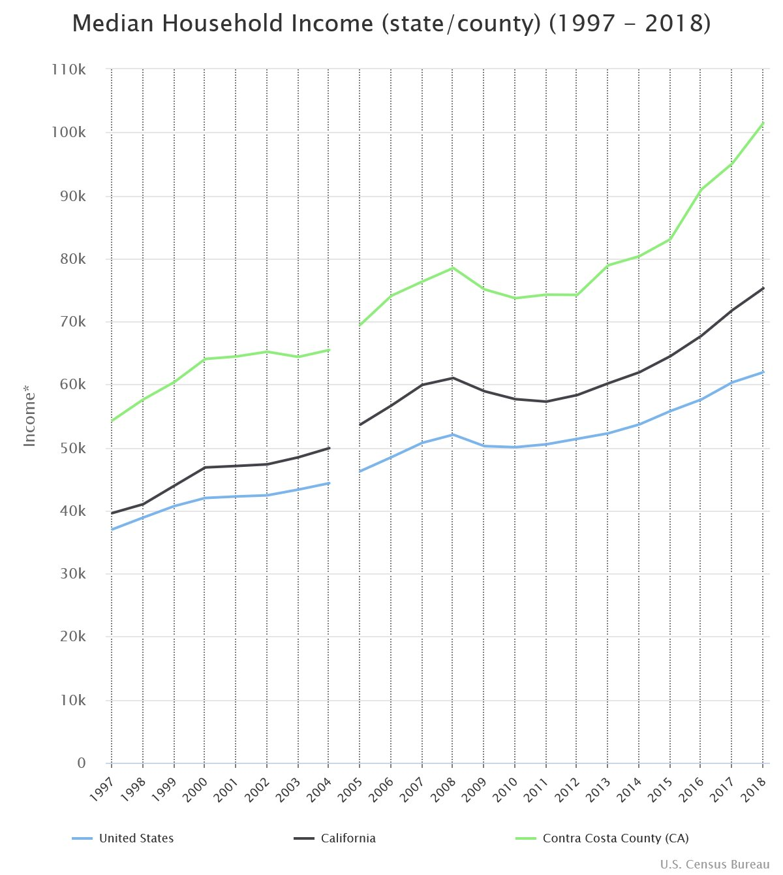

**Poverty Rate**

Higher cost of living in the Bay Area impacts families and students served by Contra Costa College. While the county’s poverty rate in 2018 is 7.8%. This rate is below the state and national levels.

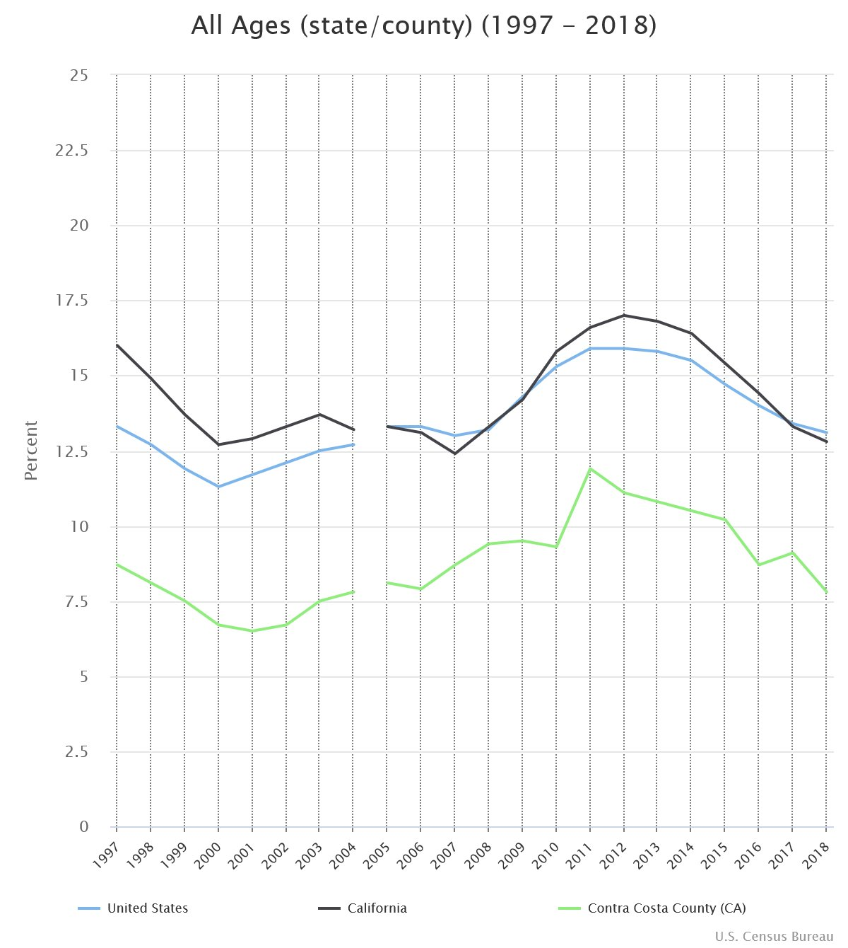

However, an area of concern is the high poverty rates experienced by youths and families. For example, the poverty rate for those under 18 years of age is higher at 9.2%. In addition, poverty rates of families headed by single mothers is at 18.9%. This is significant because households headed by single mothers account 12.3% of all households in Contra Costa.

Here is an additional breakdown of poverty rates in Contra Costa County based on the 2013-2017 American Community Survey 5-year by the United States Census:

|  |  |
| --- | --- |
| 2013-2017  PERCENTAGE OF FAMILIES AND PEOPLE WHOSE INCOME IN THE PAST 12 MONTHS IS BELOW THE POVERTY LEVEL | PERCENTAGE |
| All families | 6.9% |
| With related children under 18 years | 10.6% |
| With related children under 5 years only | 9.8% |
| Married couple families | 3.7% |
| With related children under 18 years | 5.1% |
| With related children under 5 years only | 4.0% |
| Families with female householder, no husband present | 18.9% |

Demographic profile and additional information about Contra Costa County can be accessed [here](https://www.labormarketinfo.edd.ca.gov/file/Census2017/contrdp2017.pdf).

**Job Sectors**

The table below show the employment projection through 2026 sector and the juxtaposition of Contra Costa and Alameda Counties to San Francisco Metropolitan and surrounding areas.

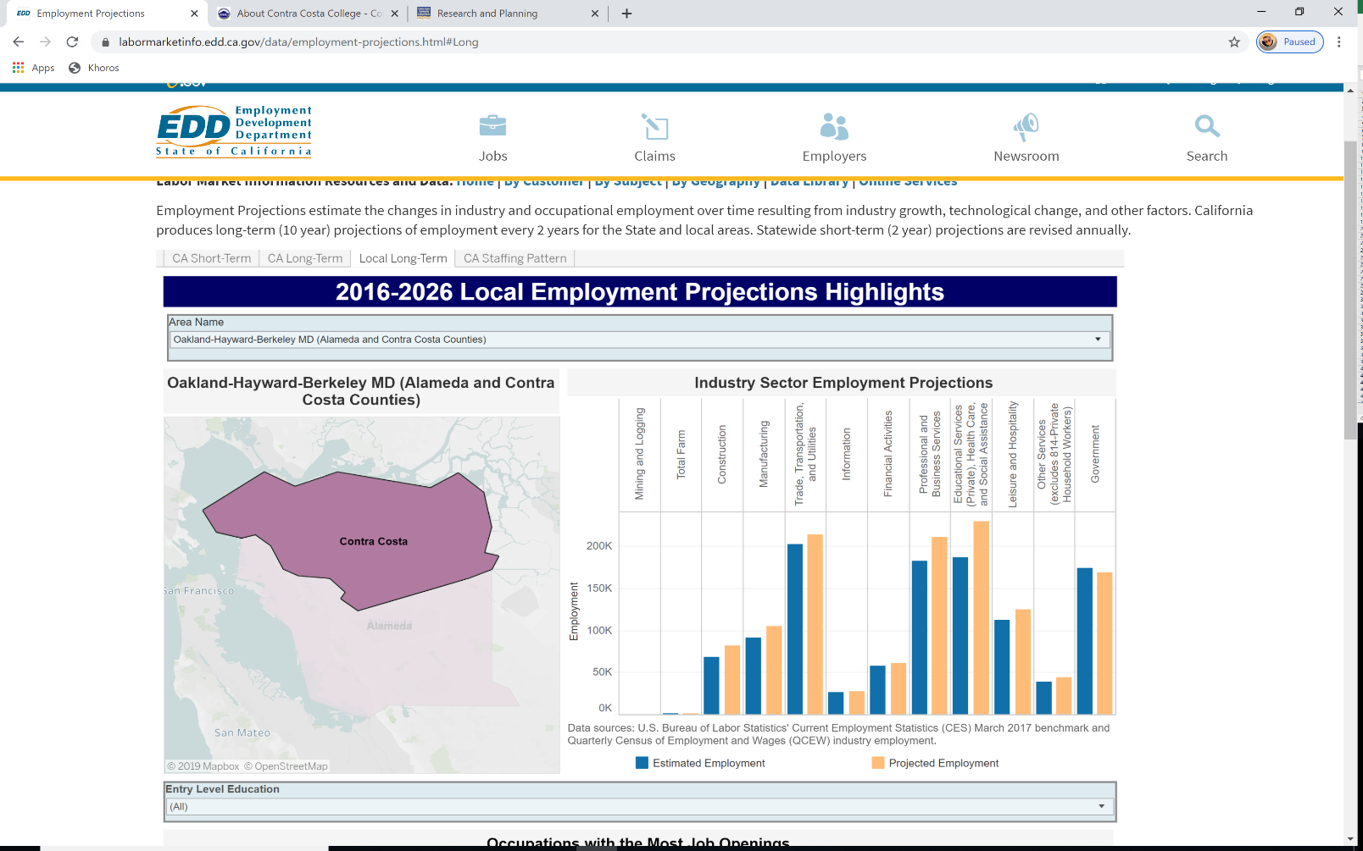

Contra Costa College is dedicated in making sure the community has the training and education opportunities to take advantage of these jobs and careers. In review of the occupations with the most opening, healthcare, service, and retail industries dominate the employment market in Contra Costa and the surrounding areas. The fastest growing occupations are in a variety of medical, Information Technology, and other Career and Technical Education fields. There is a considerable difference in wage and potential earning between jobs with the most opening and fastest growing occupations in the county.

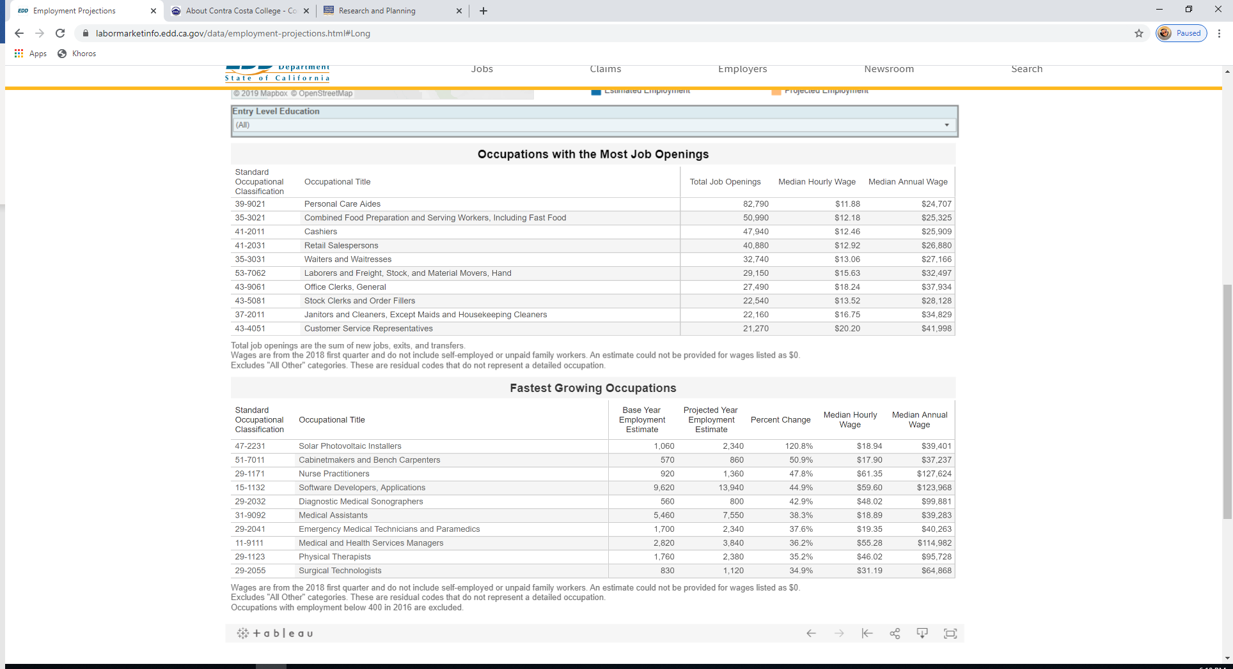

**About Our Students**

The students that attend Contra Costa College come from a diverse background, reflecting the changing demographics of the region. Confirming its status as a Hispanic Serving Institution, students who identified as Hispanic have increased steadily and represents the largest ethnic group enrolled at CCC at 39% to 45% from 2014 to 2018. Students who identify as Asian or White have remained steady, while students who identify as African American have dipped from 22% in 2014 to 17% in 2018.



Most students who attend Contra Costa College are 24 years old and younger. They comprised 62% of the student body in 2018. This enrollment trend has been consistent since 2014. However, a solid 33% of learners are also between the ages of 25 to 49. These non-traditional learners have consistently been a part of the student body in the last 5 years and with more opportunities for other ways of learning and training including non-credit offerings, enrollment trends may see an increase in this group and students who are over 50 years of age.

These trends are important to track as the population of 18-64-year-old in Contra Costa County continues to increase while the number of high school graduates continue to plateau and number of residents 19 years old and younger decrease in West County Service Area where most of Contra Costa College students come from.



Since 2014, approximately 60% of Contra Costa students identify as female, 39% identify as male and 1% have declined to identify their gender. By number, males have largely stayed around the same head count while female students have increased overtime by over 400 students.



**Contra Costa College Promise (CCCP)**

Partnering with the community, local businesses, transfer partners, and school districts, Contra Costa College launched its [Contra Costa College Promise](https://www.contracosta.edu/wp-content/uploads/2017/03/CA-College-Promise-Application_Contra-Costa-College_2_3_17.pdf) in Fall 2018. To address the low capture rate of high school graduates in the community, close the gap in high school completion, and build a strong college going culture, Contra Costa leveraged:

* An existing collaboration between a strong community-based promise initiative, innovative K12 partners, and Contra Costa College, a leader in innovative K14 pathway development and K12 integration strategies,
* Strong local business support including the leveraging of a $35 million investment by Chevron into the City of Richmond and WCCUSD.
* A comprehensive plan for strengthening school community-college connectivity in three strategic areas: 1) Early Commitment to College; 2) Comprehensive College and Career Readiness; and 3) Implementing a vibrant first year experience for students at Contra Costa College
* Leveraging of new and existing funding and initiatives within the California Community College System including Strong Workforce, SSSP, Equity, and special programs at the college (categorical programs and learning communities).
* Implementation, at scale, of innovative linkages to K12 to increase student transition to, and success in, post-secondary education including expanded priority registration, multiple measures assessment and placement, early college and career exploration in 9th grade (Get Focused Stay Focused), expanded dual enrollment and early credit options for high school students, intrusive counseling and early matriculation services for high school students, and early assessment (11th grade) to identify skills gaps and bring students up to college level math, English, and science by graduation from high school.

The CCCP strategy to ensure success builds upon current programs and infrastructure and scaling practices that are showing impact, including additional funding to students. This includes:

|  |  |  |
| --- | --- | --- |
| Early Commitment to College | College & Career Readiness | College First Year Experience |
|  $1,500 college scholarship   Expanded College Outreach   9th Grade College/Career course with 10-year career plan   Expanded matriculation support ‐ 1 on 1 counseling, FA Workshops, Ed planning   Near Peer Mentoring Program  Employer Internships |  Engage w CCC Learning Community   HS Career Academy Bridges   Expanded CCAP/DE Courses   Align STEM/Science Standards   9th Grade DE college/career course   Early College Assessment‐11th Grade   Early/Intrusive Counseling   Streamlined pathway planning |  HS Senior College Success Course   Spring workshops for Grad Seniors Ed plan, FA, “Super Saturdays”   Priority Registration   Summer Bridge‐Math/Eng Jams   Enroll into Learning Community   Social Events and Workshops  Student Coaching Program |

**Middle College, Gateway to College, and Dual Enrollment**

Contra Costa College is invested in ensuring that the young minds of West Contra Costa can be college and career ready. The following three programs allow for high school aged students to participate in college while in high school.

The [Middle College High School](https://www.contracosta.edu/student-services/high-school-programs/middle-college-high-school/) at Contra Costa College is collaboration between the West Contra Costa Unified School District and Contra Costa College. The partnership allows for high school students to participate and be challenged by the rigors of college curricula as they complete their high school diploma. One of the goals of Middle College is to increase the number of high school students who graduate and go on to pursued college degrees.

[Gateway to College](https://www.contracosta.edu/student-services/high-school-programs/gateway-to-college/) is another high school on campus program designed to help those who have dropped out or may be in danger of dropping out complete their high school diploma and enter college. Students start in learning communities and receive one-on-one support from resource specialists who are program mentors and advisers.

High School and College Dual Enrollment Program is another way high school students can start earning college credits and is a collaboration between high schools and Contra Costa College. Many courses in the Dual Enrollment Program are offered at the high schools, which makes it convenient for students and remove transportation barriers.

This table shows the increase of dual enrollment participants over time:

|  |  |  |  |
| --- | --- | --- | --- |
| Enrollment | 2016 | 2017 | 2018 |
| Dual Enrollment Students |  |  |  |
| High School Special Admit Students |  |  |  |

# Presentation of Student Achievement Data and Institution-set Standards

[see Chapter 5.3B and Appendix E of *Guide to Institutional Self- Evaluation, Improvement, and Peer Review*]

# Contra Costa College strives to create a data-informed culture that promotes responsive planning, budgeting, and programming. Collaborating with the District Institutional Research Office, CCC aligns current information and historic trends to understand, track, and respond to the changing needs of students and the community. The data is used to pursue grants, respond to reports, inform plans that guide programs, services, and the campus, and track the results of the college’s effort in closing the achievement gap.

# Enrollment by Head Count – 2014 to 2018

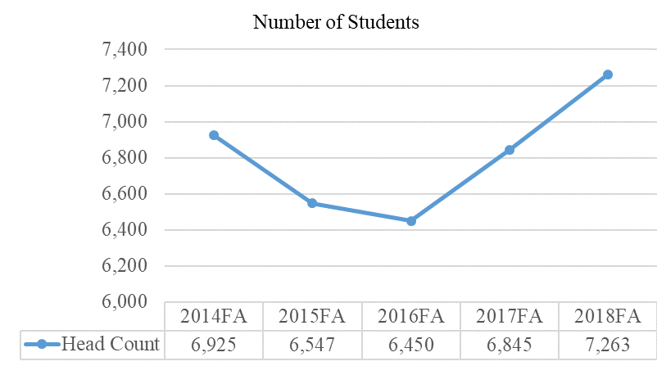

Enrollment by student head count has increased steadily since 2016 after experiencing a dip from 2014. In Fall 2018 enrollment by student head count stands at 7263.

Need Full Time and Part Time breakdown

|  |  |  |  |  |  |
| --- | --- | --- | --- | --- | --- |
| Status | 2014FA | 2015FA | 2016FA | 2017FA | 2018FA |
| Full-Time |  |  |  |  |  |
| 9-11 Credits |  |  |  |  |  |
| 6-8 Credits |  |  |  |  |  |
| 3-5 Credits |  |  |  |  |  |
| 0.5-2 Credits |  |  |  |  |  |

**Retention and Persistence**

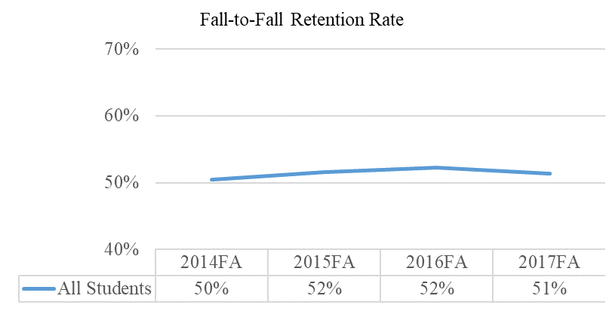

Fall to Fall Retention Rate of all students has remained relatively unchanged from 2014 to 2017 at 50-51%. Retention and persistence of students are target of different plans and initiatives including Learning Communities, Guided Pathways, AB 705, Student Equity and Achievement, and STEM tutoring.

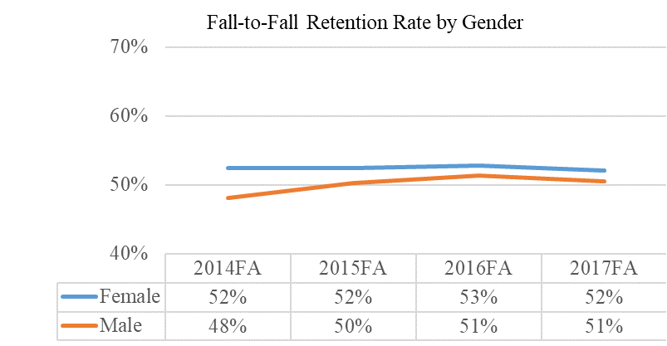

By Gender, Fall to Fall Retention rates are generally similar for both Female and Male students at 51% and 52% respectively from 2014 to 2017. Further analysis of Gender and Race/Ethnicity Retention rates and where male students are stopping in their programs may help identify the cause of the gender gap in degree/certificate completion.

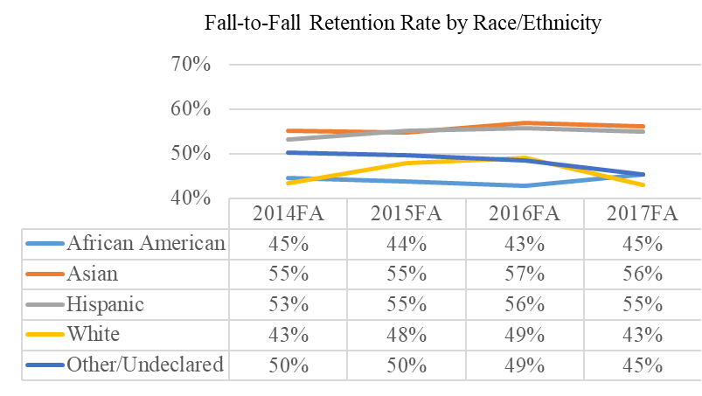

By Race/Ethnicity, Fall to Fall Retention rates have remained largely the same from 2014 to 2017. Asians (56%) and Hispanic (55%) have the highest retention rate among the major race/ethnicity groups. Other/Undeclared group experienced a 5% decline in Fall to Fall Retention from 2014 (50%) to 2017 (45%).

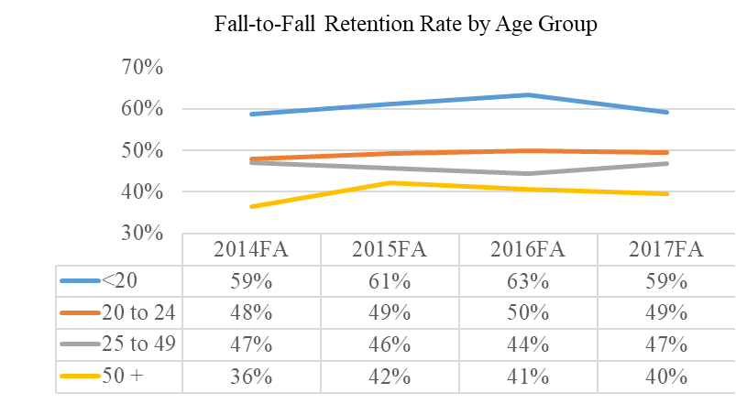

By Age Group, Fall to Fall Retention rates have generally remained for students in the 20-24 years old and 25-49 years old age groups. However, Fall to Fall Retention rate for students in the under 20 years old age group had a slight fluctuation, increasing from 2014 to 2016 and then dropping back to 2014 levels in 2017. Students in the 50+ years old group experienced the highest increase in Fall to Fall Retention rates of 4% going from 36% in 2014 to 40% in 2017.

**Student Educational Goals**

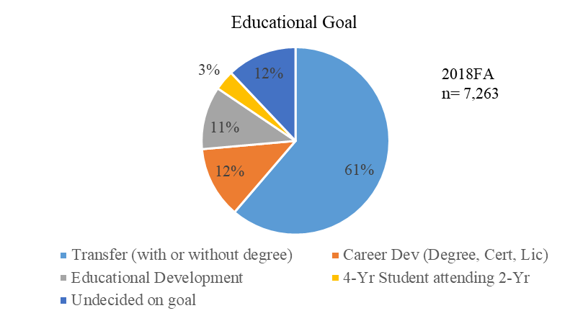

Since achievement and transfer goals are important to CCC, the table below shows the Education Goals declared by students in 2018. Note that the majority of CCC students at 61% are looking to transfer. However, 12% indicated that they are still undecided. This group is an example of students that may benefit from intensive career and program exploration.

**Pell Participation**

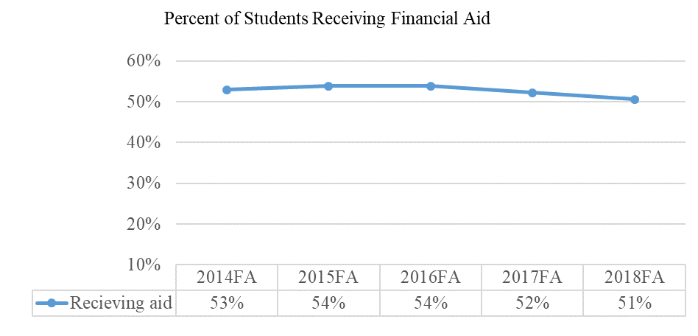

In the last few years, the number of students receiving Financial Aid at Contra Costa College has remained high at over 50%. This number does not include the students who have applied, did not finish the application processes, and did not received aid. Financial Aid outreach is a priority activity for CCC Financial Aid Office as part of the Student Equity and Achievement Program.

**Course Delivery Method**



From 2014 to 2017, Contra Costa College significantly increased it’s 100% online course enrollment, going from 448 students enrolled to 1,878 students enrolled. In the same time frame, the number of course enrollment has gone down for Face-to-Face method, dropping from 17,006 to 14,120. Hybrid courses that are 51-99% online are more popular than hybrid courses that are less than 50% online. These trends reflect the changing needs of students for more non-traditional offering via online delivery method.

**Course Completion Rate** – How is this defined? Any grade?



Of the four different types of course delivery method, 100% Online (77%) lags behind Face-to-Face method (84%) by 7% in Fall 2018. This difference in Course Completion Rate has remained consistent since Fall 2015 (5-7%). Since 2014, Course Completion Rate for 100% Online delivery method has decreased by 8% (85% to 77%).

**Course Success Rate** – How is this defined? C or D and above?



Course Success Rate is defined as completion with a grade of ## or higher. Face-to-Face success rate seem to remain consistent at 69-71% from 2014 to 2018. Similar to Course Completion Rate comparison, 100% Online courses had lower success rate than the other delivery methods, including a 7% difference in Fall 2018 as compared to courses delivered Face-to-Face.

**Career and Technical Course Enrollment, Completion, and Success Rate**



Career and Technical Education (CTE) courses are programs of distinction at Contra Costa College. From Fall 2014 to Fall 2018, total CTE course enrollment has remained steady from 2218 to 2245 respectively. Although the number of courses delivered 100% online in CTE is small, the course completion rate between courses offered 100% Online and Face-to-Face is similar at 86% and 87% respectively. Course Success Rate for CTE is also the highest for courses offered Face-to-face at 75%. Success rate for CTE courses in Face-to-Face classes is higher as compared to all other courses (75% vs 69%), and course completion in Face-to-Face classes is also higher for CTE courses when compared to all other courses (87% vs. 84%).

## Achievement – Degrees and Certificate

Contra Costa students earned 1383 degrees and certificates in academic year 2018-19: 802 AA/AS degrees, 68 certificates that are at least one year, and 513 certificates that are less than one year in length. This represents a 5% increase since 2014-15 for AA/AS degree and a consistent trend for one-year certificates. Although by percentage, there is a decreasing trend in the conferral of certificates that are less than one-year in program length, more students have received these certificates in the last three years.



By gender, Contra Costa female students have earned over 60% of degrees and certificates conferred since 2014. Male students have consistently earned 35% of degrees and certificates since 2014. The difference is significant and needs further analysis to determine the impact and effective intervention.



By race/ethnicity, Contra Costa students who identify as Hispanic had the highest rate of receiving a degree or certificate at 40%, followed by students who identify as Asians at 26%, and students who identify as African American at 16%.



By Age Group, in 2018-19 Contra Costa students 25 to 49 years old had the highest award rate at 46%. Students 20 to 24 years old had an award rate of 39% and those who were less than 20 years old had an award rate of 11%. Since 2014-15, the award rates have stayed relatively consistent for all age groups except those who are 25-49 years old. This group’s award rate has increased and has trended upwards over time.



## Program Licensure Information

As reported in previous midterm reports, Contra Costa College tracks the placement and licensure information of students in several field: Emergency Medical Services, Certified Nursing Assistant, and Nursing (RN).

|  |  |  |  |  |  |  |  |  |
| --- | --- | --- | --- | --- | --- | --- | --- | --- |
| **LICENSURE PASS RATE (Based on the number of students that took the licensure examination)** | | | | | | | | |
|  | | | **Performance** | | | **Difference** | | |
| **Program Name** | **CIP**  **Code** | **Institution Set Standard** | **2014** | **2015** | **2016** | **2014** | **2015** | **2016** |
| Emergency Medical Services | 51.08 | 70% | 77% | 52% | 40% | 7% | -18% | -30% |
| Nursing: Certified Nursing Assistant | 51.39 | 90% | 75% | 80% | 77% | -15% | -10% | -13% |
| Nursing | 51.38 | 90% | 85% | 75.8% | 88% | -5% | -14.2% | -2% |

**Job Placement – New Rates/Align with Annual Report?**

While Contra Costa College does not have a mechanism for tracking employment outcomes for any educational programs. The data below comes from the CTE Core Indicator reports generated by the Chancellor’s Office. The job placement rates reflect the College’s performance related to the “CTE Cohort” for each program.

|  |  |  |  |  |  |  |  |  |
| --- | --- | --- | --- | --- | --- | --- | --- | --- |
| **JOB PLACEMENT RATE (Definition: The placement rate is defined as the number of students employed in the year following graduation divided by the number of students who graduated from the program.)** | | | | | | | | |
|  |  |  | **Performance** | | |  | **Difference** | |
| **Program Name** | **CIP**  **Code** | **Institution Set Standard** | **2014** | **2015** | **2016** | **2014** | **2015** | **2016** |
| Administration of Justice | 43.01 | 81.48% (2014)  80.85% (2015) | 73.8% | 50% | 71.3% | -6.68% | -30.85% | -8.55% |
|  | 80.85% (2016) |  |  |  |  |  |  |
| Automotive Technology | 47.06 | 81.62% (2014)  80.85% (2015) | 75% | 77.6% | 84.6% | -6.62% | -3.25% | 3.75% |
|  |  | 80.85% (2016) |  |  |  |  |  |  |
| Automotive Collision & Repair | 47.06 | 81.48% (2014)  80.85% (2015)  80.85% (2016) | 89% | 78.6% | 55.6% | 7.52 | -2.25% | -25.25% |
| Business Administration | 52.02 | 81.48% (2014)  80.85% (2015) | 100% | *NA | *NA | 18.52% | -------- | -------- |
|  |  | 80.85% (2016) |  |  |  |  |  |  |
| Business Management | 52.02 | 81.48% (2014)  80.85% (2015) | 56.5% | 56.3% | 65.4% | -24.98% | -24.55% | -15.45% |
|  |  | 80.85% (2016) |  |  |  |  |  |  |
| Business Office Tech | 52.04 | 81.48% (2014)  80.85% (2015) | *NA | *NA | *NA | -------- | -------- | -------- |
|  |  | 80.85% (2016) |  |  |  |  |  |  |
| Biotechnology | 26.12 | 81.48% (2014)  80.85% (2015) | *NA | *NA | *NA | -------- | -------- | -------- |
|  |  | 80.85% (2016) |  |  |  |  |  |  |
| Certified Nursing Assistant | 51.39 | 81.48% (2014)  80.85% (2015) | 90% | 77.8% | 66.7% | 8.52% | -3.05% | -14.15% |
|  |  | 80.85% (2016) |  |  |  |  |  |  |
| Computer & Communications Tech. | 11.99 | 81.48% (2014)  80.85% (2015)  80.85% (2016) | 46.6% | 33.3% | 41.2% | -34.88% | -47.55% | -39.65% |
| Computer Information Systems | 11.09 | 81.48% (2014)  80.85% (2015)  80.85% (2016) | *NA | *NA | *NA | ------- | -------- | -------- |
| Culinary Arts | 12.05 | 81.48% (2014)  80.85% (2015) | 66.1% | 55.1% | 54.2% | -15.38% | -25.75% | -26.65% |
|  |  | 80.85% (2016) |  |  |  |  |  |  |
| Digital Film Production | 50.06 | 81.48% (2014)  80.85% (2015) | *NA | *NA | *NA | -------- | ------- | -------- |
|  |  | 80.85% (2016) |  |  |  |  |  |  |
| Early Childhood Education | 13.12 | 81.48% (2014)  80.85% (2015) | 80.7% | 72.4% | 68.8% | -.78% | -8.48% | -12.05% |
|  |  | 80.85% (2016) |  |  |  |  |  |  |
| Emergency Medical Services | 51.09 | 81.48% (2014)  80.85% (2015)  80.85% (2016) | *NA | *NA | *NA | -------- | -------- | -------- |
| Health & Human Services | 51.00 | 81.48% (2014)  80.85% (2015)  80.85% (2016) | 70.37  % | 50% | 65.2% | -11.11% | -30.85% | -15.65% |
| Journalism | 09.04 | 81.48% (2014)  80.85% (2015) | *NA | *NA | 85.7% | -------- | -------- | 5.15% |
|  |  | 80.85% (2016) |  |  |  |  |  |  |
| Medical Assistant | 51.08 | 81.48% (2014)  80.85% (2015) | 67.9% | 73.9% | 65.2% | -13.58% | -6.95% | -15.65% |
|  |  | 80.85% (2016) |  |  |  |  |  |  |
| Nursing | 51.38 | 81.48% (2014)  80.85% (2015)  80.85% (2016) | 85.3% | 68.5% | 62.9% | 3.82 | -12.35% | -17.95% |
| Real Estate | 52.15 | 81.48% (2014)  80.85% (2015)  80.85% (2016) | *NA | *NA | *NA | -------- | --------- | -------- |
| **Analysis of Data:** *NA or Not Available means that there were less than10 students in the cohort. As a result of the small sample size, employment outcomes could not be disclosed for privacy reasons. | | | | | | | | |

## Specialized or Programmatic Accreditation

[insert response]

**Evidence**

|  |  |
| --- | --- |
| [INTR](https://www.contracosta.edu/about/mission-vision/) | Contra Costa College Mission + Vision |
|  |  |
| [INTR](https://www.contracosta.edu/wp-content/uploads/2017/07/CCC-Construction-Calendar-Fall-2017.pdf) | Contra Costa College Construction Calendar Fall 2017 |
| [INTR](https://www.contracosta.edu/quick-links/maps-parking/campus-map/) | Contra Costa College Campus Map |
| [INTR](https://www.contracosta.edu/about/accreditation/) | Contra Costa College Accreditation |
|  |  |
| INTR | Conta Costa College |
|  |  |
| [INTR](https://www.contracosta.edu/wp-content/uploads/2018/01/Contra-Costa-College_01_26_2018.pdf) | Contra Costa College 2018 ACCJC Affirmation of Meeting All Standards |
| [INTR](https://www.contracosta.edu/wp-content/uploads/2019/06/061119_CCC_LetsDoThis_DegreeChart.jpg) | Contra Costa College Degrees and Certificates |
|  |  |
|  |  |
| [INTR](https://www.labormarketinfo.edd.ca.gov/geography/contracosta-county.html) | State of California Employment Development Department |
| [INTR](https://www.labormarketinfo.edd.ca.gov/cgi/databrowsing/localAreaProfileQSResults.asp?selectedarea=Contra+Costa+County&selectedindex=7&menuChoice=localAreaPro&state=true&geogArea=0604000013&countyName=) | Labor Market Unemployment Rate |
| INTR | Contra Costa College 2017 ACCJC Midterm Report |
| [INTR](https://www.contracosta.ca.gov/5342/Demographics) | Contra Costa County, California Demographics Data |
|  |  |
| [INTR](https://www.census.gov/data-tools/demo/saipe/#/expandedTrend?map_geoSelector=aa_c&s_county=06013&s_measures=aa_snc&s_state=06) | Small Area Income and Poverty Estimate (SAIPE) |
| [INTR](https://www.labormarketinfo.edd.ca.gov/file/Census2017/contrdp2017.pdf) | Contra Costa County Selected Social Characteristics 2013-2017 |
|  |  |
| INTR | [Contra Costa College District Research and Planning](http://www.4cd.edu/research/default.aspx) |
|  |  |
|  |  |
| [INTR](https://cccgp.cccco.edu/About-Guided-Pathways) | California Community College Guided Pathways |
| [INTR](https://www.cccco.edu/About-Us/Chancellors-Office/Divisions/Educational-Services-and-Support/Special-Populations/What-we-do/Student-Equity) | California Community College Student Equity |
| [INTR](https://assessment.cccco.edu/ab-705-implementation) | California Community College AB 705 Implementation |
| [INTR](https://www.cccco.edu/About-Us/Chancellors-Office/Divisions/College-Finance-and-Facilities-Planning/Student-Centered-Funding-Formula) | California Community College Student Centered Funding Formula |
| [INTR](https://www.contracosta.edu/wp-content/uploads/2017/03/CA-College-Promise-Application_Contra-Costa-College_2_3_17.pdf) | Contra Costa College Promise Application |
|  |  |
| [INTR](https://www.contracosta.edu/student-services/high-school-programs/middle-college-high-school/) | Contra Costa College Middle College High School |
| [INTR](https://www.contracosta.edu/student-services/high-school-programs/gateway-to-college/) | Contra Costa College Gateway to College |
|  |  |
|  |  |
|  |  |

# Organization of the Self-Evaluation Process

[insert response]

Institutional Self Evaluation Process Timeline

|  |  |  |
| --- | --- | --- |
| Date | Event | Action |
|  |  |  |
|  |  |  |
|  |  |  |
|  |  |  |
|  |  |  |
|  |  |  |

Contra Costa Accreditation Committee Members

|  |  |
| --- | --- |
| Core Team Members |  |
| Roles | Name |
| President |  |
| Accreditation Liaison Officer |  |
| Institutional Research |  |
| IT and Web Support |  |
| Administrative Support |  |
| Lead – Standard I |  |
| Lead – Standard II. A |  |
| Lead – Standard II. B/C |  |
| Lead – Standard III |  |
| Lead – Standard IV |  |
|  |  |

|  |  |
| --- | --- |
| Standard Team Members | Name |
|  |  |
| Standard I |  |
|  |  |
| Standard II. A |  |
|  |  |
| Standard II. B/C |  |
|  |  |
| Standard III |  |
|  |  |
| Standard IV |  |
|  |  |
|  |  |
|  |  |

# Organizational Information

Contra Costa College Management Structure

Contra Costa College

Office of the President

Direct Reports and Cabinet

Contra Costa College

Office of the Vice-President

Direct Reports and Cabinet

Contra Costa College

Library, Allied Health, Vocational Education

Direct Reports and Departments

Contra Costa College

Liberal Arts

Direct Reports and Departments

Contra Costa College

Natural, Social and Applied Sciences

Direct Reports and Departments

Contra Costa College

Student Services

Direct Reports and Departments

Contra Costa College

Business Services

Direct Reports and Departments

**District-College Functional Map**

**Deliniation**

Operational responsibilities and functions of the District Office and the colleges in the District are delineated in the document titled *District and College Roles, Responsibilities, and Service Outcomes – Functional Map (*FM.01). College and District personnel who have responsibility for the functions listed in the document developed the document in 2010. Every major function performed in the District is listed, and the role of the colleges and the District off for each function is stated. The document was updated in 2013 as a result of more centralization and consolidation due to restructuring at the District level. The document reflects accurately the roles and responsibilities of the college and the District office and is followed in practice.

Every four years, as part of its administrative services review process (FM.02) (FM.2a) (FM.2b), each department at the District Office meets with its college counterpart(s) to review and update the document (FM.03). In addition to the process for updating the *Functional Map*, the executive vice chancellors conduct informational sessions at various workgroup meetings at each of the colleges to communicate the application and reinforcement of the document. Further, the chancellor engages the college presidents and the cabinet in the discussion and review of the Functional Map (FM.04).

**REFERENCES**

FM.01 District and College Roles, Responsibilities, and Service Outcomes-

Functional Map.pdf

FM.02 District Office Dept. Unit Review Guide and Template Final September 2010.1.pdf

FM.02a District Office Dept. Unit Review Guide and Template Final September 2010.2.pdf

FM.02b District Office Dept. Unit Review Guide and Template Final September

2010.3.pdf

FM.03 District Office Planning Calendar v2.pdf

FM.04 October 22, 2013.pdf

Check the previous accreditation folder.

Contra Costa Community College District Roles, Responsibilities, and Service Outcomes Functional Map –

<http://www.4cd.edu/about/docs/District%20and%20College%20Roles,%20Responsibilities,%20and%20Service%20Outcomes.pdf>

# Certification of Continued Compliance with Eligibility Requirements

**Eligibility Requirement 1: Authority**

The institution is authorized or licensed to operate as a post-secondary educational institution and to award degrees by an appropriate governmental organization or agency as required by each of the jurisdictions or regions in which it operates. Private institutions, if required by the appropriate statutory regulatory body, must submit evidence of authorization, licensure, or approval by that body. If incorporated, the institution shall submit a copy of its articles of incorporation.

[Contra Costa College](http://www.4cd.edu/about/docs/Fingertip%20Facts.pdf) is a public two-year community college operating under the authority of the State of California, the Board of Governors of the California Community Colleges, and the Contra Costa Community College District Governing Board since 1949, with [accreditation status](https://www.contracosta.edu/about/accreditation/) regularly renewed by the Accrediting Commission of Community and Junior Colleges (ACCJC) of the Western Association of Schools and Colleges

**Eligibility Requirement 2: Operational Status**

The institution is operational, with students actively pursuing its degree programs.

Contra Costa College is a comprehensive college with a variety of course offerings and programs to meet the varied educational needs of its service area.

The College has been in continuous operation since 1949 and currently serves approximately 7,263 full time equivalent students who are actively pursuing degree and certificate programs in a wide variety of academic areas offered by the institution for career and transfer preparation. The College operates on a year-round [schedule](https://www.contracosta.edu/classes/class-schedule/) and offers classes in fall, spring, and summer terms. Classes are offered in the following delivery methods: Face-to-Face, Hybrid, and Online.

Link to schedule and catalogs

**Eligibility Requirement 3: Degrees**

A substantial portion of the institution’s educational offerings are programs that lead to degrees, and a significant proportion of its students are enrolled in them. At least one degree program must be of two academic years in length.

The following is a breakdown of the College’s course enrollment from 2014 to 2018. While there are Basic Skills Courses offered, these courses are used to support students in their pursuit of higher degrees. Enrollment from Basic Skills Courses are smaller than enrollment in degree applicable courses. In addition, based on student’s program plan, most students plan to complete an associate degree and/or transfer.

|  |  |  |  |  |  |
| --- | --- | --- | --- | --- | --- |
| Course Enrollment by Category | 2014FA | 2015FA | 2016FA | 2017FA | 2018FA |
| All Coursework | 18,186 | 17,165 | 16,747 | 16,647 | 17,050 |
| Degree Applicable | 14,553 | 14,105 | 13,920 | 14,273 | 15,287 |
| Basic Skills | 2600 | 2162 | 2049 | 1650 | 1237 |

**Eligibility Requirement 4: Chief Executive Officer**

The institution has a chief executive officer appointed by the governing board, whose full-time responsibility is to the institution, and who possesses the requisite authority to administer board policies. Neither the district/system chief executive officer nor the institutional chief executive officer may serve as the chair of the governing board. The institution informs the Commission immediately when there is a change in the institutional chief executive officer.

The chief executive officer of the College is appointed to his/her role as president by the Governing Board and has full-time responsibility to the institution. The Board delegates to the president the authority to administer Board policies for the College, as outlined in the *Rules and Regulations of the Governing Board* (D-7).

The president’s contract states the primary responsibility of the president as being “responsible to the Governing Board and the Chancellor for the supervision and development of all aspects of the educational programs and services of the College”

The Interim President Dr. Damon Bell was [appointed](http://www.4cd.edu/crpa/pressreleases/Dr.%20Damon%20A.%20Bell%20Selected%20as%20Contra%20Costa%20College%20Interim%20President.pdf) on November 13, 2019.

**Eligibility Requirement 5: Financial Accountability**

The institution annually undergoes and makes available an external financial audit by a certified public accountant or an audit by an appropriate public agency. Institutions that are already Title IV eligible must demonstrate compliance with federal requirements.

The Contra Costa Community College District undergoes and makes available annual financial audits for the District and the College conducted by externally contracted certified public accountants. The College also posts annual budget information for transparency. Budget reports are archived and accessible through the budget report [website](http://www.4cd.edu/business/budgetreports/Forms/AllItems.aspx), and budget [forums](http://www.4cd.edu/business/budgetforums/Forms/AllItems.aspx) are announced every April to inform the campus and district communities.

# Certification of Continued Institutional Compliance with Commission Policies

[Insert college name] certifies that it continues to be in compliance with the federal regulations noted below, and Commission Policies on Rights and Responsibilities of the Commission and Member Institutions; Institutional Degrees and Credits; Transfer of Credit; Distance Education and on Correspondence Education; Representation of Accredited Status; Student and Public Complaints Against Institutions; Institution Advertising, Student Recruitment, and Representation of Accredited Status; Contractual Relationships with Non-Regionally Accredited Organizations; and Institutional Compliance with Title IV.

**Public Notification of an Evaluation Team Visit and Third Party Comment**

*Regulation citation: 602.23(b).*

Contra Costa College regularly sends announcements to campus constituencies of important events. Accreditation notices were sent regularly via email and opportunities for feedback on the accreditation self-evaluation report were provided. The college [accreditation website](https://www.contracosta.edu/about/accreditation/) also provides information about current and previous accreditation activities.

**Standards and Performance with Respect to Student Achievement**

*Regulation citations: 602.16(a)(1)(i); 602.17(f); 602.19 (a-e).*

[Provide very brief narrative and accompanying links to evidence. If applicable, cite and hyperlink to the standards in your report where more detailed narrative and additional evidence can be found.]

**Credits, Program Length, and Tuition**

*Regulation citations: 600.2 (definition of credit hour); 602.16(a)(1)(viii); 602.24(e), (f); 668.2;*

*668.9.*

The courses or other educational experiences have identified student learning outcomes that students must meet at a defined level of performance to receive credit. All courses and programs at Contra Costa College must have student learning outcomes (SLO) on file. SLOs are included in the course outlines of record. All syllabi, which are submitted to division offices at the beginning of the semester, must also list the student learning outcomes.

When courses or programs are created or revised, the Curriculum and Instruction Committee reviews the SLOs and their connection to course objectives and content. Course level SLOs are in alignment with program level SLOs. New institutional student learning outcomes are being mapped to general education area requirements and individual courses. Program level student learning outcomes are listed under each program in Chapter 4 of the CCC Catalog.

The courses or other educational experiences meet standards of quality as defined by the institution.

* Contra Costa College is committed to providing a rigorous and transformative educational experience for all its students. The College follows standard academic practice when awarding degrees and units of credit.

The credits awarded for a course or educational experience is comparable in quantity and nature to credits awarded to other courses at the institution.

* The curriculum approval process ensures all programs and courses have the appropriate level of rigor. This is done through analysis of course content and objectives, alignment with requirements for transfer to 4-year institutions, and evaluation of program requirements. The College has numerous articulation agreements with the CSU and UC systems and private institutions so that that credits earned at CCC are accepted for transfer. The current list of transferrable courses is included in Chapter 3 of the Contra Costa College Catalog.

The credits are appropriate for higher education or for pre-collegiate education, and are defined as such.

* Contra Costa College has designated certain courses “non-degree credit.” This means that units earned in selected courses will not count toward an associate’s degree. This information is contained in the course descriptions in the College catalog.

**Transfer Policies**

*Regulation citations: 602.16(a)(1)(viii); 602.17(a)(3); 602.24(e); 668.43(a)(ii).*

The credits are appropriate and applicable to the institution’s own educational programs leading to a degree, certificate, or other defined educational outcomes.

* Contra Costa College has articulated lower division course-to-course, major-to major, and general education articulation agreements with all California State University (CSU), University of California (UC) and a number of private colleges and

**Distance Education and Correspondence Education**

*Regulation citations: 602.16(a)(1)(iv), (vi); 602.17(g); 668.38.*

As part of the Contra Costa Community College District’s commitment to learning and equitable success, the district has developed a Distance Education Strategic Plan to increase access and promote student success through high quality distance education. In addition Contra Costa College is committed to quality student experience in the online environment as the demand and offering for online courses increase:

* Collaborate with the District to implement the [2017-2022 Distance Education Strategic Plan](http://www.4cd.edu/ed/docs/Distance%20Education%20Strategic%20Plan%202017-2022.pdf),
* Contra Costa Community College District utilizes [CANVAS](http://www.4cd.edu/insite/Default.aspx) as it’s learning management system and provides training to faculty and staff on how to use and navigate the application and provides technical support to users.
* Contra Costa College provides [support](https://www.contracosta.edu/faculty-resources/distance-education-faculty-information/) and resources to faculty who are interested in adapting and offering their courses online.
* Contra Costa College tracks completion and student success in Online and Hybrid environment.

**Student Complaints**

*Regulation citations: 602.16(a)(1)(ix); 668.43.*

Narrative on student grievance about grades and procedures (Page 19).

Policy, definition and procedure in making a Sexual Harassment complaint is also available and published on the catalog. (Page 10)

Who keeps the files and for how long?

**Institutional Disclosure and Advertising and Recruitment Materials**

*Regulation citations: 602.16(a)(1))(vii); 668.6.*

[Provide very brief narrative and accompanying links to evidence. If applicable, cite and hyperlink to the standards in your report where more detailed narrative and additional evidence can be found.]

Educational programs and services offered shall be the primary emphasis of all advertisements, publications, promotional literature and recruitment activities, including electronic format.

* Contra Costa College continues to improve on providing clear and accurate information to students and prospective students in all college publications and through the website. Student recruitment is conducted by qualified college staff members and trained student ambassadors. Specifically, representations to conditions for transfer of course completion and license exams are clear and accurate. This information is provided primarily through the College catalog, schedule of classes and the college website.

The College catalog, schedule of classes and the college website contain all of the required information, as shown in table below.

Placement of Critical Information Regarding Contra Costa College

|  |  |  |  |
| --- | --- | --- | --- |
| Information Required | Catalog | Schedule | Website |
| Official Name, Address, Phone | X | X | X |
| Mission and Purpose | X |  | X |
| Information on Programs and Courses | X |  | X |
| Degree, Certificate and Program Completion Requirements | X |  | X |
| Faculty with Degrees Held | X |  | X |
| Facilities Available | X |  | X |
| Rules and Regulations for Conduct | X |  | X |
| Academic Freedom Policy | X |  | X |
| Fees | X | X | X |
| Financial Aid Opportunities | X | X | X |
| Refund Policies and Procedures | X |  | X |
| Transfer of Credit Policies | X |  | X |
| Nondiscrimination Policy | X |  | X |
| Other Locations for Policies | X |  | X |
| Governing Board | X |  | X |
| Accreditation Status | X |  | X |
| Clery Act/Student Right to Know | X |  | X |
| Consumer Information |  |  | X |

Recruitment of International Student

<https://www.nafsa.org/about-us/about-nafsa/nafsas-statement-ethical-principles>

**Title IV Compliance**

*Regulation citations: 602.16(a)(1)(v); 602.16(a)(1)(x); 602.19(b); 668.5; 668.15; 668.16; 668.71 et seq.*

[Provide very brief narrative and accompanying links to evidence. If applicable, cite and hyperlink to the standards in your report where more detailed narrative and additional evidence can be found.]

Contra Costa College complies with all Title IV requirements and is in good standing to offer Federal Financial Aid (Pell and Federal Student Loan).

Approved PPA, Loan Default, Program Review Information

|  |  |
| --- | --- |
| [INTRO](http://www.4cd.edu/crpa/pressreleases/Dr.%20Damon%20A.%20Bell%20Selected%20as%20Contra%20Costa%20College%20Interim%20President.pdf) | Contra Costa College Interim President Appointed |
| [INTRO](http://www.4cd.edu/about/docs/Fingertip%20Facts.pdf) | Contra Costa Community College District Facts |
| [INTRO](https://www.contracosta.edu/faculty-resources/distance-education-faculty-information/) | Contra Costa College Distance Education Faculty Information |
| [INTRO](https://www.contracosta.edu/classes/class-schedule/) | Contra Costa College Class Schedule and Catalogs |
| [INTRO](http://www.4cd.edu/ed/docs/Distance%20Education%20Strategic%20Plan%202017-2022.pdf) | Contra Costa Community College District 2017-2022 Distance Education Strategic Plan |
| [INTRO](http://www.4cd.edu/insite/Default.aspx) | Contra Costa College Web Portal Link- Insite |
| [INTRO](http://www.4cd.edu/about/docs/District%20and%20College%20Roles,%20Responsibilities,%20and%20Service%20Outcomes.pdf) | Contra Costa Community College District Roles, Responsibilities, and Service Outcomes Functional Map |

# Institutional Analysis

## Standard I: Mission, Academic Quality and Institutional Effectiveness, and Integrity

The institution demonstrates strong commitment to a mission that emphasizes student learning and student achievement. Using analysis of quantitative and qualitative data, the institution continuously and systematically evaluates, plans, implements, and improves the quality of its educational programs and services. The institution demonstrates integrity in all policies, actions, and communication. The administration, faculty, staff, and governing board members act honestly, ethically, and fairly in the performance of their duties.

### Mission

1. The mission describes the institution’s broad educational purposes, its intended student population, the types of degrees and other credentials it offers, and its commitment to student learning and student achievement.

**Evidence of Meeting the Standard**

Contra Costa College’s current mission appears in the homepage, schedule, catalogs and different publications:

**Mission**

Contra Costa College is a public community college serving the diverse communities of West Contra Costa County and all others seeking a quality education, since 1949.  The College equitably commits its resources using inclusive and integrated decision-making processes to foster a transformational educational experience and responsive student services that ensure institutional excellence and effective student learning.​

Additionally, the College adheres to the following goals, vision, beliefs, and values statements:

**Strategic Goals**

To fulfill its mission and to be consistent with its beliefs and values, Contra Costa College is committed to the following goals:

* Equitably Improve Student Access, Learning and Success
  + Create opportunities for thoughtful reflection that uses quantitative and qualitative data to improve student outcomes.
* Strengthen Community Relationships and Partnerships
  + Build pipelines that guide and prepare both K-12 students and the adult population for success in higher education and employment.
* Promote Innovation, Create a Culture of Continuous Improvement, and Enhance Institutional Effectiveness
  + Provide opportunities to enhance institutional effectiveness and opportunities for employees at all levels to continually gain new skills and knowledge, seek out effective practices, and share ideas with one another in order to continually enhance learning and improve student success.
* Effectively Optimize Resources to Support Student Learning and Success
  + Demonstrate sound judgement to effectively optimize the college’s human, physical, financial and organizational resources to better serve its students and community.

**Values**

Contra Costa College’s commitment to its mission derives strength and guidance from institutional values. As a community of educators, we value:

* COMMITMENT to helping students learn and to improving the economic and social vitality of communities through education;
* RESPONSIVENESS to the varied and changing learning needs of those we serve;
* DIVERSITY of opinions, ideas and peoples;
* FREEDOM to pursue and fulfill educational goals in an environment that is safe and respectful for all students, all faculty, all classified staff, and all managers alike; and
* INTEGRITY in all facets of our college interactions and operations.

**Institutional Student Learning Outcomes**

Support an environment that encourages and enables the members of our community to gain:

* Critical thinking skills and abilities, including evaluating, analyzing, and applying information;
* Communication skills using verbal, auditory, written, numerical, and visual forms;
* Awareness of themselves, their community, and the world around them, leading to personal responsibility, ethics, and civic engagement.

**Educational Purpose**

The current mission is appropriate to the purpose of Contra Costa College to deliver quality, transformational, and responsive education to meet the needs of the West Contra Costa Community.

**Student Population Served**

The College is committed to serving “diverse communities of West Contra Costa County and all others” who seek quality education. The College is the only community college located in West Contra Costa and provides both credit and non-credit courses in person and online. The College also hosts other students from other campuses in the Contra Costa Community College District, as well as students from across the state and abroad.

**Degrees/Credentials**

Over 125 degrees and certificates offered at Contra Costa College is available to students in pursuit of quality education. Add breakdown of degrees and certificates

**Commitment to Student Learning and Achievement**

The College supports Student Learning and Achievement in its mission to “equitably commits its resources using inclusive and integrated decision-making processes to foster a transformational educational experience and responsive student services that ensure institutional excellence and effective student learning.” To further support this commitment, the Strategic Goals, Values, and Institutional Learning Outcomes also reflect how the college as a body of educators are focused on the experiences, learning, and success of students.

**Analysis and Evaluation**

Contra Costa College’s Mission describes its purpose, the community and students the college serves, the academic program available for career readiness or transfer, and its commitment to student learning and achievement. In addition, the mission also describes the college’s values and intended institutional learning outcomes.

Contra Costa College is currently reviewing its Strategic Plan which includes a review of its mission, vision, values and institutional outcomes. This participatory process is slated for completion by June 30, 2020 and adoption for 2020-2025.

**Evidence**

|  |  |
| --- | --- |
| [I.A.1-1](https://www.contracosta.edu/about/mission-vision/) | Contra Costa College Mission and Vision |
| I.A.1-2 | CCC Catalog [AY2019-2020 p.7-9] |
| I.A.1-3 | Board policy that states mission [need to get]  CCCCD Mission Statement: <http://www.4cd.edu/about/default.aspx> |
| I.A.1-4 | CEO message [need to get]  A Note From the President: <https://www.contracosta.edu/about/administration/> |
|  | College Plans: <https://www.contracosta.edu/about/college-plans/> |

1. The institution uses data to determine how effectively it is accomplishing its mission, and whether the mission directs institutional priorities in meeting the educational needs of students.

**Evidence of Meeting the Standard**

Contra Costa College collects data from a variety of sources and analyzes trends to determine how purposeful is the college priorities aligned to the mission and how effectively is the college meeting its mission. Here are examples of sources of data and their usage in evaluating the work of the college:

* The California Community College Chancellor’s Office provides information on the a variety of metrics such as degree attainment, enrollment information, and impact on achievement gaps through the [Student Success Scorecard](https://scorecard.cccco.edu/scorecard.aspx).
* Data and result from various plans such as Integrated Plan, Equity Plan, SSSP Plan are also collected, evaluated and reported because their goals support the mission of the college for equitable and quality education.
* Program Reviews provide a throve of data and their implication to student learning. The report provides information on demand, efficiency, and effectiveness of programs and services.
* Assessment of SLO directly aligns with ILO assessment as demonstrated in the [SLO Assessment Flow Diagram](https://www.contracosta.edu/wp-content/uploads/2017/04/Screen-Shot-2017-04-21-at-11.09.44-AM.png).
* [Economic Impact Report](https://www.contracosta.edu/wp-content/uploads/2019/03/CCC_ZIP_1617_ExecSum_Final.pdf) completed in Fall 2018 also provides information on the college’s impact on the community and the return of investment that students, the taxpayers, the local economy, and the community as a whole benefit from Contra Costa College’s mission and purpose.
* The [State](https://www.calpassplus.org/LaunchBoard/Student-Success-Metrics), District and College Institutional web pages publishes different data about enrollment, demographics, other completion data, and environmental scans.

As part of Contra Costa’s continuous improvement cycle practice, the college engages in systematic assessment of learning and unit outcomes. Periodic collection of data in program reviews and assessment of student learning outcome help to align results to goals and action plans in the institutional learning outcomes, plans, and ultimately to the mission of the college.

Data collected are used to determine how effective the college’s work is in accomplishing its mission and are reviewed by faculty, staff, and administrators at the unit and participatory governance levels. Planning, budget prioritization and allocation, funding and grant requests, and setting institutional priorities are the result of the review and evaluation of these data.

**Analysis and Evaluation**

Several metrics collected, reviewed, and reported by the college directly support the evaluation of its mission. In addition, student learning outcome and program reviews directly assess the institutional learning outcomes. Developing strategies and practices in communicating results, impact, and clear assessment of the mission is a priority for Contra Costa College.

**Evidence**

|  |  |
| --- | --- |
| I.A.2-1 | District and college strategic plans |
| I.A.2-2 | 2018 Student Success Scorecard link on CCC webpage > CCC Completion Metrics  <https://scorecard.cccco.edu/scorecard.aspx> |
| I.A.2-3 | Equity Plan > CCC “College Plans” webpage |
| I.A.2-4 | Insite SQL and Reports Districtwide Reporting link |
| I.A.2-5 | Link to Tableau Dashboard – Joy is the owner has enrollment and student success dashboards - Mayra share link to example |
| I.A.2-6 | Program review data screen shots – [Mayra get WEPR example ] |
| I.A.2-7 | [Strategic plan environmental scan](http://www.4cd.edu/strategicplan/docs/EnvironmentalScanSummary.pdf) |
| [I.A.2-8](https://www.contracosta.edu/wp-content/uploads/2017/04/Screen-Shot-2017-04-21-at-11.09.44-AM.png) | Contra Costa College SLO Assessment Flow Diagram |
|  | <https://www.calpassplus.org/LaunchBoard/Student-Success-Metrics> |

1. The institution’s programs and services are aligned with its mission. The mission guides institutional decision-making, planning, and resource allocation and informs institutional goals for student learning and achievement.

**Evidence of Meeting the Standard**

Contra Costa College aligns its strategic plan with the District Strategic Plan and the State Chancellor’s Vision for Success as demonstrated by this Comprehensive Alignment of Goals [crosswalk](https://www.contracosta.edu/wp-content/uploads/2020/02/Comprehensive-Alignment-of-Goals-12132019-1.pdf). Besides the Strategic Plan, other plans not limited to the Academic Master Plan, Technology Plan, Equity and Integrated plans focus on initiatives that support and enable the institution to meet its goals towards student learning and achievement.

Subsequently, all student learning outcomes, programs learning outcomes, and units outcomes are aligned to the College’s mission and institutional learning outcomes. Periodic assessments of these program and unit outcomes are completed and along with other collected data, analysis is done to determine whether programs and units are meeting institutional goals. The review helps decision-making in setting program and unit priorities, planning, budgeting and allocation of resources. This continuous improvement process ensures that programs and units are aligned to and support the college in fulfilling its mission.



**Analysis and Evaluation**

The various goals from different plans on campus are aligned to their corresponding district priorities and ultimately to the state’s Vision for Success. Contra Costa College’s mission guides the direction of the campus, including discussions regarding resources and updates on the institutional learning outcomes.

**Evidence**

|  |  |
| --- | --- |
| I.A.3-1 |  |
| [I.A.3-2](https://www.contracosta.edu/wp-content/uploads/2020/02/Comprehensive-Alignment-of-Goals-12132019-1.pdf) | Contra Costa College Comprehensive Alignment of Goals |
| I.A.3-3 | Budget Allocation process (ask Budget Committee to gather this evidence) |
| I.A.3-4 | Budget Announcement |
| I.A.3-5 |  |
| I.A.3-6 | Annual Unit Plan |
| I.A.3-10 | Shared/Participatory Governance/Manual Updates? |

1. The institution articulates its mission in a widely published statement approved by the governing board. The mission statement is periodically reviewed and updated as necessary. (ER 6)

**Evidence of Meeting the Standard**

**Publication**

Contra Costa College publishes its mission in a variety of publications and locations. Primarily it is located on the “About” webpage that links information about the college such as its accreditation, plans, and [Mission + Vision](https://www.contracosta.edu/about/mission-vision/) links. The mission statement is also available in the catalog and class schedule. Any posters on campus?

**Review**

The College’s mission, along with the vision, values statement, and institutional learning

outcomes are reviewed every five years. The review is a campus-wide activity and every

participatory governance committee has an opportunity to review, provide feedback, and endorse. Contra Costa College is currently in the process of reviewing its mission as part of the 2020-2025 Strategic Plan development. The CCC College Council is responsible for the review of the strategic plan that prompts the review of the mission, vison, values statement, and institutional learning outcomes.

**Analysis and Evaluation**

The college has mechanisms to periodically review and update its mission statement as part of its comprehensive strategic planning development. This year the college’s strategic plan is going through a revision. It is anticipated to be approved by June 2020.

**Evidence of Meeting the Standard**

|  |  |
| --- | --- |
| I.A.4-1 | CCC Catalog [AY2019-2020 p.8] |
| I.A.4-2 | Strategic Plan 2015-2020 (p.24) |
| I.A.4-3 | Student handbook [need to get evidence] |
| I.A.4-4 | Faculty handbook [need to get evidence] |
| I.A.4-5 | CCC Website [ About tab > mission + vision page] |
| I.A.4-6 | CCC Facebook page “About” tab |
| I.A.4-7 | Board minutes of approval [need to get evidence] |

**Conclusions on Standard I.A. Mission**

[insert response]

**Changes and Plans Arising out of Self Evaluation Process**

|  |  |  |  |  |
| --- | --- | --- | --- | --- |
| **Standard** | **Change, Improvement and Innovation** | **College Lead(s) & Venues** | **Timeline** | **Outcome and Status** |
| 1.A.2 | Initiated discussion on student success metrics,  SCFF, Budget, SLO and PLO review data, and other data as they relate to the overall mission of the college. | Shared Governance Committees; Academic Disciplines, Academic Support Programs, and Student Services Units, and Public Forums | Spring 2020 -Ongoing | Analysis of campus performance and assessment of mission.  Develop timeline and process for communicating results. |

**Evidence List**

[insert list]

### Assuring Academic Quality and Institutional Effectiveness

Academic Quality

* 1. The institution demonstrates a sustained, substantive and collegial dialog about student outcomes, student equity, academic quality, institutional effectiveness, and continuous improvement of student learning and achievement.

**Evidence of Meeting the Standard**

Contra Costa College provides opportunities for meaningful dialogue in committees, departments, and campus-wide meetings.

**Student Outcomes**

The CIC and SLO committees guide the crafting and deliberation about [SLO](https://www.contracosta.edu/wp-content/uploads/2020/02/Student-Learning-Outcomes-BContra-Costa-College.pdf)'s for each course and the PLO's for each program.  The Planning Committee, a subcommittee of the College Council, runs and reviews the [annual program review process](https://www.contracosta.edu/wp-content/uploads/2020/02/Online-Instructional-Program-Review-Instructions-updated-Fall-2017.pdf). The annual Program Review includes data reporting and reflection of the department/program performance towards equity and other success metrics. It also includes the assessment and evaluation of SLO's and PLO's.  Intended instructional improvements and changes in response to SLO data are documented in [these program reviews](https://www.contracosta.edu/wp-content/uploads/2020/02/Program-Review-Examples.pdf).  Yearly Unit Plans prepared by each program report progress on plans for continuous improvement and requests for resources that are supported by the goals and analysis from the program reviews.

The Content Review process is documented in [CIC minutes](https://www.contracosta.edu/wp-content/uploads/2020/02/CIC-Committee-Minutes.pdf) and ensures that course outlines are current.  The faculty evaluation process, negotiated into faculty contracts by the UF, provides evidence that academic quality remains high in terms of personnel.   CTE programs incorporate feedback from advisory boards and labor market data in curriculum design and program review processes.

**Student Achievement**

According to Administrative Policy [A1003.6](https://www.contracosta.edu/wp-content/uploads/2017/02/Colleges-Procedures-Handbook-2015.01.23.pdf), the College’s Student Success Committee’s (SSC) primarily responsibilities are:

* To incorporate the ideas proposed from the district achievement gap committee.
* To brainstorm strategies to help close the achievement gap.
* To develop strategies for spending the budgeted $40,000 given to CCC for this purpose.

Using the Student Success Committee to identify gaps and implement enrollment and student success strategies is an established practice. The committee’s organization and charge have evolved over time since its inception as the achievement gap ad hoc committee. The SSC’s charge has evolved overtime but has remained consistently about reviewing data, equity and achievement, and allocation. Due to changes in mandates and strategic focus, including the implementation of Student Equity and Achievement Program and funds, the SCC is reevaluating and updating its charge and direction.

**Student Equity**

Student Equity has been the focus of the State, District, and College. This is reflected in the State Chancellor’s Office Vision for Success, the Contra Costa Community College District [Mission and Vision](http://www.4cd.edu/about/default.aspx) and [Strategic Plan](http://www.4cd.edu/research/Strategic%20Planning/District%20Strategic%20Plan%202020-2025.pdf) for 2020-2015, and Contra Costa College’s [Mission, Vision, and Strategic Goals](https://www.contracosta.edu/about/mission-vision/). SEAP Plan

The Professional Development Committee organizes many activities focused on equity. The yearly [Pedagogy Conference](https://www.contracosta.edu/wp-content/uploads/2020/02/2019-Social-Justice-Pedagogy-Conference_summary-of-survey-results.pdf) is focused on equity practices in teaching for all faculty and the Equity Hour program is targeted towards Adjunct faculty and explores equity and student learning.  Equity Office developed a web series (email announcements), NCOR (Equity training embedded in Nexus faculty training. Instituted direct student support services such as the breakfast program to combat food insecurity, mental health services with JFK, transportation assistance, Open Educational Resources and Book Loans, and learning communities.

**Academic Quality**

Collegial discussions about academic quality happens within several committees. The Contra Costa College [Academic Senate Council](https://www.contracosta.edu/faculty-resources/academic-senate/) (ASC) is active in engaging the voice of the faculty and the collective faculty efforts to:

* Represent faculty concerns to the college management.
* Promote faculty resources.
* Increase faculty professionalism.
* Provide a means for faculty participation in furthering the purposes of the college.

The [College Instruction Committee](https://www.contracosta.edu/faculty-resources/cic/) (CIC) is a subcommittee of the ASC charged with reviewing course proposals, making recommendations for adoption of credit and non-credit curricula, and develop policies that impact curriculum. Proposing or revising course content include review of pre-requisites, learning outcomes, and course objectives to ensure that the academic integrity of the courses meet the college’s and state’s standards.

**Institutional Effectiveness**

Given the statewide changes to categorical funds such as Basic Skills, Equity and SSSP, and the move towards SEAP, the faculty, staff, and administration at Contra Costa College are focusing campus dialogues on determining the best path forward to achieve high student outcomes, close equity gaps, improve academic quality, ensure institutional effectiveness and continuous improvement of student learning and achievement. Next step is to fully implement the various strategies to deliver equity and completion goals.

**Student Review and Feedback**

Dean of Equity shared plans with ASCCC (need agenda)

**Analysis and Evaluation**

Contra Costa College follows processes and holds continuous dialogs that support continuous improvement of student learning and achievement.

* 1. The institution defines and assesses student learning outcomes for all instructional programs and student and learning support services. (ER 11)

**Evidence of Meeting the Standard**

Contra Costa Community College District Curriculum and Instruction Procedure [4008](http://www.4cd.edu/gb/policies-procedures/curriculum/CI4008.pdf) requires that Contra Costa College have a program review process to evaluate all departments on campus. This includes all academic and Career Technical Education (CTE) programs, the library, and all learning support services, student services and administrative units. As identified above, The CIC and SLO committees guide the crafting and assessment of SLO's for each course and for PLO's at the program level.  [Course outlines](http://docs.contracosta.edu/docs/committees/index.php?dir=Curriculum+Instruction+Committee+%28CIC%29%2FCourse+Outlines%2F) details objectives, student learning outcome, course content, and instructional method for review. The diagram below describes the continuous cycle of improvement of learning outcomes at Contra Costa.

Continuous Cycle of Improvement of Student Learning Outcomes

|  |  |
| --- | --- |
| Steps | Activity |
| Develop Student Learning Outcomes |  |
| Identify Objectives | Guided by the mission, vision, and goals of the college. |
| Create an Assessment Plan | Plan identifies strategies to assess specific outcomes and objectives. |
| College and Analyze Data | Departments deploy their assessment strategies including identifying a common outcome to evaluate during an assessment cycle. |
| Validate and Share Findings | Assessments are documented and reviewed by Validation Team. |
| Make Updates | Results are used to update SLO’s, provide evidence for resource requests, and support program reviews that lead to the assessment of Institutional Outcomes. |

CTE programs go through a more stringent process and complete a self-study every two years —a full program review with a SLOA Report every four years and a Program Review Update in the intervening 2-year period as documented in the [Program Review and Student Learning Outcomes Assessment Report Instruction and FAQ’s](https://www.contracosta.edu/wp-content/uploads/2017/11/Online-Instructional-Program-Review-Instructions-updated-Fall-2017.pdf).

**Analysis and Evaluation**

Contra Costa College follows its policy in developing and assessing learning outcomes for all instructional, academic support, and student services programs. Contra Costa College reports the learning outcome assessment results in its annual and midterm ACCJC reports.

**Evidence**

|  |  |
| --- | --- |
| [I.B.2-2](https://www.contracosta.edu/wp-content/uploads/2017/11/Online-Instructional-Program-Review-Instructions-updated-Fall-2017.pdf) | Contra Costa College Program Review and SLO Instruction and FAQ |
| [I.B.2-1](http://docs.contracosta.edu/docs/committees/index.php?dir=Curriculum+Instruction+Committee+%28CIC%29%2FCourse+http://docs.contracosta.edu/docs/committees/index.php?dir=Curriculum+Instruction+Committee+%28CIC%29%2FCourse+Outlines%2FOutlines%2F) | Contra Costa College Course Outlines |

* 1. The institution establishes institution-set standards for student achievement, appropriate to its mission, assesses how well it is achieving them in pursuit of continuous improvement, and publishes this information. (ER 11)

**Evidence of Meeting the Standard**

Institutional-set standards are established by the college in alignment with the state’s [Vision for Success](https://vision.foundationccc.org/looking-ahead), and district goals. The College is responsible for developing baselines and aspirational goals and strategies to meet the standards. These standards include enrollment, degree and certificate completion, retention, and completion of college level math and English. Equity focused metrics are also included such as Pell Participation and closing the gap on achievement among priority target population.

Performance on the standards are reported in various ways: ACCJC Annual Report, [SEAP Plan Three-Year Goal](https://www.contracosta.edu/wp-content/uploads/2019/09/CCC_Student-Equity-Plan_Exec-Summary_2019-2022_Final-Submission_June-17-2019.pdf), MIS to the state to display on Student Success Scorecard and NOVA data analytics, as well as on Perkins Core Indicator Reports and Job Placement Data. Institutional-set standards also overlap with many of the metrics identified in the Student-Centered Formula Funding, SEAP Plan, and Perkins/Strong Workforce and are more streamlined to facilitate data gathering and analysis.

**Analysis and Evaluation**

**Evidence of Meeting the Standard**

|  |  |
| --- | --- |
| [I.B.3-2](C://Users/Jason%20Cifra/Google%20Drive/001%20Project%20Talino/CCC/Accreditation/Accreditation%20Draft/Accreditation%20Documents/Accreditation%202020/Standard%20I/Evidence%20I/2018%20ACCJC%20Annual%20Report.htm) | Contra Costa College 2018 ACCJC Annual Report |
| [I.B.3-3](https://www.contracosta.edu/wp-content/uploads/2019/09/CCC_Student-Equity-Plan_Exec-Summary_2019-2022_Final-Submission_June-17-2019.pdf) | Contra Costa College 2019-2022 Student Equity Plan Three Year Goal. |
| [I.B.3-1](https://vision.foundationccc.org/looking-ahead) | California Community College Vision for Success |
|  | Strategic Plan |
|  |  |

* 1. The institution uses assessment data and organizes its institutional processes to support student learning and student achievement.

**Evidence of Meeting the Standard**

**Use of Data**

As described in Standard I.B.2, all Contra Costa College academic programs and service units assess clear and measurable outcomes. The evidenced-based design of assessing Student Learning, Program, and Administrative Unit Outcomes is grounded on the collection and analysis of data to evaluate to what extent those outcomes are met.

In the Program Review’s [Elements of the Process](https://www.contracosta.edu/faculty-resources/program-review/), the following steps detail how program review data and analysis are used on campus:

* Recommendations
* A continuous improvement cycle whereby the recommendations and action plan for one cycle are addressed in the next cycle
* Sharing and communication of the program review summary and action plan with others at the college.

Furthermore, to assist faculty and staff in the assessing outcomes, Contra Costa is investing in eLumen – an integrated application platform for course and program management including assessment and program review, syllabus generator, and analytics and reporting to further assist faculty and programs assess, report, and utilize results in course and program improvement. The software is tentatively due for complete implementation in Fall 2020.

**Institutional Process**

Student Learning Outcomes – [Assessment Diagram Flow](https://www.contracosta.edu/wp-content/uploads/2017/04/Screen-Shot-2017-04-21-at-11.09.44-AM.png) shows the process of evaluating SLO’s and the alignment of Course, Program, and Institutional Learning Outcomes. Administrative Unit Outcomes (AUO) are also used to measure the experiences, skills, and knowledge gained by students from non-instructional programs. AUO’s enable programs to assess their contribution to student success and effective operation of the college. According to the college’s Student Learning Outcomes website, “The SLO/AUO cycle engages faculty and staff in a process of setting clear, measurable outcomes, assessing the extent to which those outcomes are met, analyzing the results and designing interventions to improve the quality of our services.”

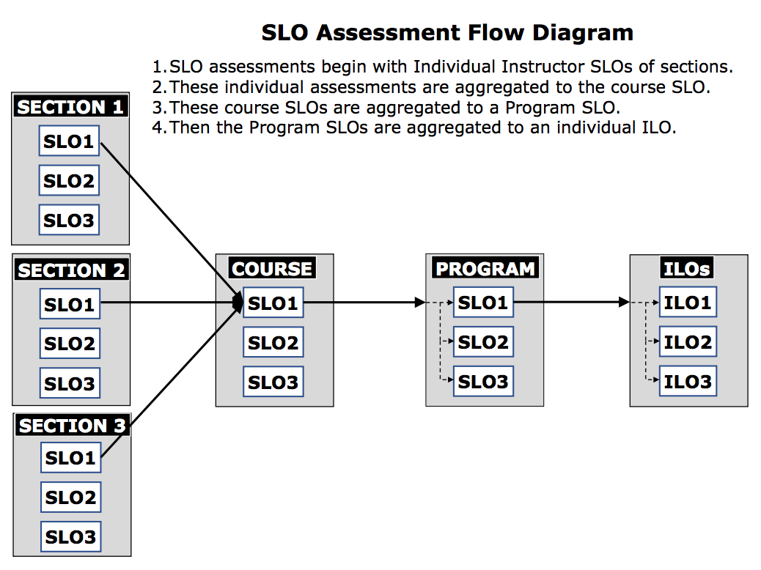

Program Review – Program Review’s [function, purpose, and components](https://www.contracosta.edu/faculty-resources/program-review/) best describe the value of program review to the college. First, program review ensures quality program through peer view and self-evaluation. Second, it encourages a culture of evidenced based assessment practice. Third, it ensures programs meet stated goals and support the overall institutional mission. Lastly, it promotes sharing and communication of successes and recommendations college-wide.

The program review template that is used district-wide and has sections including data reporting, impact on identified metrics, and budget requests. The template also the program’s review team and the program review validation reviewer to demonstrate a team approach and a campus-wide approach to evaluation.

An important area is section Self-Reflection. It asks the programs important questions about program strengths and needs, how programs integrate with our programs on campus for seamless collaboration, any accreditation related recommendation, and impact of changing trends or changes that may impact programs. These questions frame how the program’s performance, budget requests, and strategies work in the context of the college’s bigger mission and how programs can continue to improve upon their impact on student learning and success.

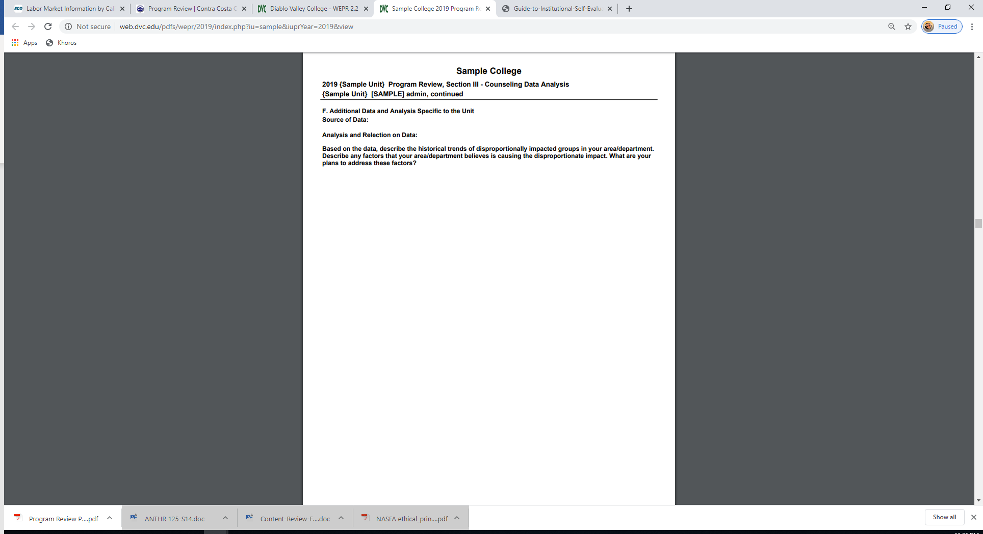

**Analysis and Evaluation**

Contra Costa College’s assessment of learning outcomes and programs informs course and programmatic changes that lead to greater success of students. The alignment of SLO’s to PLO’s to ILO’s ensures that college’s mission is the primary focus

**Evidence**

|  |  |
| --- | --- |
| [I.B.4-1](https://www.contracosta.edu/faculty-resources/program-review/) | Contra Costa College Program Review |
|  |  |
|  |  |

* 1. The institution assesses accomplishment of its mission through program review and evaluation of goals and objectives, student learning outcomes, and student achievement. Quantitative and qualitative data are disaggregated for analysis by program type and mode of delivery.

**Evidence of Meeting the Standard**

**Program Review**

The program review process, which centers data on student learning and achievement, is foundational to the effectiveness of the college. Accordingly, the program review process asks each unit to speak to how their work relates back to the campus’s overall goals and strategies. All college programs and units are also required to complete a comprehensive self-study evaluate their programs every 4 years. Career technical programs are required to complete their evaluation every two years. These program reviews are validated by a subgroup of the Planning Committee. Both commendations and recommendations are made for each unit that support programmatic implementation, continuous improvement, and innovation. An [online program review template](https://web.dvc.edu/wepr/) is being utilized to complete this process and a new template utilizing eLumen will be rolled out in Fall 2020.

As described in Standard I.B.3, Institutional-set standards are established by the college in alignment with the state’s [Vision for Success](https://vision.foundationccc.org/looking-ahead), and district goals. These standards include enrollment, degree and certificate completion, retention, and completion of college level math and English. Equity focused metrics are also included such as Pell Participation and closing the gap on achievement among priority minority population.

In short, various student data demographics, enrollment, financial needs, success and persistence, and completion are collected. Moreover, analyses of these metrics are also completed and disaggregated based on various factors like age, ethnic and racial background, socio-economic status, gender, delivery mode, and program type. Here’s a sample of what this reporting section looks like in Section III of the [sample online program review template](http://web.dvc.edu/pdfs/wepr/2019/index.php?iu=sample&iuprYear=2019&view) that reports course success rate of “C” or better by different teaching modality, gender of students, and ethnic background:

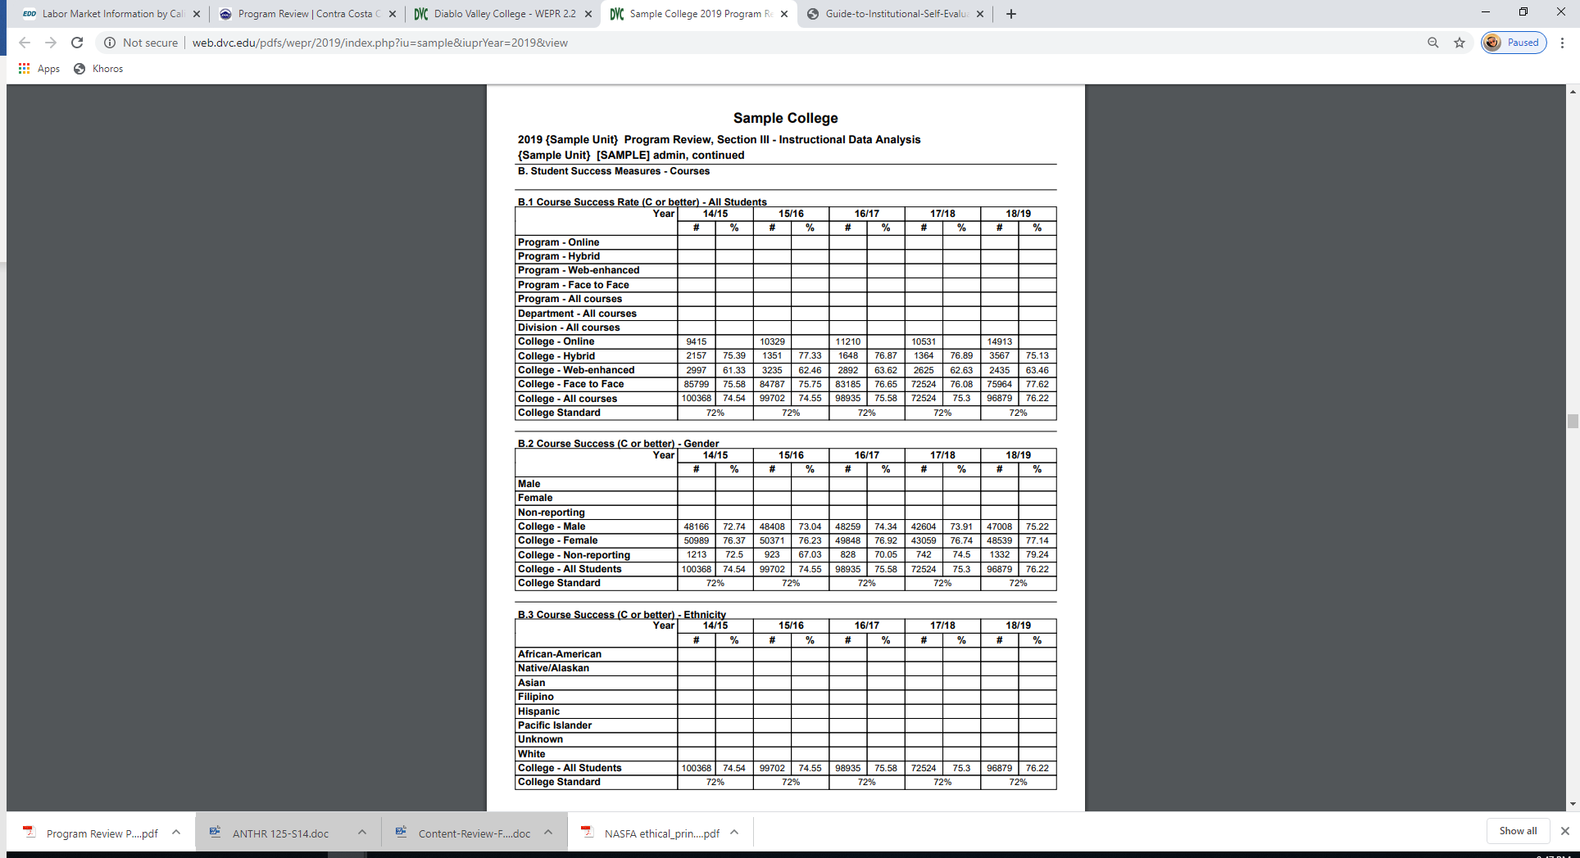

**Analysis and Evaluation**

Contra Costa College’s evaluation of learning outcomes and programs utilize data on student learning and achievement and leads to improvements and changes for continuous quality improvement.

**Evidence**

|  |  |
| --- | --- |
| [I.B.5-1](https://web.dvc.edu/wepr/) | Web Enabled Program Review Online Form |
| [I.B.5-2](http://web.dvc.edu/pdfs/wepr/2019/index.php?iu=sample&iuprYear=2019&view) | Sample Program Review Template |
|  |  |
|  |  |

* 1. The institution disaggregates and analyzes learning outcomes and achievement for subpopulations of students. When the institution identifies performance gaps, it implements strategies, which may include allocation or reallocation of human, fiscal and other resources, to mitigate those gaps and evaluates the efficacy of those strategies.

**Evidence of Meeting the Standard**

Learning outcomes and achievement data are disaggregated, as exemplified in Standard I.B.6, based on various factors like age, ethnic and racial background, socio-economic status, gender, delivery mode, and program type. These data points are aligned with the equity and success metrics in various college plans and College Scorecard, also described in Standard I.A.2.

Allocation of resources to mitigate performance gaps also start with the program review process. Depending on the funding restrictions, requested resources depend on the source. Here’s a general list of funding source and allowable:

|  |  |
| --- | --- |
| General Funds | Personnel, facilities requests, equipment repair, items not allowed in grants. |
| Categorical: (Student Equity and Achievement, Strong Workforce, Perkins, etc.) | Personnel, supplies, equipment, and other grant specific allowable expense. |
| Bonds: (Different Measures and Bonds) | Fixtures, furnitures, equipment, and other bond specific allowable expenses. |

In Section I of the program review template, the assessment of outcomes and strategies are reported an analyzed. Strategies adopted by departments and units also include facilities, personnel, and other requests. Here are examples of the areas in the program review that documents reflection, strategizing, reporting of resource impact and ranked requests:

Reflection on Strengths and Challenges in the Implementation of Strategies and Activities:

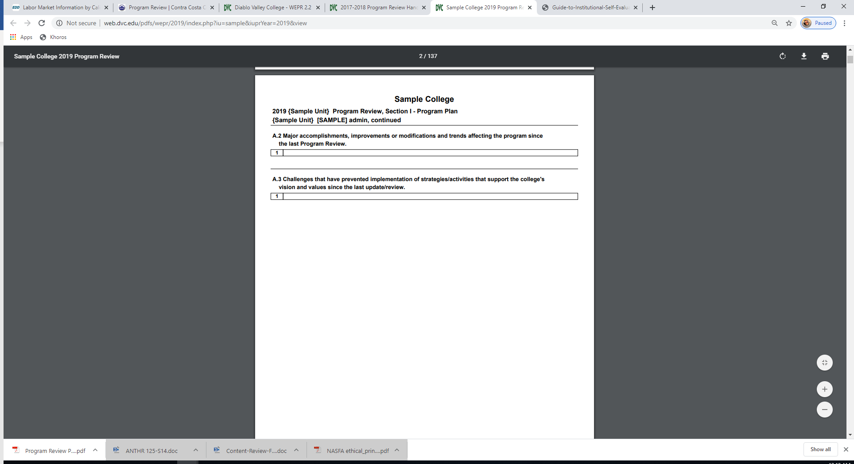

Reflection on SLO Assessment:

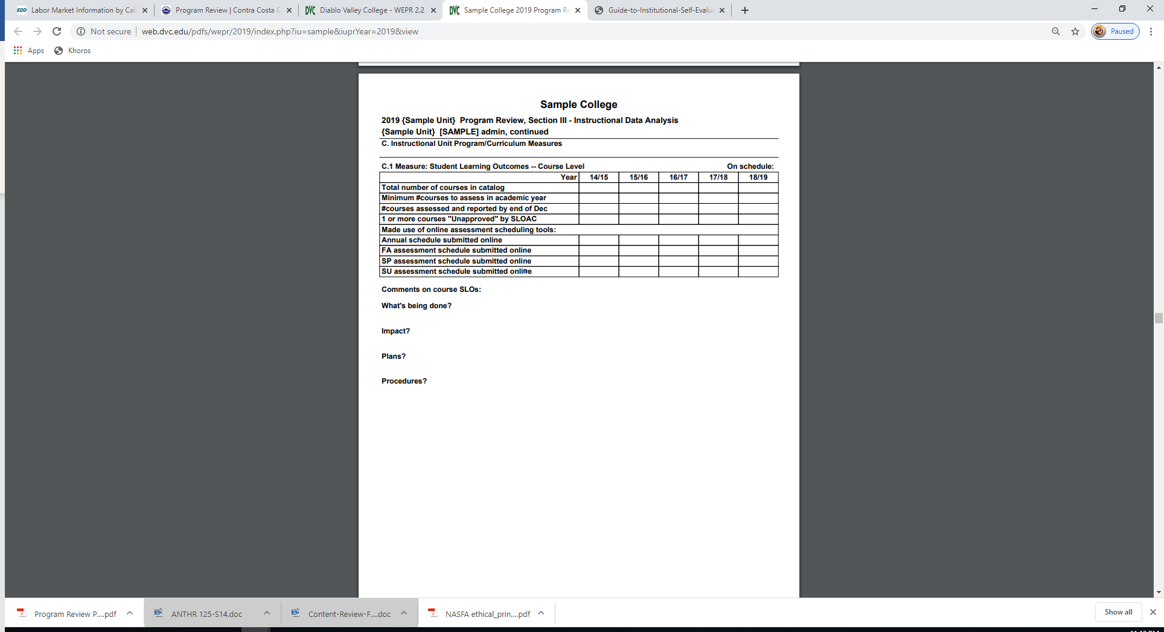

Reflection and Strategy Development.

dg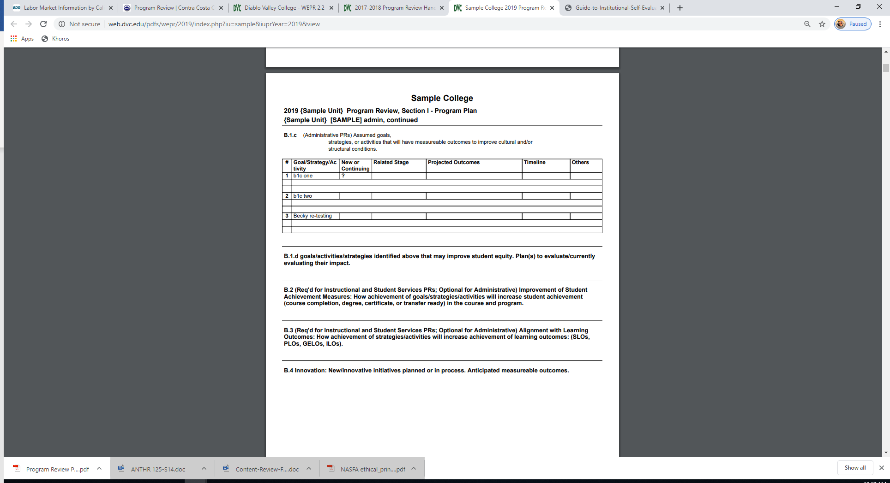

Request for Program Resources and Support:

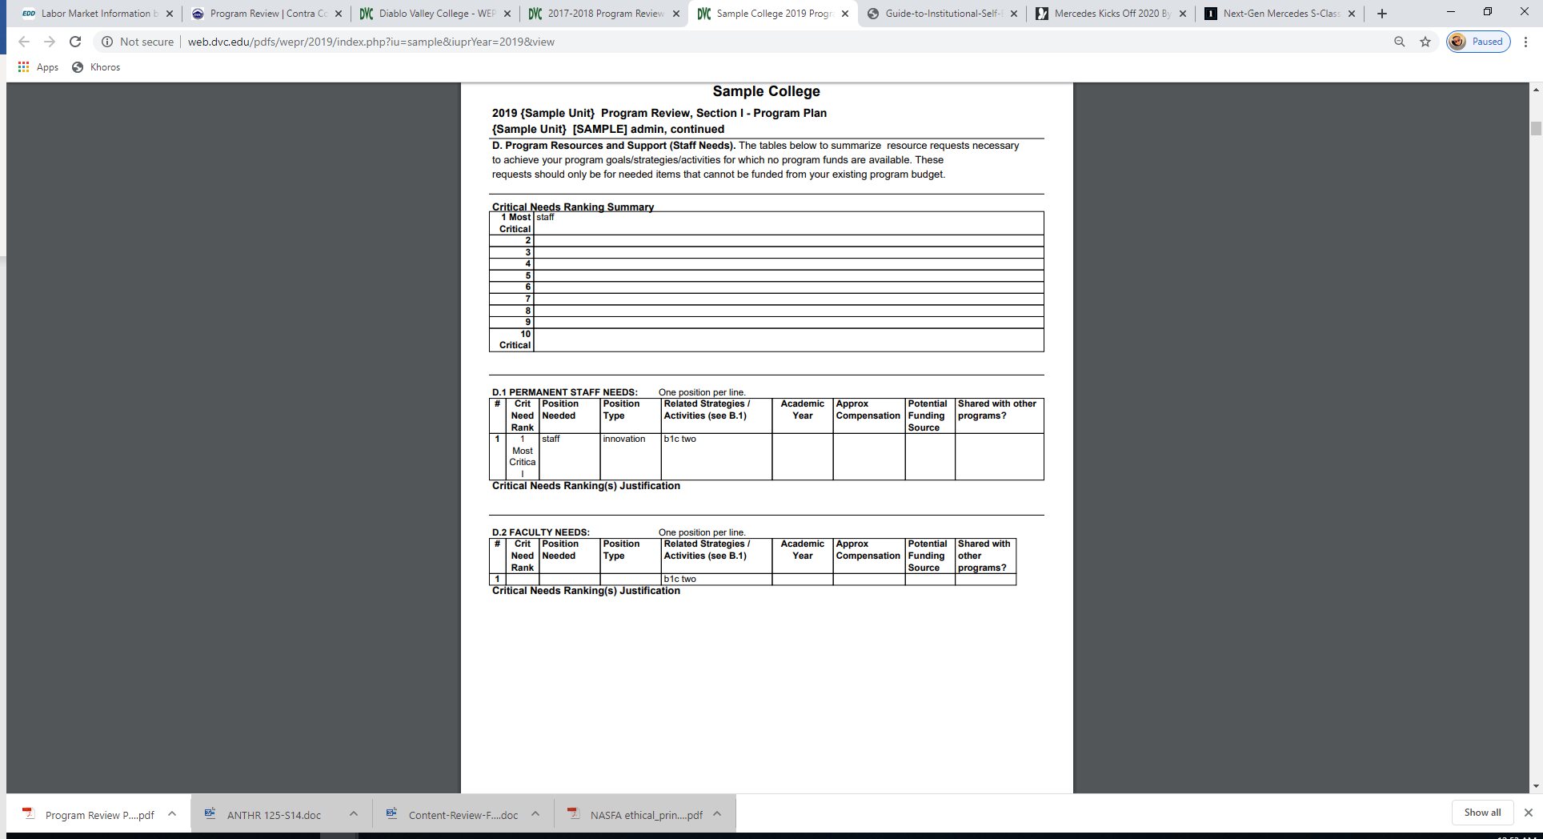

**Analysis and Evaluation**

Disaggregated data and analysis of learning outcomes for subpopulations of students lead to implementation of strategies and allocation of resources in support of the college’s mission for equitable learning. The college is dedicated to developing better mechanisms to evaluate and report efficacies of strategies.

**Evidence**

|  |  |
| --- | --- |
| I.B.6-1 |  |

**Changes and Plans Arising out of Self Evaluation Process**

|  |  |  |  |  |
| --- | --- | --- | --- | --- |
| **Standard** | **Change, Improvement and Innovation** | **College Lead(s) & Venues** | **Timeline** | **Outcome and Status** |
| I.B.6-1 | Update assessment tools and reporting processes to evaluate the efficacies of strategies identified in program review.. | Shared Governance Committees; Academic Disciplines, Academic Support Programs, and Student Services Units, and Public Forums | Spring 2020 -Ongoing | Analysis and evaluation of strategies in program reviews to “close the loop”.  Develop timeline and process for communicating results. |

* 1. The institution regularly evaluates its policies and practices across all areas of the institution, including instructional programs, student and learning support services, resource management, and governance processes to assure their effectiveness in supporting academic quality and accomplishment of mission.

**Evidence of Meeting the Standard**

Contra Costa College and the Contra Costa Community College District review and update policies and procedures as needed. However, the College recognizes that not all processes have updated policies in light of new initiatives and development and evaluations have not been formalized for all policies.

[District Governance Committee](http://www.4cd.edu/about/committees/dgc/docs/DGC%20Operational%20Guidelines.pdf)

Governance process review by the College Council, Academic and Classified Senates, and Associated Students of Contra Costa College. College Council is the primary committee charged with approving campus-wide policies and procedures, especially as they related to goals, resource allocation, and evaluation. Subcommittees such as [Curriculum Instruction Committee](https://www.contracosta.edu/faculty-resources/cic/) (CIC) is charged with examining and approving courses and programs at Contra Costa College, including developing policies concerning curriculum issues. Another campus committee charged with assisting in coordinating, supporting, planning, and monitoring institutional effectiveness is the [Planning Committee](https://www.contracosta.edu/event/planning-committee/).

Budget Committee

Student Success

**Analysis and Evaluation**

**Evidence**

|  |  |
| --- | --- |
| [I.B.7-](https://www.contracosta.edu/event/college-council-meeting-2/) | Contra Costa College College Council |
| [I.B.7-](https://www.contracosta.edu/faculty-resources/cic/) | Contra Costa College Curriculum Instruction Committee |
| [I.B.7-](https://www.contracosta.edu/event/planning-committee/) | Contra Costa College Planning Committee |

* 1. The institution broadly communicates the results of all of its assessment and evaluation activities so that the institution has a shared understanding of its strengths and weaknesses and sets appropriate priorities.

**Evidence of Meeting the Standard**

[insert response]

**Analysis and Evaluation**

[insert response]

* 1. The institution engages in continuous, broad based, systematic evaluation and planning. The institution integrates program review, planning, and resource allocation into a comprehensive process that leads to accomplishment of its mission and improvement of institutional effectiveness and academic quality. Institutional planning addresses short- and long-range needs for educational programs and services and for human, physical, technology, and financial resources. (ER 19)

**Evidence of Meeting the Standard**

There are many ways integrated planning occur at Contra Costa College. Integrated planning is critical in the development of performance metrics, assessing outcomes, discussion of results and resources, and strategic planning. This model from Contra Costa College’s Strategic Plan 2015-2020 best visualizes the integrated planning process for the college.

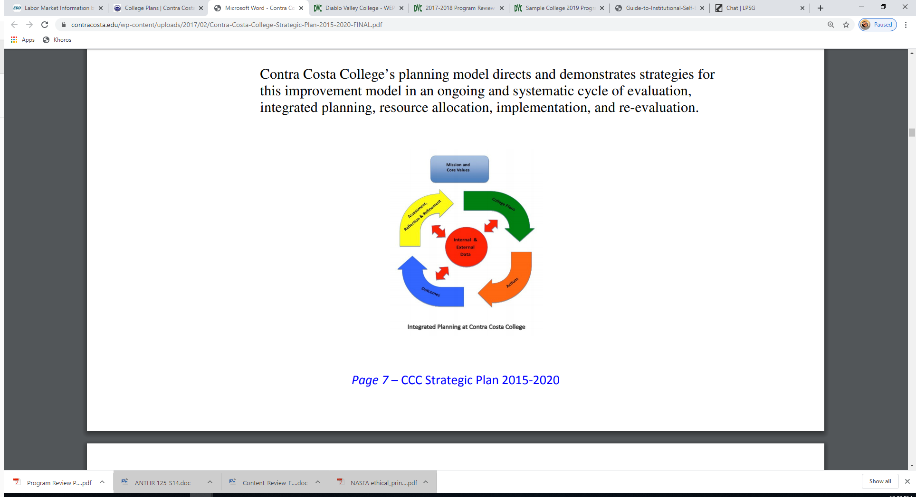

Integrated planning is well demonstrated in College’s strategic planning process. Integrated planning is evident in the In Appreciation, Plan Development Chronology, and College Integrated Planning sections of the current 2015-2020 [Strategic Plan](https://www.contracosta.edu/wp-content/uploads/2017/02/Contra-Costa-College-Strategic-Plan-2015-2020-FINAL.pdf). These sections list the philosophy and process behind integrated planning at Contra Costa; the collective efforts and contribution of faculty, staff, and students; and the opportunities for feedback from campus constituencies. In addition, Contra Costa College is utilizing the Planning Committee, a sub-committee of the College Council charged to review and revise the Strategic Plan that will lead Contra Costa through 2025.

Another evidence of integrated planning at Contra Costa College is in the development of the [2017-19 Integrated Plan](https://www.contracosta.edu/wp-content/uploads/2018/01/1217-special-BU-CCC-Integrated-Plan-Executive-Summary.pdf) that aligned Basic Skills, Equity, and Student Success and Support Program activities, goals and funding. The goal of this plan to streamline the goals, initiatives and activities, as well as data gathering and funding to maximize the impact of the work of the college on equity and student success.

Similarly, Program Review is the completed by a committee within the department and validated by a cross-campus team of the Planning Committee. Results are shared in departments, committees, and meetings. Results and analyses form the basis for budget, recommendations resource allocation, and strategies as described in Standard I.B.6. They also inform the short- and long-term analysis of institutional goals, and the development of future goals and major campus planning to ensure data driven and inclusive processes.

**Analysis and Evaluation**

**Evidence of Meeting the Standard**

|  |  |
| --- | --- |
| [I.B.9-](https://www.contracosta.edu/wp-content/uploads/2017/02/Contra-Costa-College-Strategic-Plan-2015-2020-FINAL.pdf) | Contra Costa College 2015-2020 Strategic Plan |
| I.B.9- | Planning Committee updates on Strategic Plan progress |
|  | * + Final strategic plan update – STD4 evidence moved copy to STD1 |
| [I.B.9-](https://www.contracosta.edu/wp-content/uploads/2018/01/1217-special-BU-CCC-Integrated-Plan-Executive-Summary.pdf) | Contra Costa College 2017-19 Integrated Plan |

**Conclusions on Standard I.B. Academic Quality and Institutional Effectiveness**

[insert response]

**Improvement Plan(s)**

[insert response if applicable]

**Evidence List**

[insert list]

### Institutional Integrity

1. The institution assures the clarity, accuracy, and integrity of information provided to students and prospective students, personnel, and all persons or organizations related to its mission statement, learning outcomes, educational programs, and student support services. The institution gives accurate information to students and the public about its accreditation status with all of its accreditors. (ER 20)

**Evidence of Meeting the Standard**

[insert response]

**Analysis and Evaluation**

[insert response]

1. The institution provides a print or online catalog for students and prospective students with precise, accurate, and current information on all facts, requirements, policies, and procedures listed in the “Catalog Requirements”. (ER 20)

**Evidence of Meeting the Standard**

[insert response]

**Analysis and Evaluation**

[insert response]

1. The institution uses documented assessment of student learning and evaluation of student achievement to communicate matters of academic quality to appropriate constituencies, including current and prospective students and the public. (ER 19)

**Evidence of Meeting the Standard**

[insert response]

**Analysis and Evaluation**

[insert response]

1. The institution describes its certificates and degrees in terms of their purpose, content, course requirements, and expected learning outcomes.

**Evidence of Meeting the Standard**

[insert response]

**Analysis and Evaluation**

[insert response]

1. The institution regularly reviews institutional policies, procedures, and publications to assure integrity in all representations of its mission, programs, and services.

**Evidence of Meeting the Standard**

[insert response]

**Analysis and Evaluation**

[insert response]

1. The institution accurately informs current and prospective students regarding the total cost of education**,** including tuition, fees, and other required expenses, including textbooks, and other instructional materials.

**Evidence of Meeting the Standard**

[insert response]

**Analysis and Evaluation**

[insert response]

1. In order to assure institutional and academic integrity, the institution uses and publishes governing board policies on academic freedom and responsibility. These policies make clear the institution’s commitment to the free pursuit and dissemination of knowledge, and its support for an atmosphere in which intellectual freedom exists for all constituencies, including faculty and students. (ER 13)

**Evidence of Meeting the Standard**

[insert response]

**Analysis and Evaluation**

[insert response]

1. The institution establishes and publishes clear policies and procedures that promote honesty, responsibility and academic integrity. These policies apply to all constituencies and include specifics relative to each, including student behavior, academic honesty and the consequences for dishonesty.

**Evidence of Meeting the Standard**

[insert response]

**Analysis and Evaluation**

[insert response]

1. Faculty distinguish between personal conviction and professionally accepted views in a discipline. They present data and information fairly and objectively.

**Evidence of Meeting the Standard**

[insert response]

**Analysis and Evaluation**

[insert response]

1. Institutions that require conformity to specific codes of conduct of staff, faculty, administrators, or students, or that seek to instill specific beliefs or world views, give clear prior notice of such policies, including statements in the catalog and/or appropriate faculty and student handbooks.

**Evidence of Meeting the Standard**

[insert response]

**Analysis and Evaluation**

[insert response]

1. Institutions operating in foreign locations operate in conformity with the Standards and applicable Commission policies for all students. Institutions must have authorization from the Commission to operate in a foreign location.

**Evidence of Meeting the Standard**

[insert response]

**Analysis and Evaluation**

[insert response]

1. The institution agrees to comply with Eligibility Requirements, Accreditation Standards, Commission policies, guidelines, and requirements for public disclosure, institutional reporting, team visits, and prior approval of substantive changes. When directed to act by the Commission, the institution responds to meet requirements within a time period set by the Commission. It discloses information required by the Commission to carry out its accrediting responsibilities. (ER 21)

**Evidence of Meeting the Standard**

[insert response]

**Analysis and Evaluation**

[insert response]

1. The institution advocates and demonstrates honesty and integrity in its relationships with external agencies, including compliance with regulations and statutes. It describes itself in consistent terms to all of its accrediting agencies and communicates any changes in its accredited status to the Commission, students, and the public. (ER 21)

**Evidence of Meeting the Standard**

[insert response]

**Analysis and Evaluation**

[insert response]

1. The institution ensures that its commitments to high quality education, student achievement and student learning are paramount to other objectives such as generating financial returns for investors, contributing to a related or parent organization, or supporting external interests.

**Evidence of Meeting the Standard**

[insert response]

**Analysis and Evaluation**

[insert response]

**Conclusions on Standard I.C. Institutional Integrity**

[insert response]

**Improvement Plan(s)**

[insert response if applicable]

**Evidence List**

[insert list]

## Standard II: Student Learning Programs and Support Services

The institution offers instructional programs, library and learning support services, and student support services aligned with its mission. The institution’s programs are conducted at levels of quality and rigor appropriate for higher education. The institution assesses its educational quality through methods accepted in higher education, makes the results of its assessments available to the public, and uses the results to improve educational quality and institutional effectiveness. The institution defines and incorporates into all of its degree programs a substantial component of general education designed to ensure breadth of knowledge and to promote intellectual inquiry. The provisions of this standard are broadly applicable to all instructional programs and student and learning support services offered in the name of the institution.

### Instructional Programs

* 1. All instructional programs, regardless of location or means of delivery, including distance education and correspondence education, are offered in fields of study consistent with the institution’s mission, are appropriate to higher education, and culminate in student attainment of identified student learning outcomes, and achievement of degrees, certificates, employment, or transfer to other higher education programs. (ER 9 and ER 11)

**Evidence of Meeting the Standard**

[insert response]

**Analysis and Evaluation**

[insert response]

* 1. ***(Applicable to institutions with comprehensive reviews scheduled through Fall 2019.[1])***Faculty, including full time, part time, and adjunct faculty, ensure that the content and methods of instruction meet generally accepted academic and professional standards and expectations. Faculty and others responsible act to continuously improve instructional courses, programs and directly related services through systematic evaluation to assure currency, improve teaching and learning strategies, and promote student success.

(***Applicable to institutions with comprehensive reviews scheduled after Fall 2019.******)*** Faculty, including full time, part time, and adjunct faculty, regularly engage in ensuring that the content and methods of instruction meet generally accepted academic and professional standards and expectations. In exercising collective ownership over the design and improvement of the learning experience, faculty conduct systematic and inclusive program review, using student achievement data, in order to continuously improve instructional courses and programs, thereby ensuring program currency, improving teaching and learning strategies, and promoting student success.

**Evidence of Meeting the Standard**

[insert response]

**Analysis and Evaluation**

[insert response]

* 1. The institution identifies and regularly assesses learning outcomes for courses, programs, certificates and degrees using established institutional procedures. The institution has officially approved and current course outlines that include student learning outcomes. In every class section students receive a course syllabus that includes learning outcomes from the institution’s officially approved course outline.

**Evidence of Meeting the Standard**

[insert response]

**Analysis and Evaluation**

[insert response]

* 1. If the institution offers pre-collegiate level curriculum, it distinguishes that curriculum from college level curriculum and directly supports students in learning the knowledge and skills necessary to advance to and succeed in college level curriculum.

**Evidence of Meeting the Standard**

[insert response]

**Analysis and Evaluation**

[insert response]

* 1. The institution’s degrees and programs follow practices common to American higher education, including appropriate length, breadth, depth, rigor, course sequencing, time to completion, and synthesis of learning. The institution ensures that minimum degree requirements are 60 semester credits or equivalent at the associate level, and 120 credits or equivalent at the baccalaureate level. (ER 12)

**Evidence of Meeting the Standard**

[insert response]

**Analysis and Evaluation**

[insert response]

* 1. The institution schedules courses in a manner that allows students to complete certificate and degree programs within a period of time consistent with established expectations in higher education. (ER 9)

**Evidence of Meeting the Standard**

[insert response]

**Analysis and Evaluation**

[insert response]

* 1. The institution effectively uses delivery modes, teaching methodologies and learning support services that reflect the diverse and changing needs of its students, in support of equity in success for all students.

**Evidence of Meeting the Standard**

[insert response]

**Analysis and Evaluation**

[insert response]

* 1. The institution validates the effectiveness of department-wide course and/or program examinations, where used, including direct assessment of prior learning. The institution ensures that processes are in place to reduce test bias and enhance reliability.

**Evidence of Meeting the Standard**

[insert response]

**Analysis and Evaluation**

[insert response]

* 1. The institution awards course credit, degrees and certificates based on student attainment of learning outcomes. Units of credit awarded are consistent with institutional policies that reflect generally accepted norms or equivalencies in higher education. If the institution offers courses based on clock hours, it follows Federal standards for clock-to-credit-hour conversions. (ER 10)

**Evidence of Meeting the Standard**

[insert response]

**Analysis and Evaluation**

[insert response]

* 1. The institution makes available to its students clearly stated transfer-of-credit policies in order to facilitate the mobility of students without penalty. In accepting transfer credits to fulfill degree requirements, the institution certifies that the expected learning outcomes for transferred courses are comparable to the learning outcomes of its own courses. Where patterns of student enrollment between institutions are identified, the institution develops articulation agreements as appropriate to its mission. (ER 10)

**Evidence of Meeting the Standard**

[insert response]

**Analysis and Evaluation**

[insert response]

* 1. The institution includes in all of its programs, student learning outcomes, appropriate to the program level, in communication competency, information competency, quantitative competency, analytic inquiry skills, ethical reasoning, the ability to engage diverse perspectives, and other program-specific learning outcomes.

**Evidence of Meeting the Standard**

[insert response]

**Analysis and Evaluation**

[insert response]

* 1. The institution requires of all of its degree programs a component of general education based on a carefully considered philosophy for both associate and baccalaureate degrees that is clearly stated in its catalog. The institution, relying on faculty expertise, determines the appropriateness of each course for inclusion in the general education curriculum, based upon student learning outcomes and competencies appropriate to the degree level. The learning outcomes include a student’s preparation for and acceptance of responsible participation in civil society, skills for lifelong learning and application of learning, and a broad comprehension of the development of knowledge, practice, and interpretive approaches in the arts and humanities, the sciences, mathematics, and social sciences. (ER 12)

**Evidence of Meeting the Standard**

[insert response]

**Analysis and Evaluation**

[insert response]

* 1. All degree programs include focused study in at least one area of inquiry or in an established interdisciplinary core. The identification of specialized courses in an area of inquiry or interdisciplinary core is based upon student learning outcomes and competencies, and include mastery, at the appropriate degree level, of key theories and practices within the field of study.

**Evidence of Meeting the Standard**

[insert response]

**Analysis and Evaluation**

[insert response]

* 1. Graduates completing career-technical certificates and degrees demonstrate technical and professional competencies that meet employment standards and other applicable standards and preparation for external licensure and certification.

**Evidence of Meeting the Standard**

[insert response]

**Analysis and Evaluation**

[insert response]

* 1. When programs are eliminated or program requirements are significantly changed, the institution makes appropriate arrangements so that enrolled students may complete their education in a timely manner with a minimum of disruption.

**Evidence of Meeting the Standard**

[insert response]

**Analysis and Evaluation**

[insert response]

* 1. The institution regularly evaluates and improves the quality and currency of all instructional programs offered in the name of the institution, including collegiate, pre-collegiate, career-technical, and continuing and community education courses and programs, regardless of delivery mode or location. The institution systematically strives to improve programs and courses to enhance learning outcomes and achievement for students.

**Evidence of Meeting the Standard**

[insert response]

**Analysis and Evaluation**

[insert response]

**Conclusions on Standard II.A. Instructional Programs**

[insert response]

**Improvement Plan(s)**

[insert response if applicable]

**Evidence List**

[insert list]

### Library and Learning Support Services

1. The institution supports student learning and achievement by providing library, and other learning support services to students and to personnel responsible for student learning and support. These services are sufficient in quantity, currency, depth, and variety to support educational programs, regardless of location or means of delivery, including distance education and correspondence education. Learning support services include, but are not limited to, library collections, tutoring, learning centers, computer laboratories, learning technology, and ongoing instruction for users of library and other learning support services. (ER 17)

**Evidence of Meeting the Standard**

[insert response]

**Analysis and Evaluation**

[insert response]

1. Relying on appropriate expertise of faculty, including librarians, and other learning support services professionals, the institution selects and maintains educational equipment and materials to support student learning and enhance the achievement of the mission.

**Evidence of Meeting the Standard**

[insert response]

**Analysis and Evaluation**

[insert response]

1. The institution evaluates library and other learning support services to assure their adequacy in meeting identified student needs. Evaluation of these services includes evidence that they contribute to the attainment of student learning outcomes. The institution uses the results of these evaluations as the basis for improvement.

**Evidence of Meeting the Standard**

[insert response]

**Analysis and Evaluation**

[insert response]

1. When the institution relies on or collaborates with other institutions or other sources for library and other learning support services for its instructional programs, it documents that formal agreements exist and that such resources and services are adequate for the institution’s intended purposes, are easily accessible and utilized. The institution takes responsibility for and assures the security, maintenance, and reliability of services provided either directly or through contractual arrangement. The institution regularly evaluates these services to ensure their effectiveness. (ER 17)

**Evidence of Meeting the Standard**

[insert response]

**Analysis and Evaluation**

[insert response]

**Conclusions on Standard II.B. Library and Learning Support Services**

[insert response]

**Improvement Plan(s)**

[insert response if applicable]

**Evidence List**

[insert list]

### Student Support Services

1. The institution regularly evaluates the quality of student support services and demonstrates that these services, regardless of location or means of delivery, including distance education and correspondence education, support student learning, and enhance accomplishment of the mission of the institution. (ER 15)

**Evidence of Meeting the Standard**

[insert response]

**Analysis and Evaluation**

[insert response]

1. The institution identifies and assesses learning support outcomes for its student population and provides appropriate student support services and programs to achieve those outcomes. The institution uses assessment data to continuously improve student support programs and services.

**Evidence of Meeting the Standard**

[insert response]

**Analysis and Evaluation**

[insert response]

1. The institution assures equitable access to all of its students by providing appropriate, comprehensive, and reliable services to students regardless of service location or delivery method. (ER 15)

**Evidence of Meeting the Standard**

[insert response]

**Analysis and Evaluation**

[insert response]

1. Co-curricular programs and athletics programs are suited to the institution’s mission and contribute to the social and cultural dimensions of the educational experience of its students. If the institution offers co-curricular or athletic programs, they are conducted with sound educational policy and standards of integrity. The institution has responsibility for the control of these programs, including their finances.

**Evidence of Meeting the Standard**

[insert response]

**Analysis and Evaluation**

[insert response]

1. The institution provides counseling and/or academic advising programs to support student development and success and prepares faculty and other personnel responsible for the advising function. Counseling and advising programs orient students to ensure they understand the requirements related to their programs of study and receive timely, useful, and accurate information about relevant academic requirements, including graduation and transfer policies.

**Evidence of Meeting the Standard**

[insert response]

**Analysis and Evaluation**

[insert response]

1. The institution has adopted and adheres to admission policies consistent with its mission that specify the qualifications of students appropriate for its programs. The institution defines and advises students on clear pathways to complete degrees, certificate and transfer goals. (ER 16)

**Evidence of Meeting the Standard**

[insert response]

**Analysis and Evaluation**

[insert response]

1. The institution regularly evaluates admissions and placement instruments and practices to validate their effectiveness while minimizing biases.

**Evidence of Meeting the Standard**

[insert response]

**Analysis and Evaluation**

[insert response]

1. The institution maintains student records permanently, securely, and confidentially, with provision for secure backup of all files, regardless of the form in which those files are maintained. The institution publishes and follows established policies for release of student records.

**Evidence of Meeting the Standard**

[insert response]

**Analysis and Evaluation**

[insert response]

**Conclusions on Standard II.C. Student Support Services**

[insert response]

**Improvement Plan(s)**

[insert response if applicable]

**Evidence List**

[insert list]

## Standard III: Resources

The institution effectively uses its human, physical, technology, and financial resources to achieve its mission and to improve academic quality and institutional effectiveness.

Accredited colleges in multi-college systems may be organized so that responsibility for resources, allocation of resources, and planning rests with the district/system. In such cases, the district/system is responsible for meeting the Standards, and an evaluation of its performance is reflected in the accredited status of the institution(s).

### Human Resources

* 1. The institution assures the integrity and quality of its programs and services by employing administrators, faculty and staff who are qualified by appropriate education, training, and experience to provide and support these programs and services. Criteria, qualifications, and procedures for selection of personnel are clearly and publicly stated and address the needs of the institution in serving its student population. Job descriptions are directly related to institutional mission and goals and accurately reflect position duties, responsibilities, and authority.

**Evidence of Meeting the Standard**

[insert response]

**Analysis and Evaluation**

[insert response]

* 1. Faculty qualifications include knowledge of the subject matter and requisite skills for the service to be performed. Factors of qualification include appropriate degrees, professional experience, discipline expertise, level of assignment, teaching skills, scholarly activities, and potential to contribute to the mission of the institution. Faculty job descriptions include development and review of curriculum as well as assessment of learning. (ER 14)

**Evidence of Meeting the Standard**

[insert response]

**Analysis and Evaluation**

[insert response]

* 1. Administrators and other employees responsible for educational programs and services possess qualifications necessary to perform duties required to sustain institutional effectiveness and academic quality.

**Evidence of Meeting the Standard**

[insert response]

**Analysis and Evaluation**

[insert response]

* 1. Required degrees held by faculty, administrators and other employees are from institutions accredited by recognized U.S. accrediting agencies. Degrees from non-

U.S. institutions are recognized only if equivalence has been established.

**Evidence of Meeting the Standard**

[insert response]

**Analysis and Evaluation**

[insert response]

* 1. The institution assures the effectiveness of its human resources by evaluating all personnel systematically and at stated intervals. The institution establishes written criteria for evaluating all personnel, including performance of assigned duties and participation in institutional responsibilities and other activities appropriate to their expertise. Evaluation processes seek to assess effectiveness of personnel and encourage improvement. Actions taken following evaluations are formal, timely, and documented.

**Evidence of Meeting the Standard**

[insert response]

**Analysis and Evaluation**

[insert response]

* 1. ~~The evaluation of faculty, academic administrators, and other personnel directly responsible for student learning includes, as a component of that evaluation, consideration of how these employees use the results of the assessment of learning outcomes to improve teaching and learning.~~ *(Effective January 2018, Standard III.A.6 is no longer applicable. The Commission acted to delete the Standard during its January 2018 Board of Directors meeting.)*

[Skip Standard III.A.6. Continue responses with Standard III.A.7)

* 1. The institution maintains a sufficient number of qualified faculty, which includes full time faculty **and** may include part time and adjunct faculty, to assure the fulfillment of faculty responsibilities essential to the quality of educational programs and services to achieve institutional mission and purposes. (ER 14)

**Evidence of Meeting the Standard**

[insert response]

**Analysis and Evaluation**

[insert response]

* 1. An institution with part time and adjunct faculty has employment policies and practices which provide for their orientation, oversight, evaluation, and professional development. The institution provides opportunities for integration of part time and adjunct faculty into the life of the institution.

**Evidence of Meeting the Standard**

[insert response]

**Analysis and Evaluation**

[insert response]

* 1. The institution has a sufficient number of staff with appropriate qualifications to support the effective educational, technological, physical, and administrative operations of the institution. (ER 8)

**Evidence of Meeting the Standard**

[insert response]

**Analysis and Evaluation**

[insert response]

* 1. The institution maintains a sufficient number of administrators with appropriate preparation and expertise to provide continuity and effective administrative leadership and services that support the institution’s mission and purposes. (ER 8)

**Evidence of Meeting the Standard**

[insert response]

**Analysis and Evaluation**

[insert response]

* 1. The institution establishes, publishes, and adheres to written personnel policies and procedures that are available for information and review. Such policies and procedures are fair and equitably and consistently administered.

**Evidence of Meeting the Standard**

[insert response]

**Analysis and Evaluation**

[insert response]

* 1. Through its policies and practices, the institution creates and maintains appropriate programs, practices, and services that support its diverse personnel. The institution regularly assesses its record in employment equity and diversity consistent with its mission.

**Evidence of Meeting the Standard**

[insert response]

**Analysis and Evaluation**

[insert response]

* 1. The institution upholds a written code of professional ethics for all of its personnel, including consequences for violation.

**Evidence of Meeting the Standard**

[insert response]

**Analysis and Evaluation**

[insert response]

* 1. The institution plans for and provides all personnel with appropriate opportunities for continued professional development, consistent with the institutional mission and based on evolving pedagogy, technology, and learning needs. The institution systematically evaluates professional development programs and uses the results of these evaluations as the basis for improvement.

**Evidence of Meeting the Standard**

[insert response]

**Analysis and Evaluation**

[insert response]

* 1. The institution makes provision for the security and confidentiality of personnel records. Each employee has access to his/her personnel records in accordance with law.

**Evidence of Meeting the Standard**

[insert response]

**Analysis and Evaluation**

[insert response]

**Conclusions on Standard III.A. Human Resources**

[insert response]

**Improvement Plan(s)**

[insert response if applicable]

**Evidence List**

[insert list]

### Physical Resources

* 1. The institution assures safe and sufficient physical resources at all locations where it offers courses, programs, and learning support services. They are constructed and maintained to assure access, safety, security, and a healthful learning and working environment.

**Evidence of Meeting the Standard**

[insert response]

**Analysis and Evaluation**

[insert response]

* 1. The institution plans, acquires or builds, maintains, and upgrades or replaces its physical resources, including facilities, equipment, land, and other assets, in a manner that assures effective utilization and the continuing quality necessary to support its programs and services and achieve its mission.

**Evidence of Meeting the Standard**

[insert response]

**Analysis and Evaluation**

[insert response]

* 1. To assure the feasibility and effectiveness of physical resources in supporting institutional programs and services, the institution plans and evaluates its facilities and equipment on a regular basis, taking utilization and other relevant data into account.

**Evidence of Meeting the Standard**

[insert response]

**Analysis and Evaluation**

[insert response]

* 1. Long-range capital plans support institutional improvement goals and reflect projections of the total cost of ownership of new facilities and equipment.

**Evidence of Meeting the Standard**

[insert response]

**Analysis and Evaluation**

[insert response]

**Conclusions on Standard III.B. Physical Resources**

[insert response]

**Improvement Plan(s)**

[insert response if applicable]

**Evidence List**

[insert list]

### Technology Resources

* 1. Technology services, professional support, facilities, hardware, and software are appropriate and adequate to support the institution’s management and operational functions, academic programs, teaching and learning, and support services.

**Evidence of Meeting the Standard**

[insert response]

**Analysis and Evaluation**

[insert response]

* 1. The institution continuously plans for, updates and replaces technology to ensure its technological infrastructure, quality and capacity are adequate to support its mission, operations, programs, and services.

**Evidence of Meeting the Standard**

[insert response]

**Analysis and Evaluation**

[insert response]

* 1. The institution assures that technology resources at all locations where it offers courses, programs, and services are implemented and maintained to assure reliable access, safety, and security.

**Evidence of Meeting the Standard**

[insert response]

**Analysis and Evaluation**

[insert response]

* 1. The institution provides appropriate instruction and support for faculty, staff, students, and administrators, in the effective use of technology and technology systems related to its programs, services, and institutional operations.

**Evidence of Meeting the Standard**

[insert response]

**Analysis and Evaluation**

[insert response]

* 1. The institution has policies and procedures that guide the appropriate use of technology in the teaching and learning processes.

**Evidence of Meeting the Standard**

[insert response]

**Analysis and Evaluation**

[insert response]

**Conclusions on Standard III.C. Technology Resources**

[insert response]

**Improvement Plan(s)**

[insert response if applicable]

**Evidence List**

[insert list]

### Financial Resources

Planning

* 1. Financial resources are sufficient to support and sustain student learning programs and services and improve institutional effectiveness. The distribution of resources supports the development, maintenance, allocation and reallocation, and enhancement of programs and services. The institution plans and manages its financial affairs with integrity and in a manner that ensures financial stability. (ER 18)

**Evidence of Meeting the Standard**

[insert response]

**Analysis and Evaluation**

[insert response]

* 1. The institution’s mission and goals are the foundation for financial planning, and financial planning is integrated with and supports all institutional planning. The institution has policies and procedures to ensure sound financial practices and financial stability. Appropriate financial information is disseminated throughout the institution in a timely manner.

**Evidence of Meeting the Standard**

[insert response]

**Analysis and Evaluation**

[insert response]

* 1. The institution clearly defines and follows its guidelines and processes for financial planning and budget development, with all constituencies having appropriate opportunities to participate in the development of institutional plans and budgets.

**Evidence of Meeting the Standard**

[insert response]

**Analysis and Evaluation**

[insert response]

Fiscal Responsibility and Stability

* 1. Institutional planning reflects a realistic assessment of financial resource availability, development of financial resources, partnerships, and expenditure requirements.

**Evidence of Meeting the Standard**

[insert response]

**Analysis and Evaluation**

[insert response]

* 1. To assure the financial integrity of the institution and responsible use of its financial resources, the internal control structure has appropriate control mechanisms and widely disseminates dependable and timely information for sound financial decision making. The institution regularly evaluates its financial management practices and uses the results to improve internal control systems.

**Evidence of Meeting the Standard**

[insert response]

**Analysis and Evaluation**

[insert response]

* 1. Financial documents, including the budget, have a high degree of credibility and accuracy, and reflect appropriate allocation and use of financial resources to support student learning programs and services.

**Evidence of Meeting the Standard**

[insert response]

**Analysis and Evaluation**

[insert response]

* 1. Institutional responses to external audit findings are comprehensive, timely, and communicated appropriately.

**Evidence of Meeting the Standard**

[insert response]

**Analysis and Evaluation**

[insert response]

* 1. The institution’s financial and internal control systems are evaluated and assessed for validity and effectiveness, and the results of this assessment are used for improvement.

**Evidence of Meeting the Standard**

[insert response]

**Analysis and Evaluation**

[insert response]

* 1. The institution has sufficient cash flow and reserves to maintain stability, support strategies for appropriate risk management, and, when necessary, implement contingency plans to meet financial emergencies and unforeseen occurrences.

**Evidence of Meeting the Standard**

[insert response]

**Analysis and Evaluation**

[insert response]

* 1. The institution practices effective oversight of finances, including management of financial aid, grants, externally funded programs, contractual relationships, auxiliary organizations or foundations, and institutional investments and assets.

**Evidence of Meeting the Standard**

[insert response]

**Analysis and Evaluation**

[insert response]

Liabilities

* 1. The level of financial resources provides a reasonable expectation of both short- term and long-term financial solvency. When making short-range financial plans, the institution considers its long-range financial priorities to assure financial stability. The institution clearly identifies, plans, and allocates resources for payment of liabilities and future obligations.

**Evidence of Meeting the Standard**

[insert response]

**Analysis and Evaluation**

[insert response]

* 1. The institution plans for and allocates appropriate resources for the payment of liabilities and future obligations, including Other Post-Employment Benefits (OPEB), compensated absences, and other employee related obligations. The actuarial plan to determine Other Post-Employment Benefits (OPEB) is current and prepared as required by appropriate accounting standards.

**Evidence of Meeting the Standard**

[insert response]

**Analysis and Evaluation**

[insert response]

* 1. On an annual basis, the institution assesses and allocates resources for the repayment of any locally incurred debt instruments that can affect the financial condition of the institution.

**Evidence of Meeting the Standard**

[insert response]

**Analysis and Evaluation**

[insert response]

* 1. All financial resources, including short- and long-term debt instruments (such as bonds and Certificates of Participation), auxiliary activities, fund-raising efforts, and grants, are used with integrity in a manner consistent with the intended purpose of the funding source.

**Evidence of Meeting the Standard**

[insert response]

**Analysis and Evaluation**

[insert response]

* 1. The institution monitors and manages student loan default rates, revenue streams, and assets to ensure compliance with federal requirements, including Title IV of the Higher Education Act, and comes into compliance when the federal government identifies deficiencies.

**Evidence of Meeting the Standard**

[insert response]

**Analysis and Evaluation**

[insert response]

Contractual Agreements

* 1. Contractual agreements with external entities are consistent with the mission and goals of the institution, governed by institutional policies, and contain appropriate provisions to maintain the integrity of the institution and the quality of its programs, services, and operations.

**Evidence of Meeting the Standard**

[insert response]

**Analysis and Evaluation**

[insert response]

**Conclusions on Standard III.D. Financial Resources**

[insert response]

**Improvement Plan(s)**

[insert response if applicable]

**Evidence List**

[insert list]

## Standard IV: Leadership and Governance

The institution recognizes and uses the contributions of leadership throughout the organization for promoting student success, sustaining academic quality, integrity, fiscal stability, and continuous improvement of the institution. Governance roles are defined in policy and are designed to facilitate decisions that support student learning programs and services and improve institutional effectiveness, while acknowledging the designated responsibilities of the governing board and the chief executive officer. Through established governance structures, processes, and practices, the governing board, administrators, faculty, staff, and students work together for the good of the institution. In multi-college districts or systems, the roles within the district/system are clearly delineated. The multi-college district or system has policies for allocation of resources to adequately support and sustain the colleges.

### Decision-Making Roles and Processes

* 1. Institutional leaders create and encourage innovation leading to institutional excellence. They support administrators, faculty, staff, and students, no matter what their official titles, in taking initiative for improving the practices, programs, and services in which they are involved. When ideas for improvement have policy or significant institution-wide implications, systematic participative processes are used to assure effective planning and implementation.

**Evidence of Meeting the Standard**

[insert response]

**Analysis and Evaluation**

[insert response]

* 1. The institution establishes and implements policy and procedures authorizing administrator, faculty, and staff participation in decision-making processes. The policy makes provisions for student participation and consideration of student views in those matters in which students have a direct and reasonable interest. Policy specifies the manner in which individuals bring forward ideas and work together on appropriate policy, planning, and special-purpose committees.

**Evidence of Meeting the Standard**

[insert response]

**Analysis and Evaluation**

[insert response]

* 1. Administrators and faculty, through policy and procedures, have a substantive and clearly defined role in institutional governance and exercise a substantial voice in institutional policies, planning, and budget that relate to their areas of responsibility and expertise.

**Evidence of Meeting the Standard**

[insert response]

**Analysis and Evaluation**

[insert response]

* 1. Faculty and academic administrators, through policy and procedures, and through well-defined structures, have responsibility for recommendations about curriculum and student learning programs and services.

**Evidence of Meeting the Standard**

[insert response]

**Analysis and Evaluation**

[insert response]

* 1. Through its system of board and institutional governance, the institution ensures the appropriate consideration of relevant perspectives; decision-making aligned with expertise and responsibility; and timely action on institutional plans, policies, curricular change, and other key considerations.

**Evidence of Meeting the Standard**

[insert response]

**Analysis and Evaluation**

[insert response]

* 1. The processes for decision-making and the resulting decisions are documented and widely communicated across the institution.

**Evidence of Meeting the Standard**

[insert response]

**Analysis and Evaluation**

[insert response]

* 1. Leadership roles and the institution’s governance and decision-making policies, procedures, and processes are regularly evaluated to assure their integrity and effectiveness. The institution widely communicates the results of these evaluations and uses them as the basis for improvement.

**Evidence of Meeting the Standard**

[insert response]

**Analysis and Evaluation**

[insert response]

**Conclusions on Standard IV.A. Decision Making Roles and Processes**

[insert response]

**Improvement Plan(s)**

[insert response if applicable]

**Evidence List**

[insert list]

### Chief Executive Officer

* 1. The institutional chief executive officer (CEO) has primary responsibility for the quality of the institution. The CEO provides effective leadership in planning, organizing, budgeting, selecting and developing personnel, and assessing institutional effectiveness.

**Evidence of Meeting the Standard**

[insert response]

**Analysis and Evaluation**

[insert response]

* 1. The CEO plans, oversees, and evaluates an administrative structure organized and staffed to reflect the institution’s purposes, size, and complexity. The CEO delegates authority to administrators and others consistent with their responsibilities, as appropriate.

**Evidence of Meeting the Standard**

[insert response]

**Analysis and Evaluation**

[insert response]

* 1. Through established policies and procedures, the CEO guides institutional improvement of the teaching and learning environment by:
     + establishing a collegial process that sets values, goals, and priorities;
     + ensuring the college sets institutional performance standards for student achievement;
     + ensuring that evaluation and planning rely on high quality research and analysis of external and internal conditions;
     + ensuring that educational planning is integrated with resource planning and allocation to support student achievement and learning;
     + ensuring that the allocation of resources supports and improves learning and achievement; and
     + establishing procedures to evaluate overall institutional planning and implementation efforts to achieve the mission of the institution.

**Evidence of Meeting the Standard**

[insert response]

**Analysis and Evaluation**

[insert response]

* 1. The CEO has the primary leadership role for accreditation, ensuring that the institution meets or exceeds Eligibility Requirements, Accreditation Standards, and Commission policies at all times. Faculty, staff, and administrative leaders of the institution also have responsibility for assuring compliance with accreditation requirements.

**Evidence of Meeting the Standard**

[insert response]

**Analysis and Evaluation**

[insert response]

* 1. The CEO assures the implementation of statutes, regulations, and governing board policies and assures that institutional practices are consistent with institutional mission and policies, including effective control of budget and expenditures.

**Evidence of Meeting the Standard**

[insert response]

**Analysis and Evaluation**

[insert response]

* 1. The CEO works and communicates effectively with the communities served by the institution.

**Evidence of Meeting the Standard**

[insert response]

**Analysis and Evaluation**

[insert response]

**Conclusions on Standard IV.B. CEO**

[insert response]

**Improvement Plan(s)**

[insert response if applicable]

**Evidence List**

[insert list]

### Governing Board

* 1. The institution has a governing board that has authority over and responsibility for policies to assure the academic quality, integrity, and effectiveness of the student learning programs and services and the financial stability of the institution. (ER 7)

**Evidence of Meeting the Standard**

[insert response]

**Analysis and Evaluation**

[insert response]

* 1. The governing board acts as a collective entity. Once the board reaches a decision, all board members act in support of the decision.

**Evidence of Meeting the Standard**

[insert response]

**Analysis and Evaluation**

[insert response]

* 1. The governing board adheres to a clearly defined policy for selecting and evaluating the CEO of the college and/or the district/system.

**Evidence of Meeting the Standard**

[insert response]

**Analysis and Evaluation**

[insert response]

* 1. The governing board is an independent, policy-making body that reflects the public interest in the institution’s educational quality. It advocates for and defends the institution and protects it from undue influence or political pressure. (ER 7)

**Evidence of Meeting the Standard**

[insert response]

**Analysis and Evaluation**

[insert response]

* 1. The governing board establishes policies consistent with the college/district/sys- tem mission to ensure the quality, integrity, and improvement of student learning programs and services and the resources necessary to support them. The governing board has ultimate responsibility for educational quality, legal matters, and financial integrity and stability.

**Evidence of Meeting the Standard**

[insert response]

**Analysis and Evaluation**

[insert response]

* 1. The institution or the governing board publishes the board bylaws and policies specifying the board’s size, duties, responsibilities, structure, and operating procedures.

**Evidence of Meeting the Standard**

[insert response]

**Analysis and Evaluation**

[insert response]

* 1. The governing board acts in a manner consistent with its policies and bylaws. The board regularly assesses its policies and bylaws for their effectiveness in fulfilling the college/district/system mission and revises them as necessary.

**Evidence of Meeting the Standard**

[insert response]

**Analysis and Evaluation**

[insert response]

* 1. To ensure the institution is accomplishing its goals for student success, the governing board regularly reviews key indicators of student learning and achievement and institutional plans for improving academic quality.

**Evidence of Meeting the Standard**

[insert response]

**Analysis and Evaluation**

[insert response]

* 1. The governing board has an ongoing training program for board development, including new member orientation. It has a mechanism for providing for continuity of board membership and staggered terms of office.

**Evidence of Meeting the Standard**

[insert response]

**Analysis and Evaluation**

[insert response]

* 1. Board policies and/or bylaws clearly establish a process for board evaluation. The evaluation assesses the board’s effectiveness in promoting and sustaining academic quality and institutional effectiveness. The governing board regularly evaluates its practices and performance, including full participation in board training, and makes public the results. The results are used to improve board performance, academic quality, and institutional effectiveness.

**Evidence of Meeting the Standard**

[insert response]

**Analysis and Evaluation**

[insert response]

* 1. The governing board upholds a code of ethics and conflict of interest policy, and individual board members adhere to the code. The board has a clearly defined policy for dealing with behavior that violates its code and implements it when necessary. A majority of the board members have no employment, family, ownership, or other personal financial interest in the institution. Board member interests are disclosed and do not interfere with the impartiality of governing body members or outweigh the greater duty to secure and ensure the academic and fiscal integrity of the institution. (ER 7)

**Evidence of Meeting the Standard**

[insert response]

**Analysis and Evaluation**

[insert response]

* 1. The governing board delegates full responsibility and authority to the CEO to implement and administer board policies without board interference and holds the CEO accountable for the operation of the district/system or college, respectively.

**Evidence of Meeting the Standard**

[insert response]

**Analysis and Evaluation**

[insert response]

* 1. The governing board is informed about the Eligibility Requirements, the Accreditation Standards, Commission policies, accreditation processes, and the college’s accredited status, and supports through policy the college’s efforts to improve and excel. The board participates in evaluation of governing board roles and functions in the accreditation process.

**Evidence of Meeting the Standard**

[insert response]

**Analysis and Evaluation**

[insert response]

**Conclusions on Standard IV.C. Governing Board**

[insert response]

**Improvement Plan(s)**

[insert response if applicable]

**Evidence List**

[insert list]

### Multi-College Districts or Systems

* 1. In multi-college districts or systems, the district/system CEO provides leadership in setting and communicating expectations of educational excellence and integrity throughout the district/system and assures support for the effective operation of the colleges. Working with the colleges, the district/system CEO establishes clearly defined roles, authority and responsibility between the colleges and the district/system.

**Evidence of Meeting the Standard**

[insert response]

[insert link to functional map here]

**Analysis and Evaluation**

[insert response]

* 1. The district/system CEO clearly delineates, documents, and communicates the operational responsibilities and functions of the district/system from those of the colleges and consistently adheres to this delineation in practice. The district/system CEO ensures that the colleges receive effective and adequate district/system provided services to support the colleges in achieving their missions. Where a district/system has responsibility for resources, allocation of resources, and planning, it is evaluated against the Standards, and its performance is reflected in the accredited status of the institution.

**Evidence of Meeting the Standard**

[insert response]

**Analysis and Evaluation**

[insert response]

* 1. The district/system has a policy for allocation and reallocation of resources that are adequate to support the effective operations and sustainability of the colleges and district/system. The district/system CEO ensures effective control of expenditures.

**Evidence of Meeting the Standard**

[insert response]

**Analysis and Evaluation**

[insert response]

* 1. The CEO of the district or system delegates full responsibility and authority to the CEOs of the colleges to implement and administer delegated district/system policies without interference and holds college CEO’s accountable for the operation of the colleges.

**Evidence of Meeting the Standard**

[insert response]

**Analysis and Evaluation**

[insert response]

* 1. District/system planning and evaluation are integrated with college planning and evaluation to improve student learning and achievement and institutional effectiveness.

**Evidence of Meeting the Standard**

[insert response]

**Analysis and Evaluation**

[insert response]

* 1. Communication between colleges and districts/systems ensures effective operations of the colleges and should be timely, accurate, and complete in order for the colleges to make decisions effectively.

**Evidence of Meeting the Standard**

[insert response]

**Analysis and Evaluation**

[insert response]

* 1. The district/system CEO regularly evaluates district/system and college role delineations, governance and decision-making processes to assure their integrity and effectiveness in assisting the colleges in meeting educational goals for student achievement and learning. The district/system widely communicates the results of these evaluations and uses them as the basis for improvement.

**Evidence of Meeting the Standard**

[insert response]

**Analysis and Evaluation**

[insert response]

**Conclusions on Standard IV.D. Multi-College Districts or Systems**

[insert response]

**Improvement Plan(s)**

[insert response if applicable]

**Evidence List**

[insert list]

# Quality Focus Essay

**Introduction of Projects**

[insert response]

**Anticipated Impact on Student Learning and Achievement**

[insert response]

**Outcome Measures**

[insert response]

**Action Plan(s)**

[insert plan for each project]

|  |  |  |  |
| --- | --- | --- | --- |
| Activity | Responsible Party | Resources | Timeline |
|  |  |  |  |
|  |  |  |  |
|  |  |  |  |
|  |  |  |  |
|  |  |  |  |

1. The Commission acted to modify the Standard during its January 2018 Board of Directors meeting.